**Management of Judicial System**

**Dhaka CMM Court**

**Chowdhury Md Rakin Haider, 1005009**

**Shakil Ahmed, 1005014**

**Md Touhiduzzaman, 1005018**

**Shohan Al Jannat, 1005023**

**Tanzeer Hossain, 1005029**

**CSE , BUET**

# Table of Contents:

Chapter 1: Overview of the Project

1.1 Introduction

1.2 Organization Overview

1.3 Project Overview

1.4 Aims / Goals of the Project

1.5 Motivation of the Project

1.6 Report Overview

Chapter 2: Existing System Study & Scope Definition

2.1 Introduction

2.2 System Analysis

2.3 Problem Analysis

2.4 Scope of Implementation

Chapter 3: Requirement Analysis & Feasibility Study

3.1 Introduction

3.2 Requirement Analysis

3.2.1 Case Filing Subsystem

3.2.2 Cause List Generation

3.2.3 Magistrate Assignment

3.2.4 Document Collection

3.2.5 Trial Documentation

3.3 Feasibility Analysis

3.3.1 Operational Feasibility

3.3.2 Cultural Feasibility

3.3.3 Technical Feasibility

Chapter 4: Proposed System Design

4.1 Introduction

4.2 Use Case Diagram

4.3 Data Flow Diagram

4.4 System Design

4.4.1 Sequence Diagram

4.4.2 State Chart Diagram

4.4.3 Activity Diagram

Chapter 5: Database Design

5.1 Introduction

5.2 Overview of the Design Process

5.3 ERD & Its Brief Description

5.3.1 The ERD at a Glance

5.3.2 Anatomizing the ERD

5.4 Database Schema

5.5 Triggers

5.6 Procedures

Chapter 6: Input & Output Design

6.1 Introduction

6.2 Common UIs

6.2.1 Log In UI:

6.2.2 Case Details Show

6.3 UIs for Case Filing Subsystem

6.3.1 Case Filing

6.3.2 Charge Sheet Submission

6.4 UIs for Cause List Generation Subsystem

6.4.1 Case List Sending UI

6.4.2 Cause List Show UI

6.4.3 Magistrate Home UI

6.4.4 Magistrate Case List Show

6.4.5 Magistrate Notification UI

6.5 UIs for Magistrate Assignment Subsystem

6.5.1 Court List Generation UI

6.6 UIs for Document Collection

6.6.1 Document Copying UI

6.6.2 Document Comparison UI

6.7 UIs for Trial Documentation

6.7.1 Order Posting UI

6.7.2 Judgment Documentation UI

6.8 UI Conclusion

Chapter 7: Project Timeline & Activity

7.1 Introduction

7.2 Work Schedule & Project Time Analysis

7.2.1 Activity Network

7.2.2 Activity Timeline

7.2.3 PERT Chart

7.3 Cost Benefit Analysis

7.3.1 Development Cost

7.3.2 Operational Cost

7.3.2.1 Training Cost

7.3.2.2 Hardware J& Software Implementation Cost

7.3.2.3 Variable Cost

7.3.3 Tangible Benefits

7.3.4 Intangible Benefit of the System

7.4 Risk Analysis

7.4.1 Long Term Risk Analysis & Management

7.4.1.1 Risk Identification

7.4.1.2 Risk Planning

7.4.1.2 Risk Monitoring

Chapter 8: Conclusion

**Chapter 2**

**Existing System Study & Scope Definition**

**2.1 Introduction:**

Existing judicial management system is manual and error prone. With huge amount cases and less human power, management has become clumsy and tedious. But with proper and modern technology base management system things can be changed to great extent. By comparing the existing system and our proposed system we can see that a easy, efficient management system can be built with reasonable cost and time for managing the judicial system more effectively.

**2.2 Existing System Analysis:** In the existing system there are 3 active elements. Police station, Court and people. They interact with each other in the existing system.

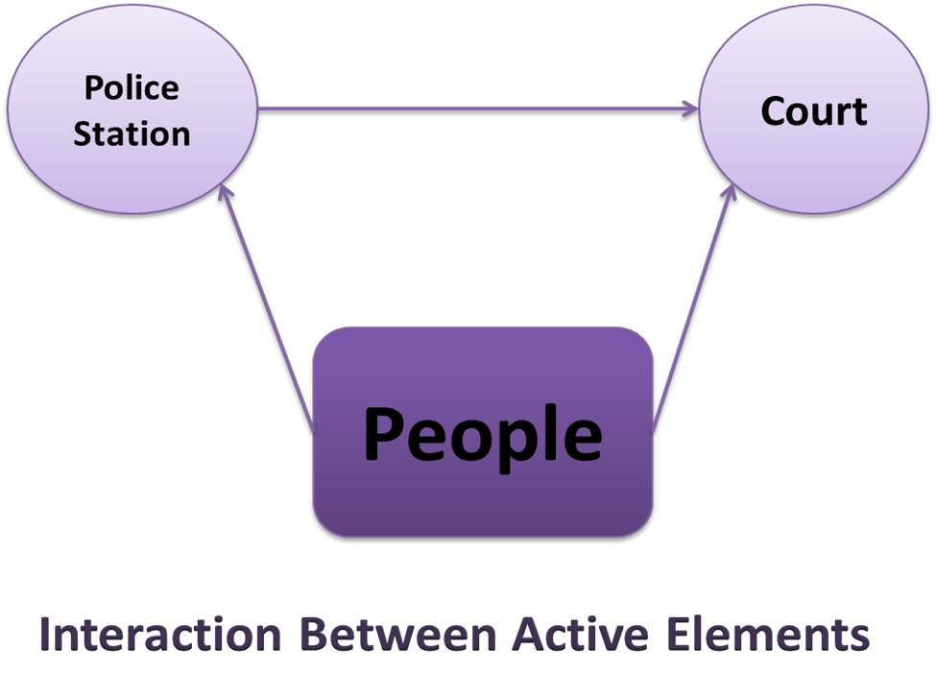

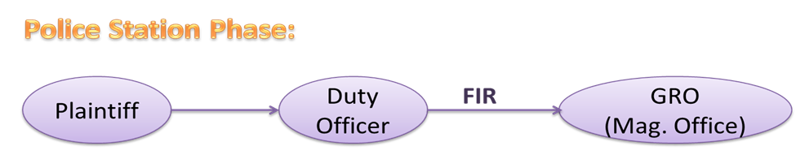

Plaintiff goes to the police station with a complain. Duty officer then files that case if his complain is worthy of filing. Then this form is sent to the GRO of the court of that zone.

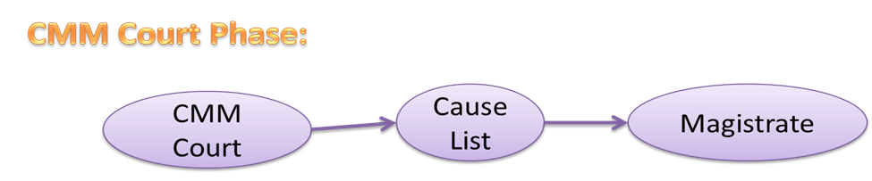

Chief Metropolitan judge (CMM) assigns magistrate to different courts. With this list of assigned courts a cause list is generated. According to the cause list the magistrates do their duty.

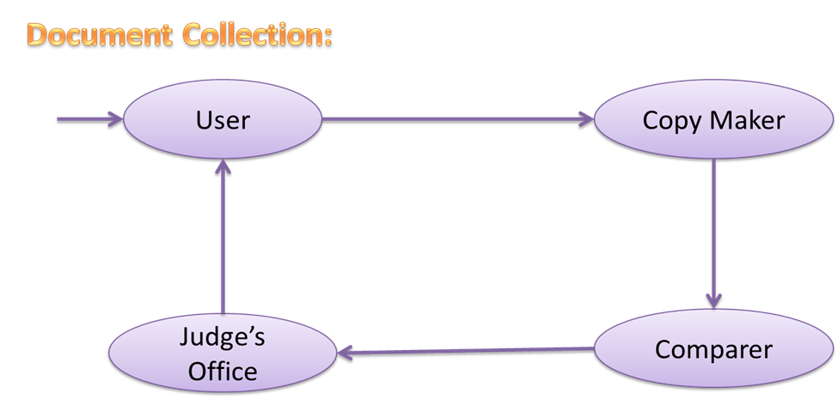

To collect a document user goes to the copy maker with appropriate case number. Then copy maker copies the requested document and pass then to the copy maker for further checking. If copy maker finds everything ok then he sends them to the judge’s office for approval. Finally the requested document is supplied to the user.

**2.3 Problem Analysis:**

**2.3.1 Baseline Problem Analysis:**

* Filling up & Forwarding the FIR to the GRO: After the case is filed at the police station, the FIR (First Information Record) is submitted within a certain time to the GRO of the respective Magistrate office. This whole manual process requires time and is also error-prone.
* Management & categorization of the cases by GRO: On receiving the FIR, the GRO categorizes the case by respective laws as women right, fast-trial tribunal etc.
* Assignment of the Magistrates by CMM: Each day the CMM court assigns different magistrates to different zones and thus assigns different cases to them. This shuffling process is done due to security issues.
* Generating the cause-list: A cause-list is generated every day by the CMM which contains information about which magistrate is assigned to which zone, what are the running cases of this zone and also information about the case’s state.
* Notifying the Magistrates: The magistrates need to know in which zone they are assigned. Now there is no way of notifying them. What they do is collect required information form the cause-list which is put up on some notice board of the court.
* Generating the requested certified copies: For different reason one can need different certified copies about the case. The existing process is one have to request for a copy and wait until the copy makers supply the copy then he has to contact the comparers’ office who will certify that the actual copy and the newly made copy has same information. Finally the copy has to get a signature of the judge’s office to be counted as a certified copy.
* Proper documentation of the trial phase: In the trial phase, there are lots of data like the witnesses, arguments presented by the lawyers, the judgment, which are needed to be documented. Nowadays these are written by hand by the greffier.
* Managing & updating the running case records: There is a record book for every case. These records are updated with the progress of the case. Managing these records is one of the major problems in this process.
* Managing the huge amount of past case: The record files for the past cases have to be managed in such a way that searching and viewing of previous judgments doesn’t become hazardous.

**2.3.1 Baseline Problem Analysis:**

|  |  |  |  |
| --- | --- | --- | --- |
| Brief Statements Problems | Urgency/  Priority Rank | Proposed Solution | Benefits |
| 1. Filling up and forwarding the FIR to the GRO | ASAP | Automated FIR submission to the GRO from the Duty Officer, as soon as the case is filled. | Manual labor and time saved with more accuracy |
| 2. Management & categorization of the cases by GRO | 1 Month | GRO selects the category of the case and sends to CMM for Magistrate assignment through web-service | “ |
| 3. Assignment of the Magistrates by CMM | 2 Month | CMM assigns the respective Magistrate to a case, when they’re notified with and auto-generated cause-list | “ |
| 4. Notifying the Magistrates | 2 Month |
| 5.Generating the cause-list | 1 Month |
| 6.Generating requested certified copies | 2 Month | Certified print-outs of the online documents | **“** |
| 7.Proper documentation of the trial phase | 2 Month | Greffier writes and updates case details | **“** |
| 8.Managing and updating the running case records | 3 Month | Respective people updates the records in real time | **“** |
| 9. Managing the huge amount of past case | 5 Month | Saving completed cases | **“** |

**2.4 Scope of Implementation:**

**2.4.1 Negotiation of Baseline Scopes:**

The included aspects of the existing system in our proposed system can be divided into three parts for the sake of discussion. They are as the followings:

* Required Data:
  + Police Station: We must acquire data about corresponding duty officers in the police station to ensure security and authenticity.
  + Cases: For each case, information about FIR, charge-sheet, witness, states classification and judgment record are a must for our system.
  + Magistrates’ data: To build an automated cause-list we need to acquire data about magistrates.
  + Cause list: The cause-list made by the CMM court should be accessed in our system.
  + Judgment data: Information about judgments have to be gathered to update case record and for later references.
* User Interface:
  + Police Station: We want to implement a user interface for the police officers so that the process of filling a case can be accelerated.
  + Magistrate Office:
    - Magistrate: The magistrates must be notified about there assignment to different zone and the cases under them via an interface.
    - GRO: To receive and submit received cases to the magistrate the GRO must be provided a user interface.
    - CMM Court: An interface for the CMM court can be greatly helpful to generate cause-list and assign magistrates and sending notifications to them automatically.
  + Trial Phase:
    - Judge: To notify judges about their cases the can be provided with an interface to observe progress about their cases.
    - Greffier: The greffier needs an interface to help him with the documentation of trials.
* Processes:
  + Included Processes: The included aspects of the system are categorized as the following sub-systems:
    - Case Filing: We want to automatize the flow of maintenance and reduce human effort in this process.
    - Cause List Generation: Under a single general recording officer there can be several police stations. Each day the GRO has to handle new cases as well as other cases under corresponding magistrate. So his works should be brought under a computerized system to reduce errors.
    - Magistrate Assignment: The CMM court assigns magistrates but takes minimum steps to broadcast the assignments to magistrates. The process of shuffling magistrates, notifying them about their assignment and generate a well-designed cause-list should be one of our processes.
    - Trial Documentation: The greffier documents every phase of trial like witnesses, argument and finally judgment. These documents have to be preserved for later use.
    - Document Collection: Even if a case is finished its record book is preserved in by the court for a long time. Storing a large amount of files can cause a number of problems and loss of information. So this process is included in our proposed system.
* Not Included Processes:
  + Online request for the authenticated documents: Due to security reasons the process of online requests for authenticated documents is not included in our system.
  + Money transaction system for relative payments: All of the payments are a part of a different system i.e. the banking system. So we are leaving this part out of the scope of our system.
  + Physical presence in the trial phase: The idea of online trial might seem to be implementable but considering current scenario it will be found that it is not. So this process is excluded from our system.

**2.4.2 Assessment of Scope:**

* Advantages:
  + Less paper works: Nearly 90% of paper consumption in this process can be reduced by our proposed solution.
  + Easier Management: A computerized process is easy to manage than managing everything manually. Searching, storing and getting copies can be matter of clicks.
  + Quickening the whole process: The time of some subsystem like acquiring certified copies can be reduced drastically often resulting in a reduction of 1 month even. But in other cases it might help quickening the process by providing an easy alternative than saving time.
* Pitfalls:
  + Hardware requirements: The main drawback will be a large number of computers have to be set up. Also large server computer might also be needed for storing data.
  + Trained & skilled personnel: In our country people must be trained to use this system before applying it in field level.
  + Web service consumption: Huge data transfers are required to combine subsystem between each other.
  + Security measures must be maintained: Security and Authentication can be an issue to ponder on.

**2.5 Conclusion:**

After considering both positive and negative aspects we can come to a conclusion that the project should go ahead. The project under consideration can play a huge roll in advancement of the judicial system of Bangladesh.

**Chapter 3**

**Requirement Analysis & Feasibility Study**

**3.1 Introduction:** Before going to the development phase to build a better system we need to analyze the system thoroughly. A developer needs have a complete and clear idea about what they are planning to build. To know about the system requirement analysis and feasibility analysis is a must. By doing requirement analysis the features of the system are revealed. Also if a system is not feasible in this circumstances then one should not proceed to the development phase. As feasibility analysis can give us how much beneficial a project is from both financial and cultural prospect we can decide whether this system can be worthy of development from the results of feasibility analysis.

**3.2 Requirement Analysis:**

The requirements of the system are here analyzed by Ishikawa or Fishbone diagrams by per sub-systems. Ishikawa diagram is also called cause and effect diagram. The fishbone diagram identifies mane possible causes for an effect or problem. It can be used to structure a brainstorming session. It immediately sorts ideas into useful categories. The following diagrams shows some of the reasons related to environment, materials, people, methods and policies, which results in the current problems of the existing system.

**3.2.1 Case Filing Sub-system:**

In this sub-system the actors are less skilled and there is shortage of people to serve the users. Also there are no fixed medium for filling a case i.e. it can be filed from either the court or the police station. Thirdly managing the records for each filed case needs a huge paper work. Lastly the overall method is lengthy and error prone. As a result repetition of same work occurs and the management of the data is poor.

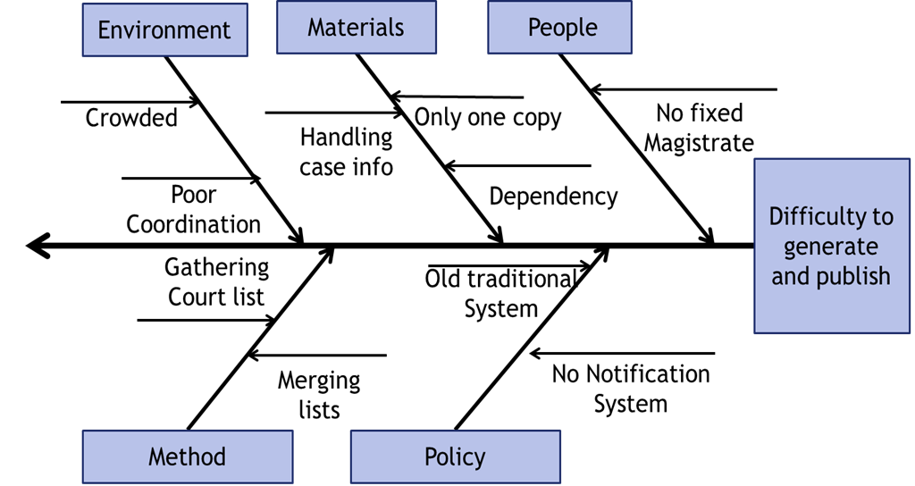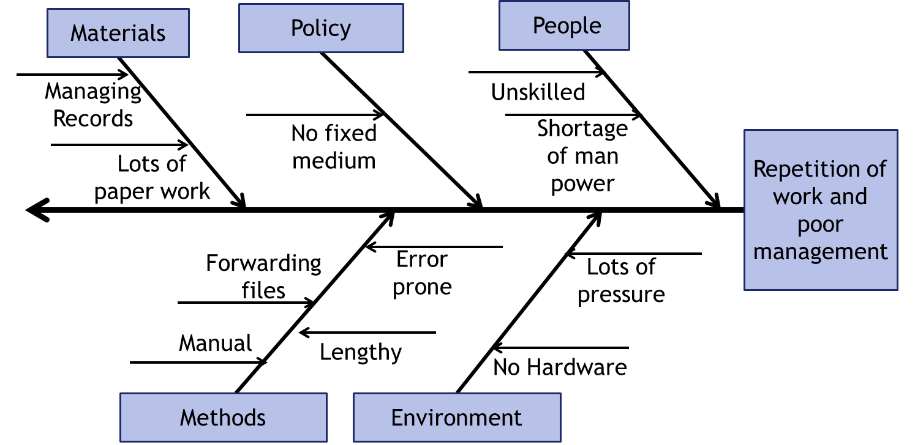**3.2.2 Cause List Generation Sub-system:** The existing problem in the cause list generation sub-system is difficult and the process of publishing it is not a very favorable process. The main reason behind this is that there dependency of this process on several other processes. The clerks have to gather information from other process to fulfill their job. Also only one copy of this list is generated on which everyone who wants to know about the proceedings of a case must depend starting from the magistrate to the plaintiff.

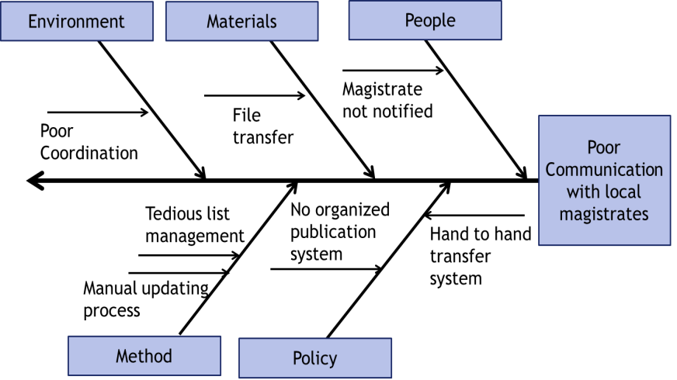**3.2.3 Magistrate Assignment Sub-system:** Magistrate assignment sub-system also has some problem. In short we can say that the problems are poor communication between magistrate and CMM court. The reasons are there is no notification system and management of these lists and updating day by day becomes hazardous. Last but not the least reason is that there is no other way for the magistrates to get these lists rather than a hand to hand transfer.

**3.2.4 Document Collection Sub-system:** In our fourth sub-system the main problem that is identified is that this process causes wastage of money and time. In this process on has to make copies after copies of the same document. This repetition is quiet unnecessary. Also the process becomes lengthy when it is done by people.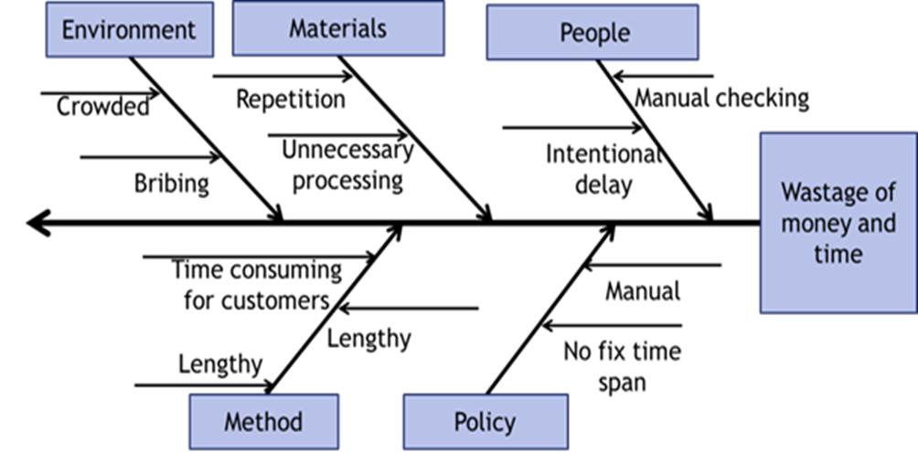

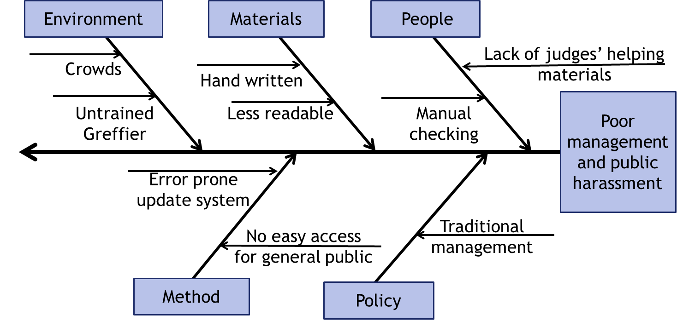**3.2.5 Trial Documentation Sub-system:** Our last sub-system is trial documentation. In this sub-system the management of the delivered verdict is not very developed and to get the corresponding paper people has to suffer lots of harassment.

**3.3 Feasibility Analysis:**

**3.3.1 Operational Feasibility:**

* PIECES Analysis:
  + P: Performance:
    - In this system, all documents will be transferred immediately saving much manual labor and time.
    - No re-writing of any document will be necessary.
    - There will be almost no paper works when this system gets well-implemented.
    - There will be almost zero manual labor in this system compared to the current system.
  + I: Information:
    - All information of any case will be available in web after the FIR is submitted, so that anyone as plaintiff, accused, witnesses and even lawyers can see the documents when needed – since these were legally supposed to be open to all people.
    - In this system, the previous case-documents are also saved in an organized way, so that any lawyer/judge may collect any information of any case for the help of any decision/reference for any later case.
    - The system is capable of sending notifications to magistrates about the cause & court list, which keeps them informed regularly in a much fast, convenient & trustworthy way.
    - The system can also send notifications to plaintiffs & other interested people-when they register themselves to get notification.
  + E: Economics:
    - All transportation costs for document transfers among police station, magistrate office, CMM office and courts is saved, since the documents are readily forwarded to the expected location when the respective people completes those.
    - The management of the case files will have about no paper document cost.
    - The documentation cost of any case will be lower in this system.
  + C: Control:
    - A database for the whole process with secured backups will be in control for the system.
    - Well isolated desktop apps for DO, GRO, greffier and so on will control the data flows among these entities;
    - Passwords protection with IP/MAC address tracking will ensure the safety of the system.
    - Only authenticated documents will be viewable via a website, which ensures the local laws.
    - No excessive controls / bureaucratic procedures will be followed, so that the users may get bored or disgusted with the system.
  + E: Efficiency:
    - All case docs will be generated from a single time input saving a huge time and manual labor.
    - Necessary fields will be timely placed to generate next docs.
    - Regular updates of a running case will be enabled in the system.
  + S: Service:
    - More accurate case structure will result, which is verified at different levels.
    - Consistent service is a great outcome of the system.
    - The service is also flexible.
    - Notification service is a unique feature of the system
    - All services of the system are easy to learn & use.
    - All services of the system will cost less time, money & labor.

**3.3.2 Cultural Feasibility**:

* + Web-based communications are getting common, so the system will be easily acceptable.
  + Now the employees are getting much skilled.
  + Future development on this digital data system will make the system much acceptable.
  + The system can bring a good recognition of our country in the international area also.

**3.3.3 Technical Feasibility:**

* + **Required Hardware:**
    - Computers with Printers
    - Internet Connection
    - Electronic Signature Pad(Optional)
    - Fingerprint reader
  + **Required Language/Platforms:** 
    - Java Desktop App Development Environment
    - PHP Framework
    - MySQL for DB Operations
    - SMS Gateway

**Chapter 4**

**Proposed System Design**

**4.1 Introduction:**

In the planning phase many diagrams are drawn to have a better overview of the project. These diagram improve the system incrementally. These diagrams are shown in this section with necessary details.

**4.2 Use Case Diagram:**

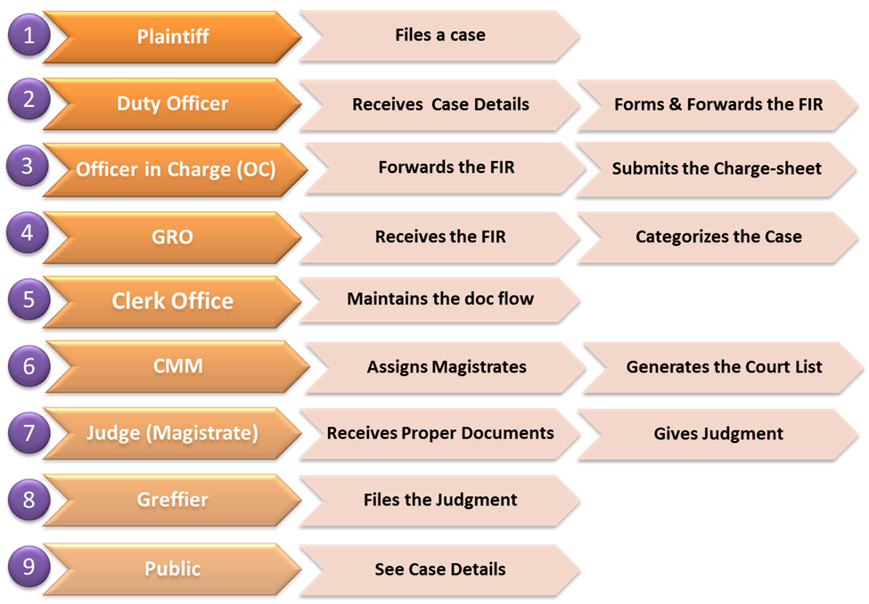**Actors of our system:**

Plaintiff:

Plaintiff is the person who files a case. When something unusual happens, he/she goes to the nearest police station to file a case.

Duty Officer:

Duty officer receives case details from the plaintiff. He also makes the FIR (First Information Record) & forwards it the OC.

Officer in Charge (OC):

Officer of the respective police station gets the FIR from the duty officer. Based on the FIR, he makes the charge-sheet & forwards it to the GRO.

General Record officer(GRO):

GRO receives the FIR from the OC of the police station . He then categorises the cases. There are many types of cases such as civil case, crime case.

Clerk Office:

Clerk office maintains the doc flow. In a particular case, the FIR, charge-sheet, other relevant papers are very important. They are very important for the smooth flow of case continuation. Clerk Office manages this.

Chief Metropolitan Magistrate(CMM):

CMM assigns magistrates for the cases of various types. He also generates the Court List.

Judge(Magistrate):

Judge receives proper documents & gives judgment. He is mainly the detector of right & wrong in a case. So his work is very important.

Greffier:

Greffier mainly files the judgment. He takes important notes about the case & stores it. These notes are very important for a case. In future , the judge takes these notes & gives proper judgment.

Public:

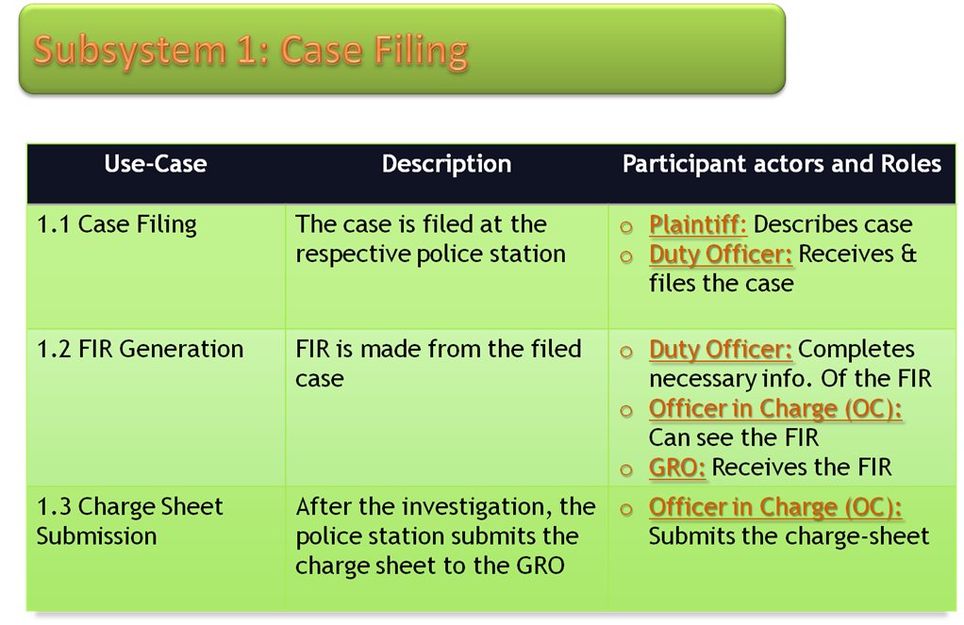Public, interested can see the case details also.They can see the the pros & cons of the case though some information are kept secret.

**4.2.1.1 : Case Filing**

Under case filing subsystem,we have case filing,FIR generation & charge sheet submission use case.

**4.2.1.2 : FIR Generation**

The case is filed at a police station where plaintiff describes the case & the Duty officer takes necessary information for the FIR.

**4.2.1.3 : Charge-sheet Submission**

**Use Case Diagram:**



The FIR is made on the filed case.Duty officer completes necessary information foe the FIR. OC of the police station forwards the FIR to the GRO.

When OC forwards the FIR & charge sheet to the GRO, he categorizes the cases & assigns magistrates for the cases.

Here is the use case model for case filing subsystem.The actors are plaintiff,duty officer,OC & GRO.

Plaintiff goes to the police station to file a case. The duty officer takes necessary information about the case.He makes the FIR & forwards it to the OC.The OC makes the charge sheet & sends it to the GRO.

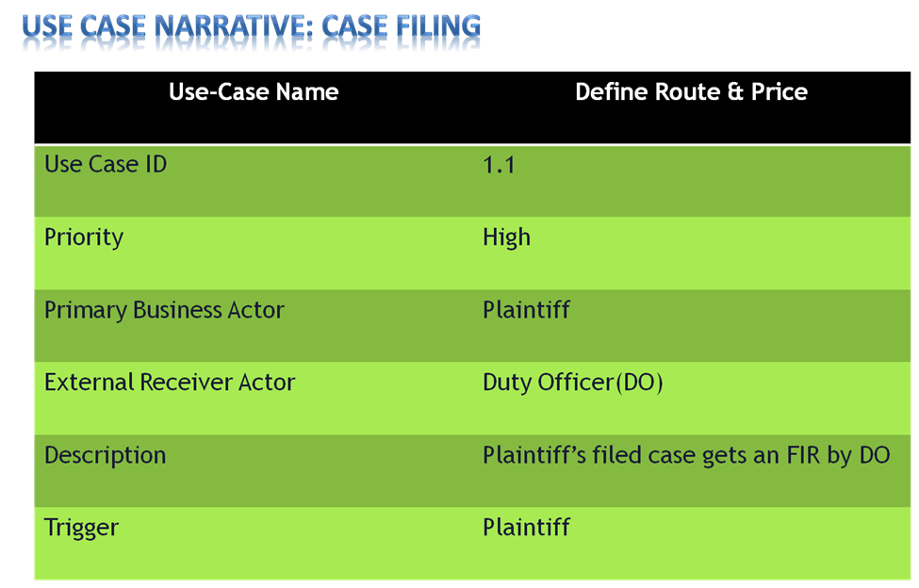

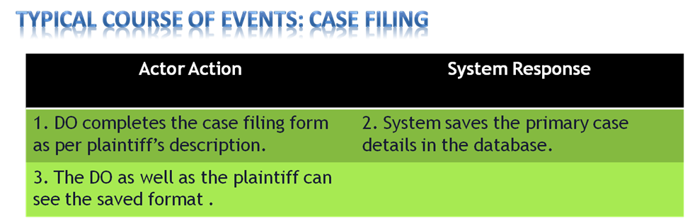

Here is use case narrative & typical course of events for case filing.

The use case narrative has define route & price with the use case name.Plaintiff is the trigger here & his priority is high.

Typical course of events has the actor action & system response. Actions of the actors have already been described earlier.

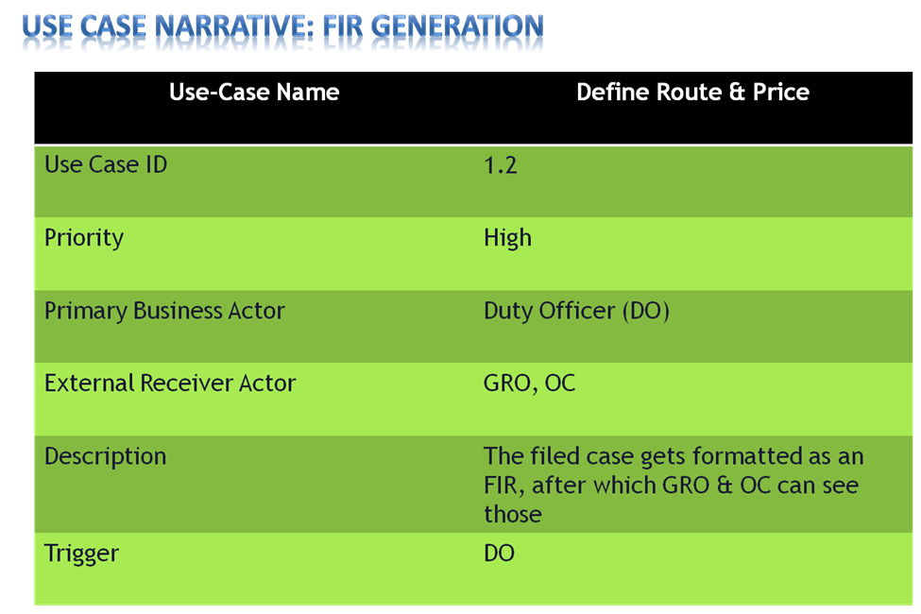

Here is use case narrative & typical course of events for FIR generation.

The use case narrative has define route & price with the use case name. Duty Officer is the trigger here & its priority is also high.

Typical course of events has the actor action & system response. Actions of the actors have already been described earlier.

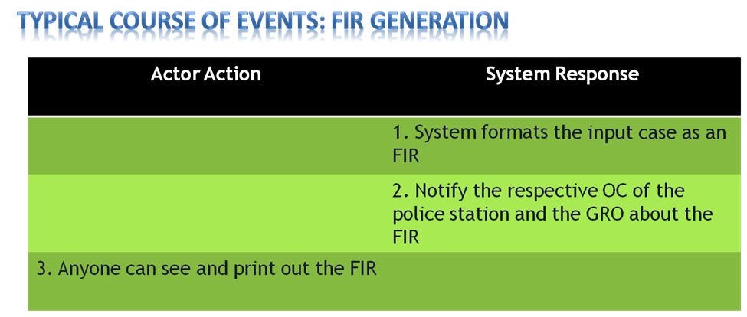

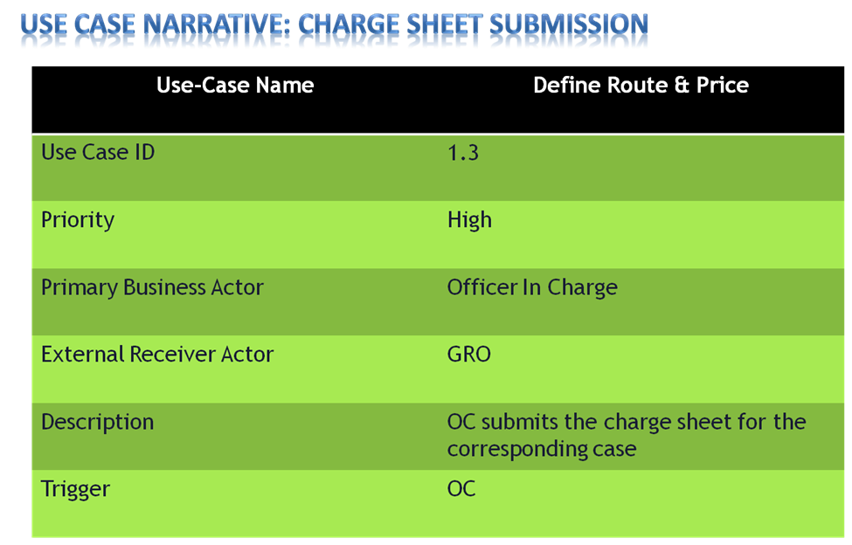

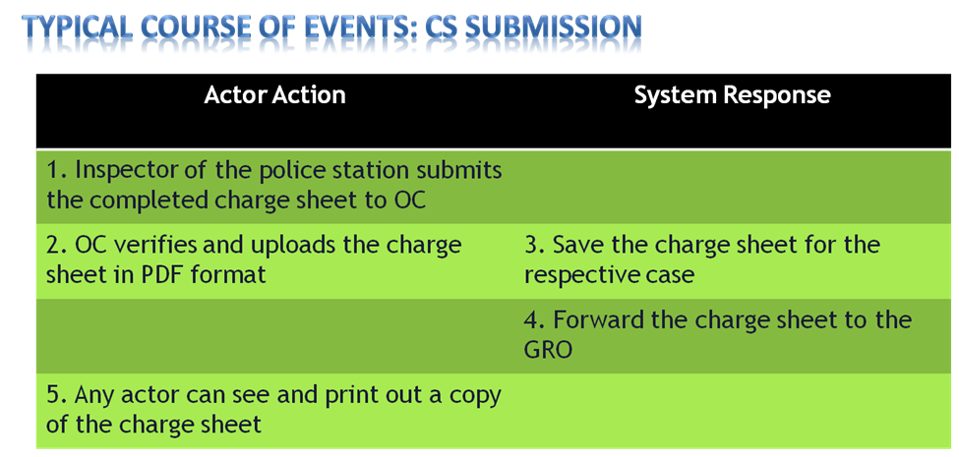

Here is use case narrative & typical course of events for Charge Sheet Submission.

The use case narrative has define route & price with the use case name. OC is the trigger here & its priority is also high.

Typical course of events has the actor action & system response. Actions of the actors have already been described earlier.

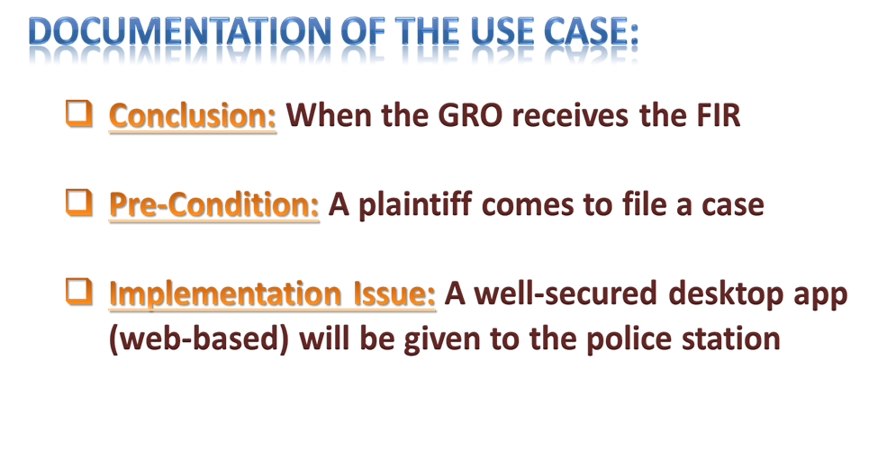

Documentation of this use case includes its pre-condition, implementation issue & conclusion.

When a plaintiff comes to file a case,this subsystem starts.And when the GRO receives the FIR, this subsystem ends.

A well secured desktop app will be given to the police station to implement this subsystem.

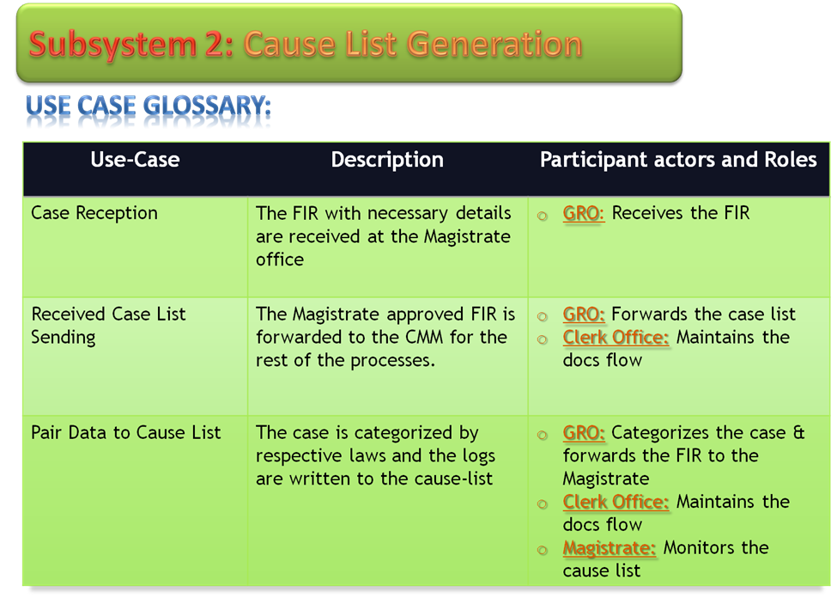

**4.2.2.1 Case Reception**

The FIR with necessary details are sent to the Magistrate office & GRO receives the FIR.

**4.2.2.2 Received Case List Sending**

The Magistrate approves the FIR & forwards it to the CMM office .At the CMM office, the clerk offie maintains the doc flow.

**4.2.2.3 Pair Data to Cause List**

The case is categorized by respective laws & the logs are written in the cause list.Mainly GRO categorizes the cases & CMM monitors the case.

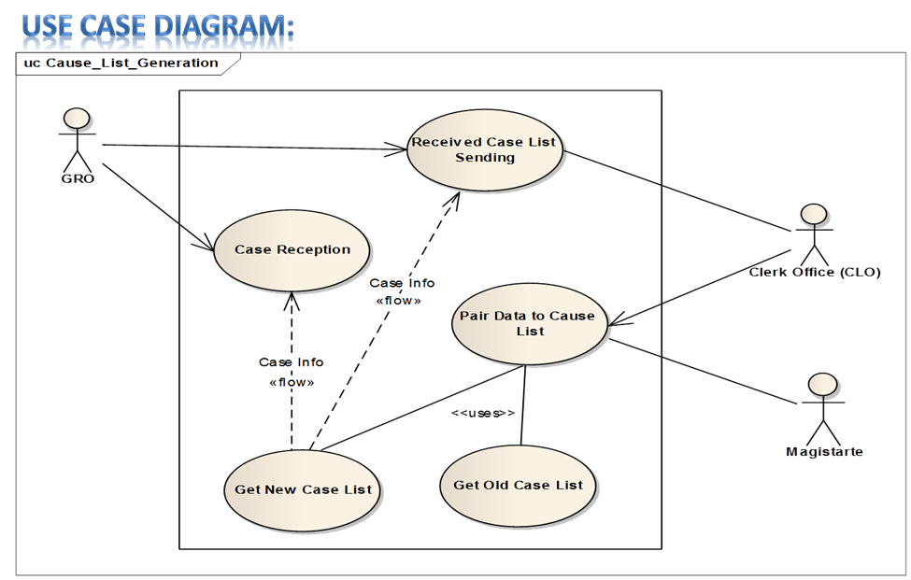

Here is the use case model for cause list generation subsystem.The actors are GRO, CLO & magistrate.

GRO received the details in FIR & Charge-sheet from the police station.After categorizing them,GRO sends them to the CMM.CMM assigns magistrates for the cases, it is known as court list.CLO maintains the doc flow at the CMM office.Both CLO & Magistrate can access the old & new case list.

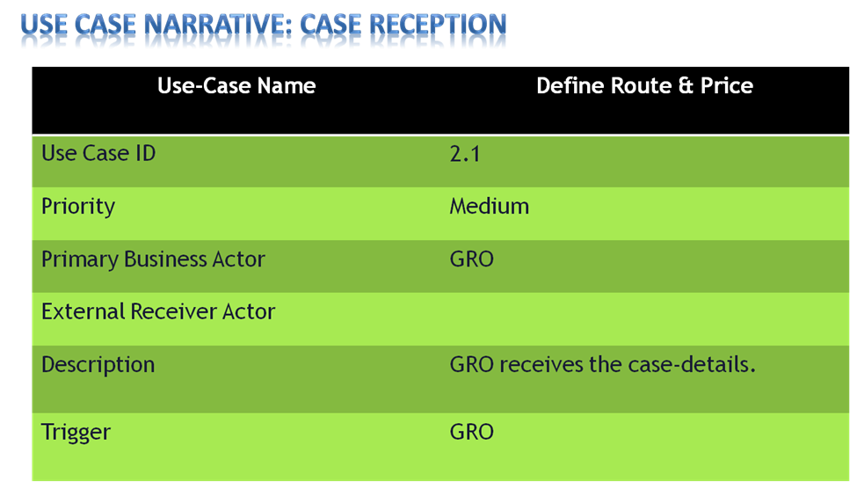

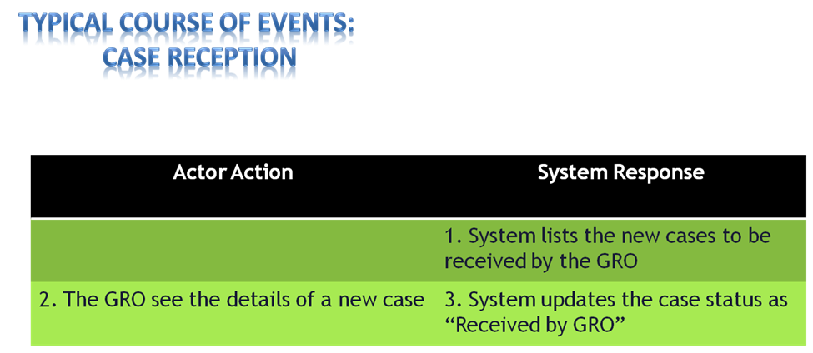

Here is use case narrative & typical course of events for case reception.

The use case narrative has define route & price with the use case name.GRO is the trigger here & the priority is medium.

Typical course of events has the actor action & system response. Actions of the actors have already been described earlier.

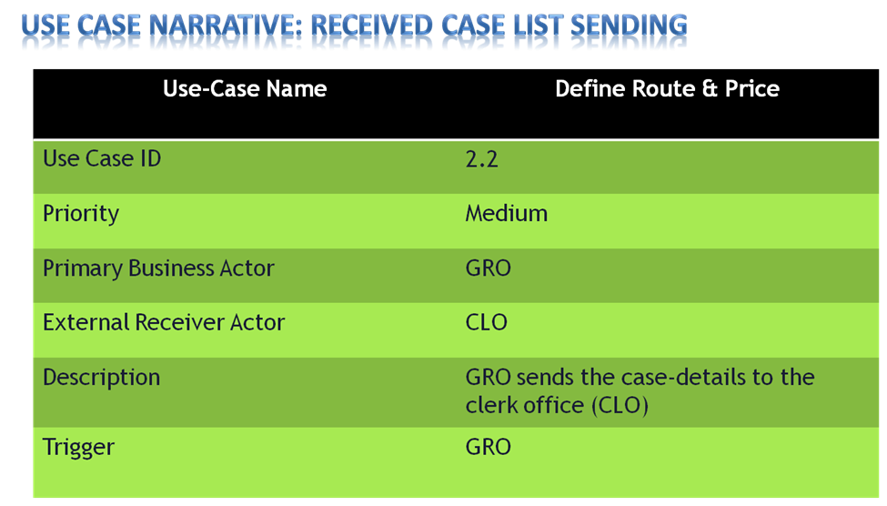

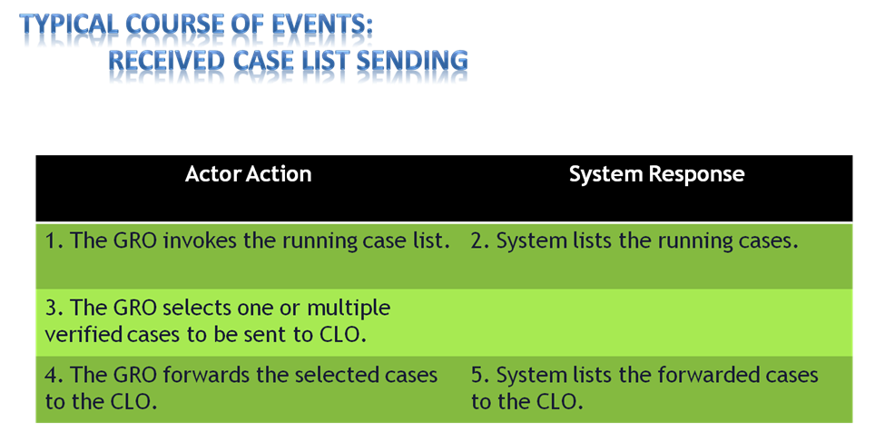

Here is use case narrative & typical course of events for received case list sending.

The use case narrative has define route & price with the use case name.GRO is the trigger here & the priority is medium.

Typical course of events has the actor action & system response. Actions of the actors have already been described earlier.

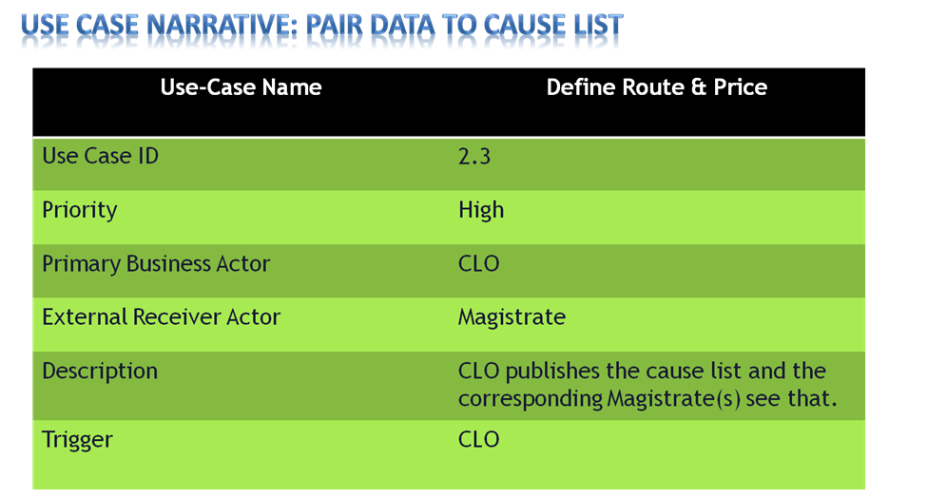

Here is use case narrative for pair data to cause list.

The use case narrative has define route & price with the use case name.CLO is the trigger here & its priority is high.

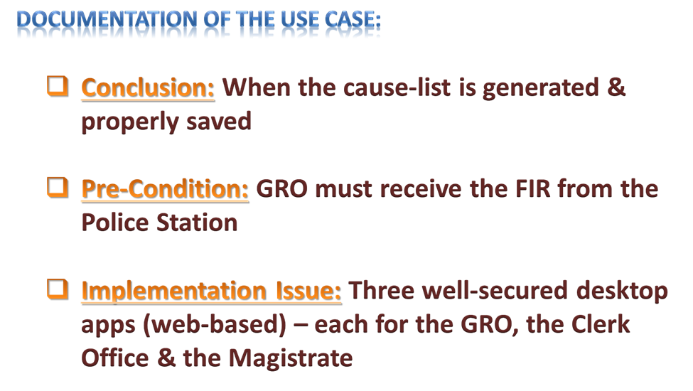

Documentation of this use case includes its pre-condition, implementation issue & conclusion.

When GRO receives the FIR form from the police station,this subsystem starts.And when the cause list is generated & properly generated, this subsystem ends.

Three well secured desktop app will be given to the GRO,the Clerk office & the magistrate to implement this subsystem.

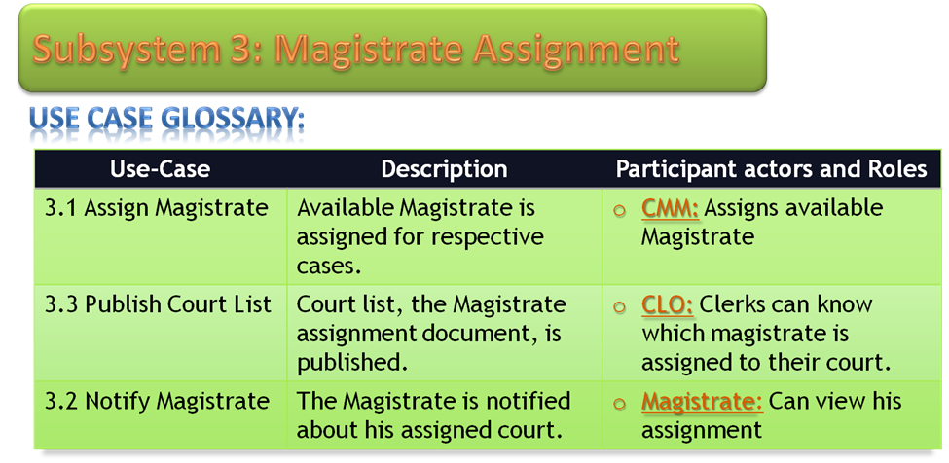

**4.2.3.1 : Assign Magistrate**

CMM assigns available magistrates for the respective cases.

**4.2.3.2 : Publish Court List**

Court list which is basically list of magistrate assignment is published.Clerks can know about it.

**4.2.3.3 : Notify Magistrate**

The magistrate is notified about his assignment. So he can know where & for which case – he is assigned.

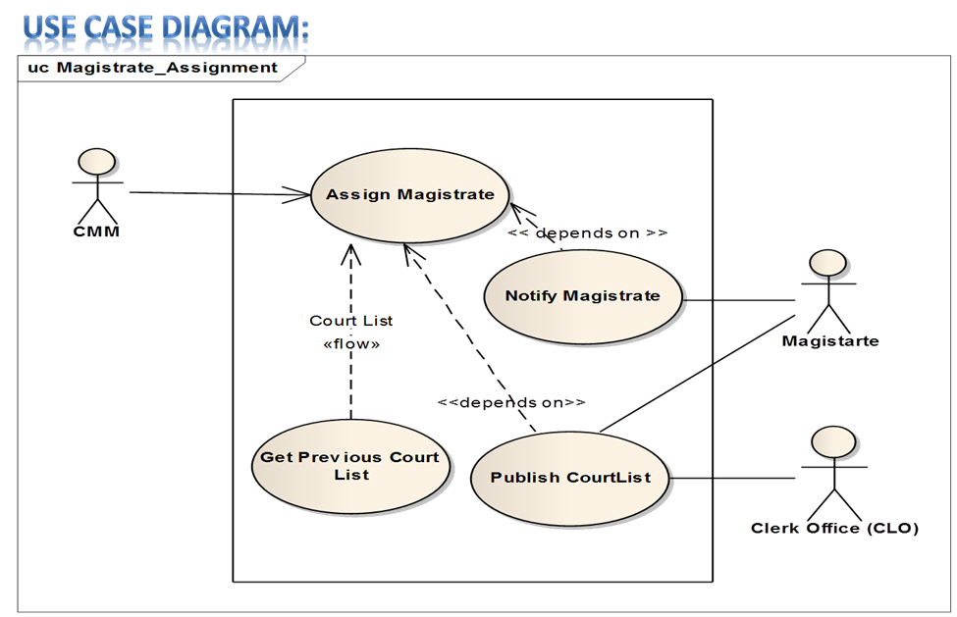

Here is the use case model for magistrate assignment subsystem.The actors are CMM, CLO & magistrate.

CMM assigns Magistrates for old & new cases.He publishes a list through the CLO which is better known as Court List.CLO publishes this list.The magistrates are notified about their cases & other things.

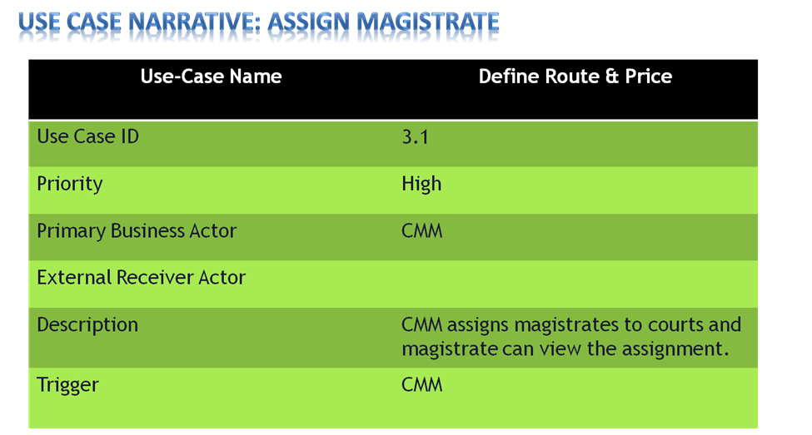

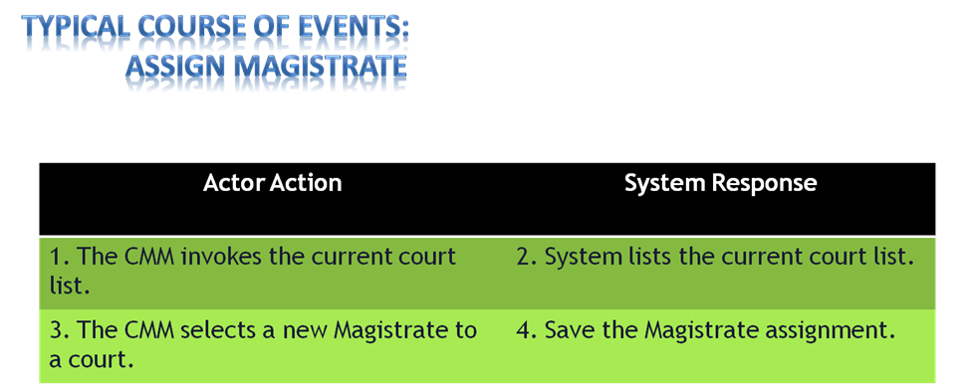

Here is use case narrative & typical course of events for assign magistrate.

The use case narrative has define route & price with the use case name.CMM is the trigger here & its priority is high.

Typical course of events has the actor action & system response. Actions of the actors have already been described earlier.

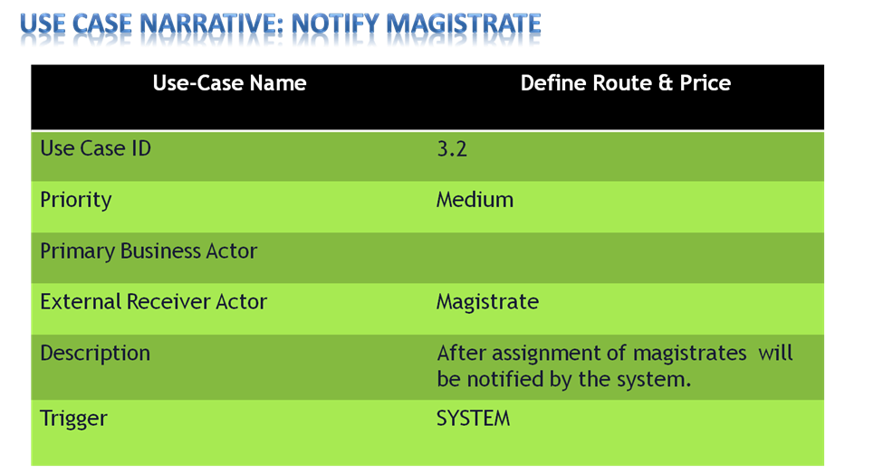

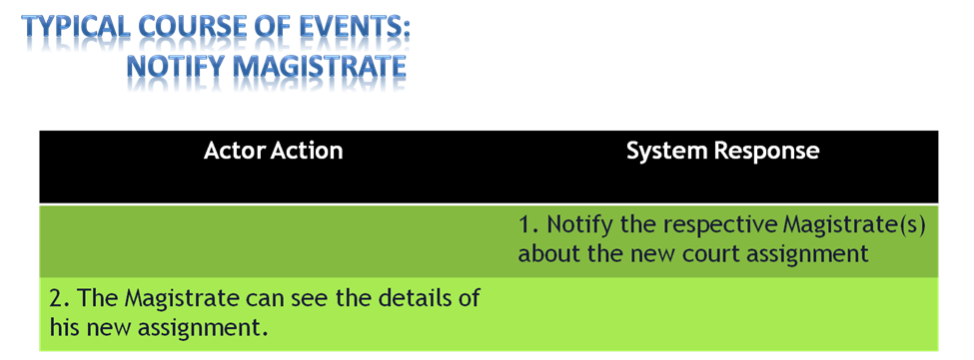

Here is use case narrative & typical course of events for notify magistrate.

The use case narrative has definite route & price with the use case name. System itself is the trigger here & its priority is medium.

Typical course of events has the actor action & system response. Actions of the actors have already been described earlier.

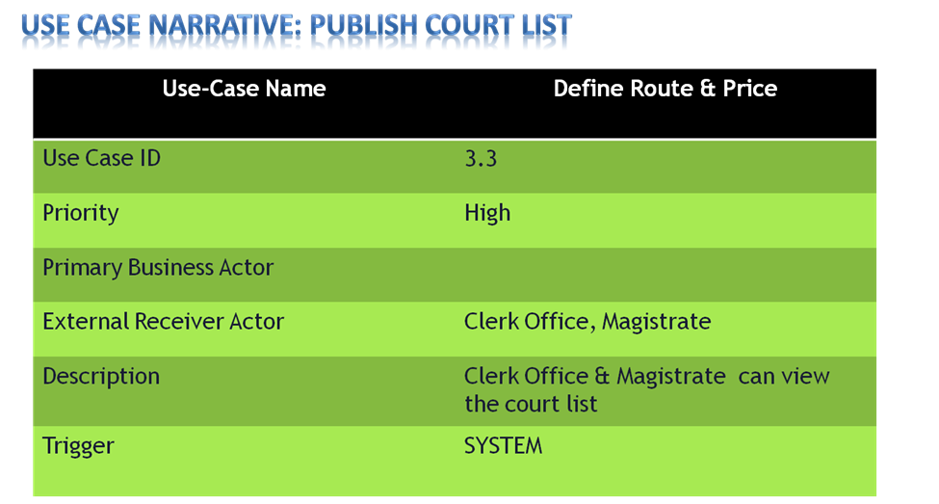

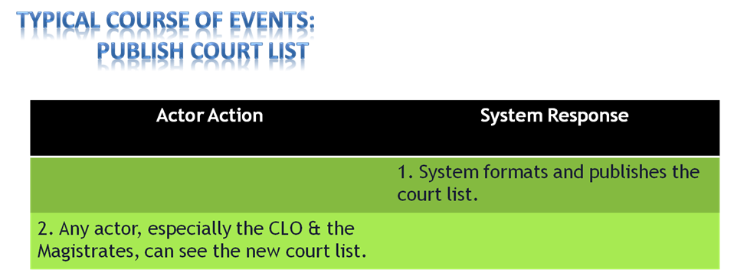

Here is use case narrative & typical course of events for publish court list.

The use case narrative has define route & price with the use case name. System is the trigger here & its priority is high.

Typical course of events has the actor action & system response. Actions of the actors have already been described earlier.

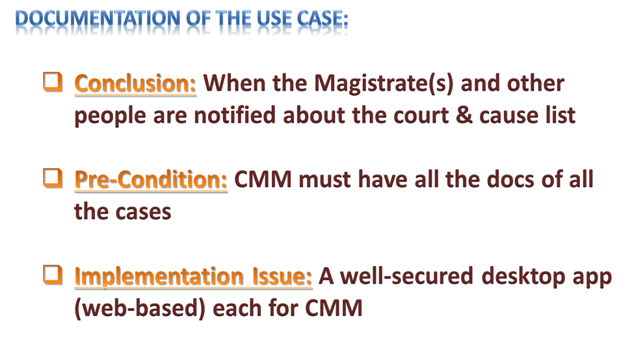

Documentation of this use case includes its pre-condition, implementation issue & conclusion.

When CMM has all the docs of all the cases, this subsystem starts. And when the magistrate & others are notified about the court & cause list, this subsystem ends.

A well secured desktop app will be given to the CMM to implement this subsystem.

**4.2.4.1 Compare payment info:**

Copy maker checks the payment slip with the case to copy. If it is ok, he gives the necessary copies.

**4.2.4.2 Copy requested case info:**

Copy maker prompts to generate copy of the requested files & documents if the provided pay slip is ok. 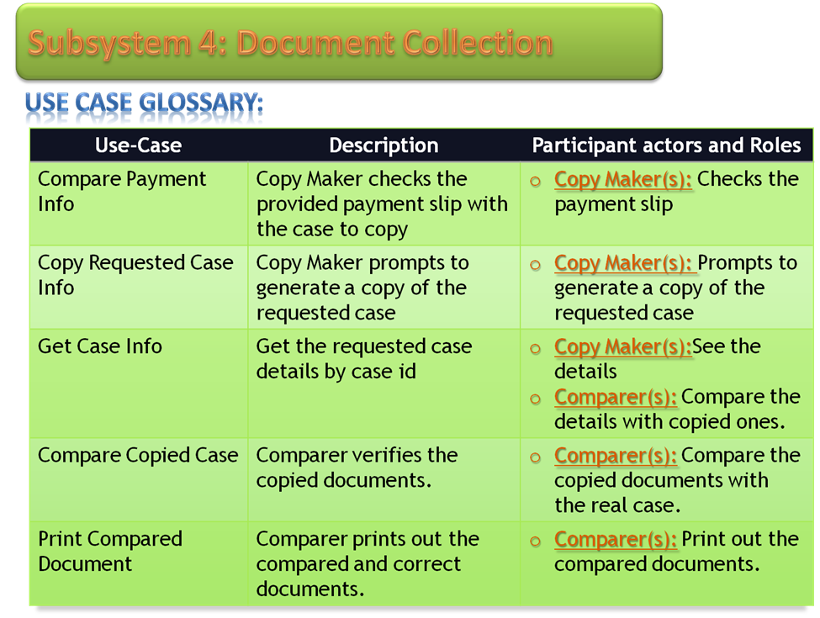

**4.2.4.3 Get case info:**

Copy maker gets the requested case information by case id .

**4.2.4.4 Compare copied case:**

After getting the requested files & documents, the copy maker verifies them by comparing them with the real copies.

**4.2.4.5 Print compared document**:

If all is ok, then the copy maker prints out the necessary files.

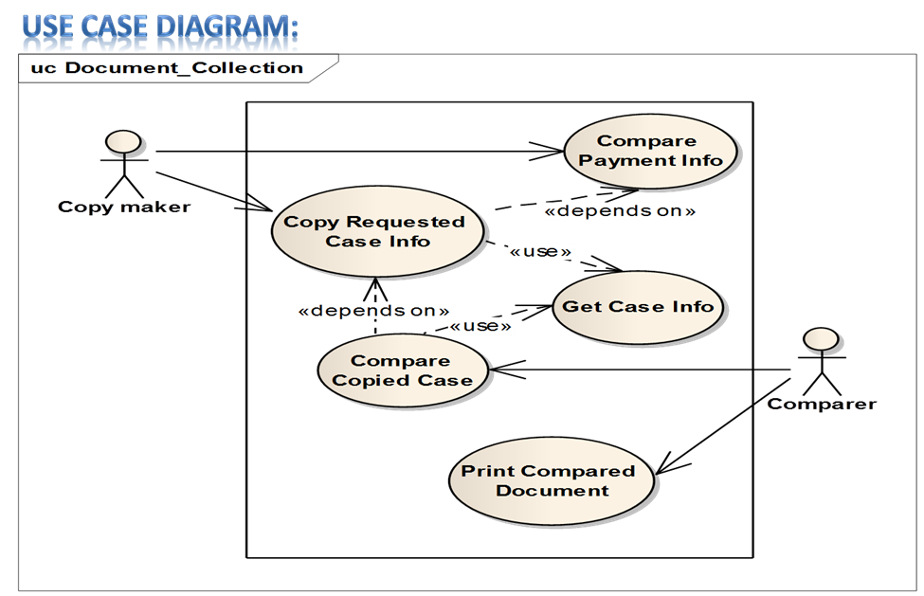

Here is our Document collection use case. Copy maker & comparer are the actors here.

First the copy maker is requested to supply the necessary copies with the payment slip. If the slip is ok, then he gathers the necessary information & gives the copies to comparer for verification. If all matches, then finally it is served to the needed.

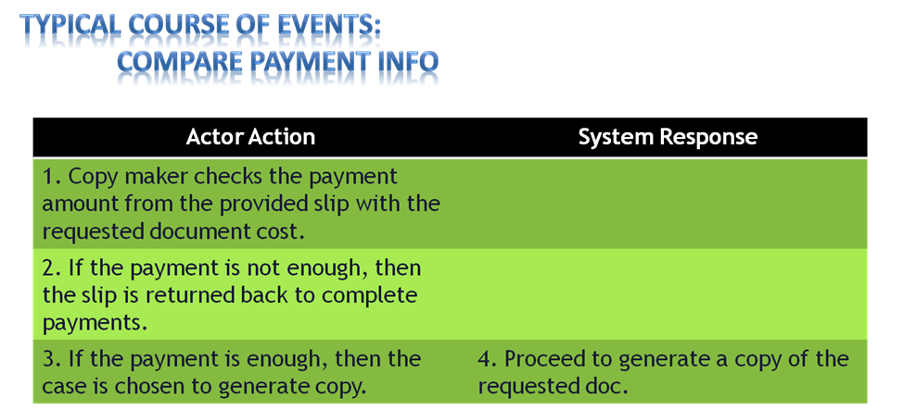

Here is typical course of events for compare payment info.

Typical course of events has the actor action & system response. Actions of the actors have already been described earlier.

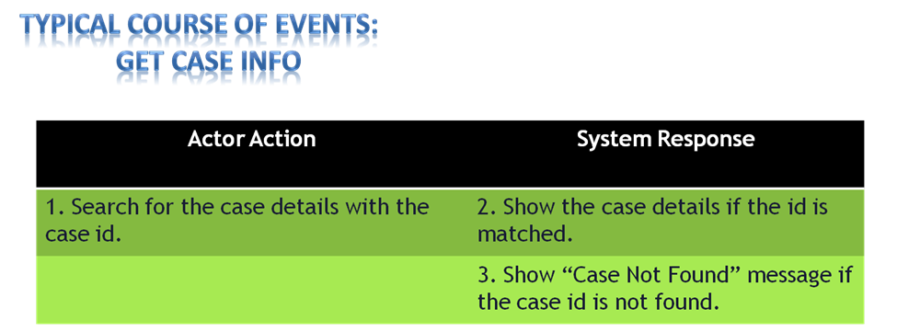

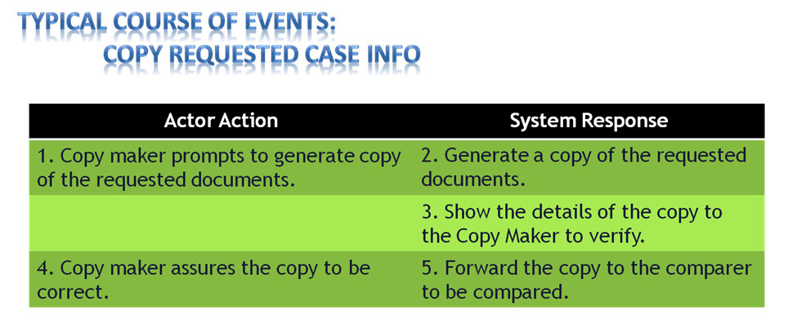

Here is typical course of events for get case info.

Typical course of events has the actor action & system response. Actions of the actors have already been described earlier.

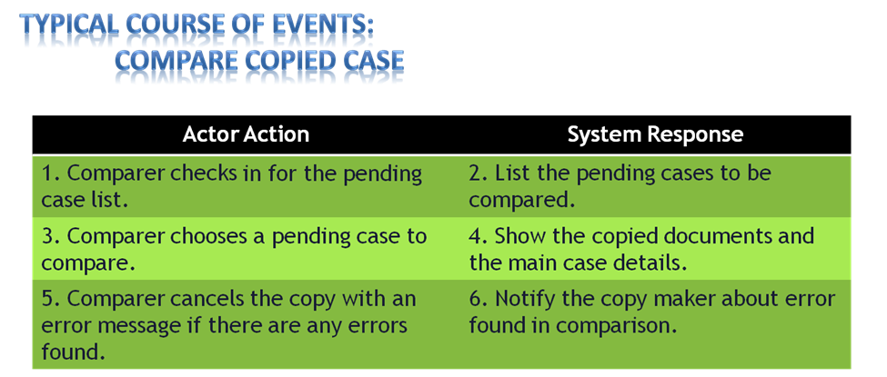

Here is typical course of events for compare copied case.

Typical course of events has the actor action & system response. Actions of the actors have already been described earlier.

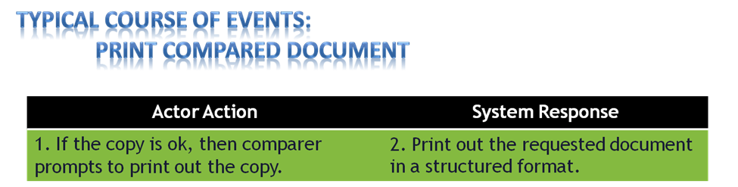

Here is typical course of events for print compared document.

Typical course of events has the actor action & system response. Actions of the actors have already been described earlier.

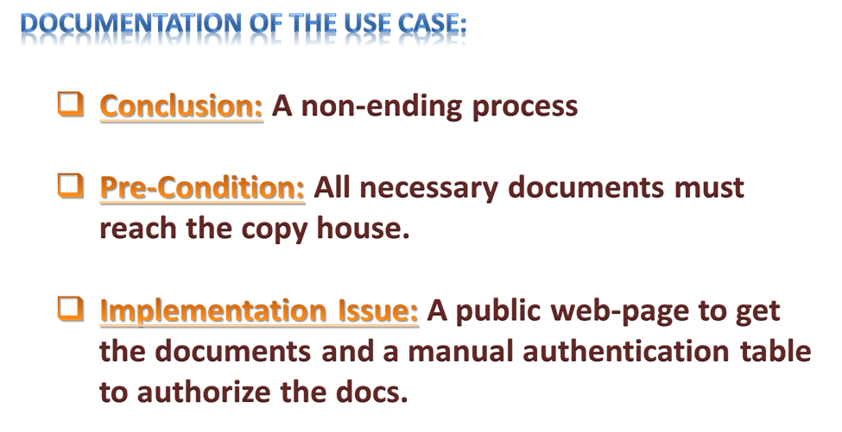

Documentation of this use case includes its pre-condition, implementation issue & conclusion.

When all necessary documents reach copy house ,this subsystem starts.And this process is non-ending.

A public web page to get the documents & a manual authentication table is needed to implement this subsystem.

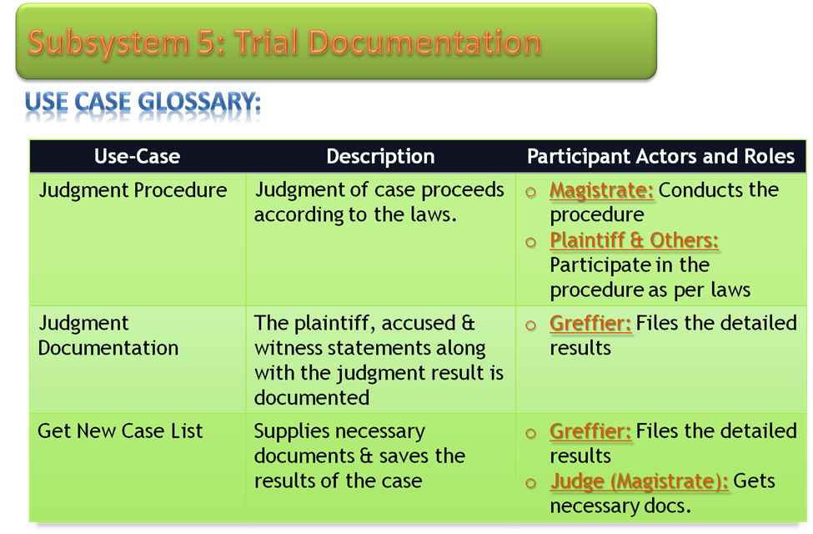

**4.2.5.1. Judgment Procedure:**

Judgment of case proceeds according to laws. Magistrate conducts the process where plaintiff & others participate.

**4.2.5.2.Judgement Documentation:**

The whole judgment procedure is documented. Greffier files all the necessary informantions of the case.

**4.2.5.3. Get new case list:**

After the judgment, the greffier supplies necessary docs & saves case information in the doc .

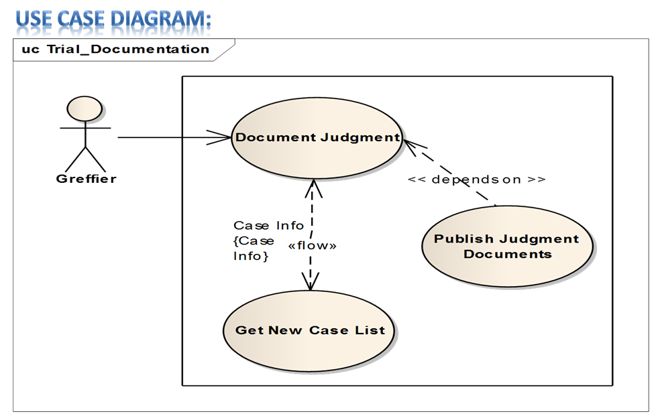

Here is our Trial Documentation use case. Greffier is the actor here.

Greffier stores the documents for judgment. He gets the new case list. He also publish the judgment documents.

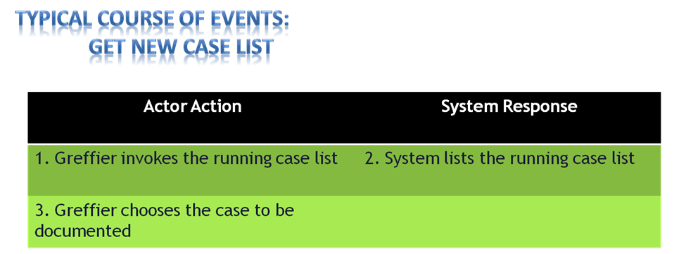

Here is typical course of events for get new case list.

Typical course of events has the actor action & system response. Actions of the actors have already been described earlier.

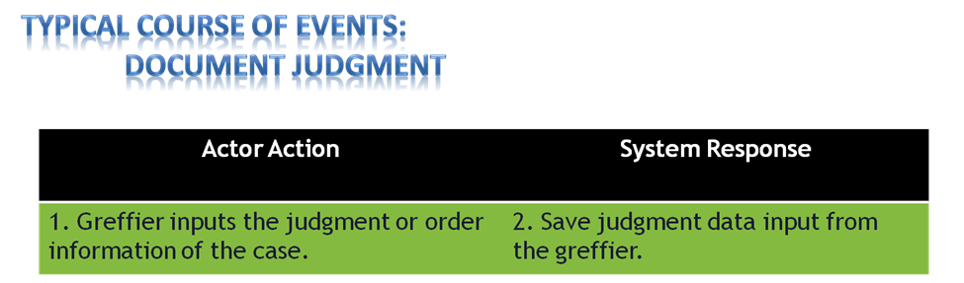

Here is typical course of events for document judgement.

Typical course of events has the actor action & system response. Actions of the actors have already been described earlier.

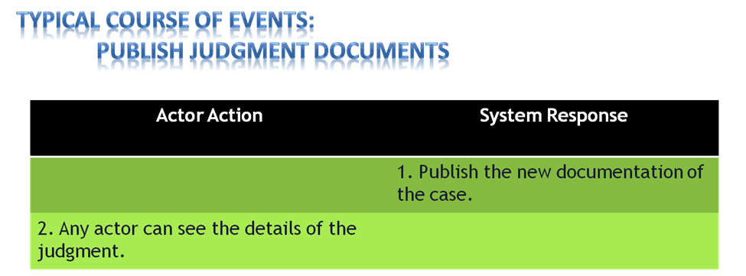

Here is typical course of events for publish judgment documents.

Typical course of events has the actor action & system response. Actions of the actors have already been described earlier.

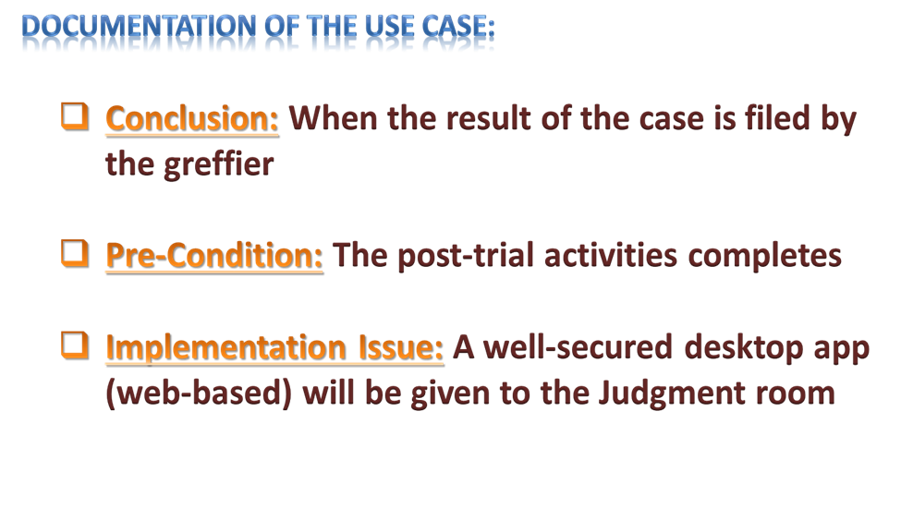

Documentation of this use case includes its pre-condition, implementation issue & conclusion.

When all post –trial activities complete , this subsystem starts. And when the result of the case is filed by the greffier, the subsystem ends.

A well secured desktop app will be given to the judgment room to implement this subsystem.

**4.3 Data Flow Diagram:**

Data flow Diagram is a process model used to depict the flow of data through a system and the work or processing performed by the system. Synonyms are bubble chart, transformation graph, and process model. Below a series of sub-system wise DFDs are shown and described.

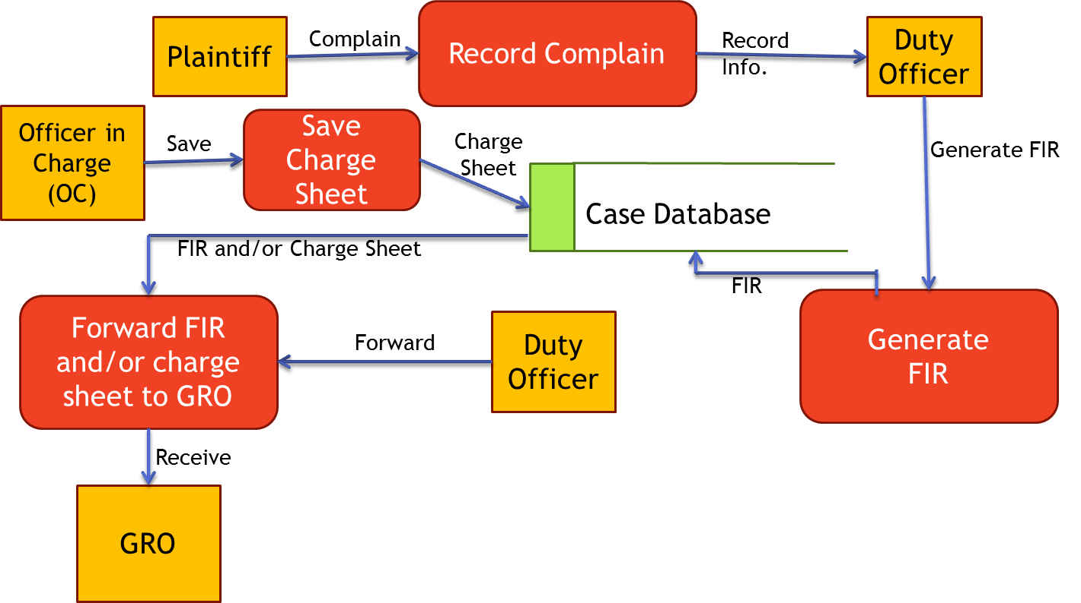**4.3.1 DFD for Case Filing Sub-system:**

The first subsystem is case filling subsystem. In this process the flow of data starts from the plaintiff and then the plaintiff records complain which is received by the duty officer. The duty officer generates the FIR and the generated FIR is saved in the case database. The OC saves the charge sheet in case database. Duty officer then forwards the FIR and charge sheet from the case database and GRO receives these data.

**4.3.2 DFD for Cause List Generation Sub-system:**

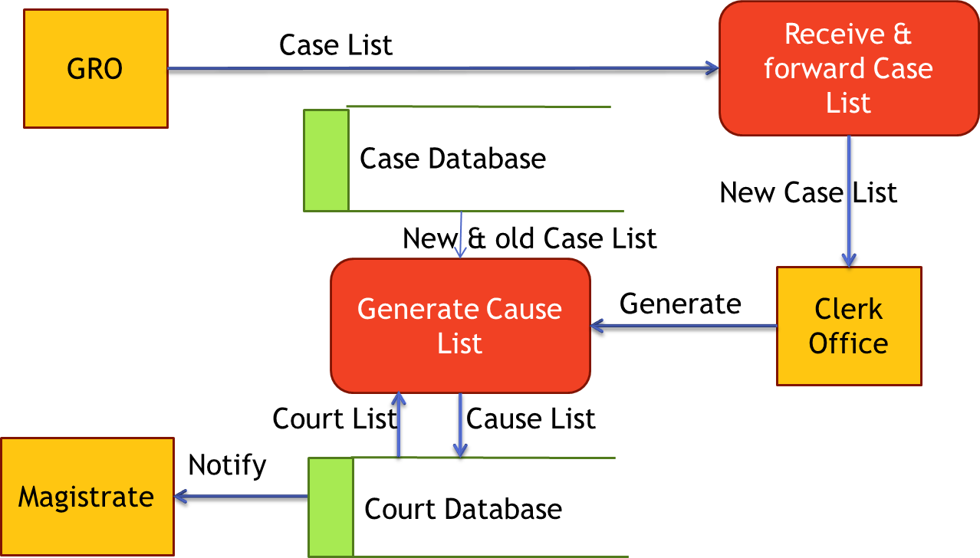The next subsystem is cause list generation. In this subsystem data flow starts from the GRO when GRO forwards the received cases to the clerk office. Here the clerks get new and old case lists from case database and get the court list from court database to create the cause list. This court list is then stored in the court database. At last the magistrates are notified about their assignments by retrieving data from court database.

**4.3.3 DFD for Magistrate Assignment Sub-system:**

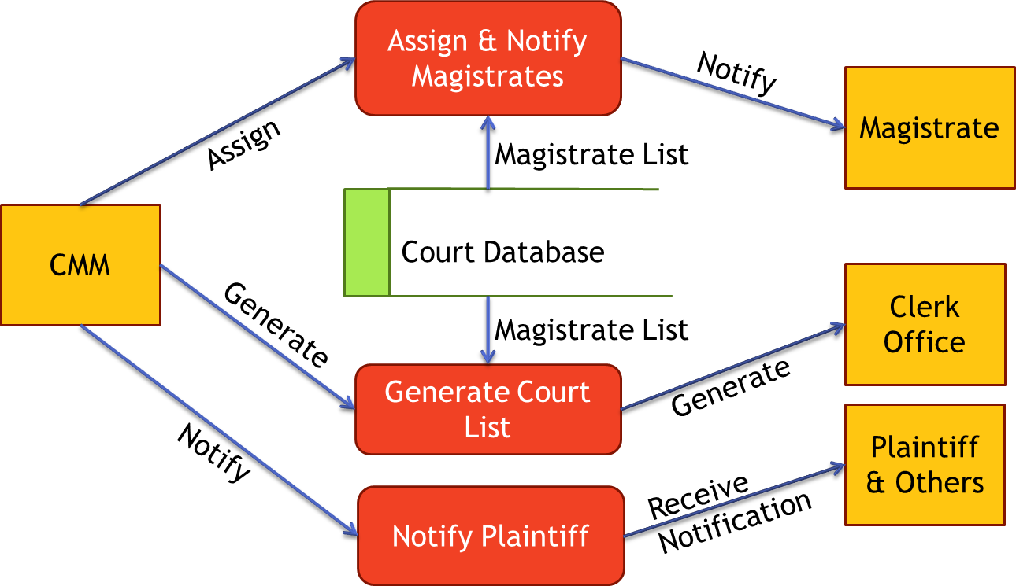

In this sub-system the CMM is the main source of data. CMM assigns magistrates to courts, generates court list and notifies plaintiffs (optional). To assign magistrates to different courts and to generate new court list it is a must to get the magistrate list from the court database. After this magistrates and clerk office gets to know about the assignment.

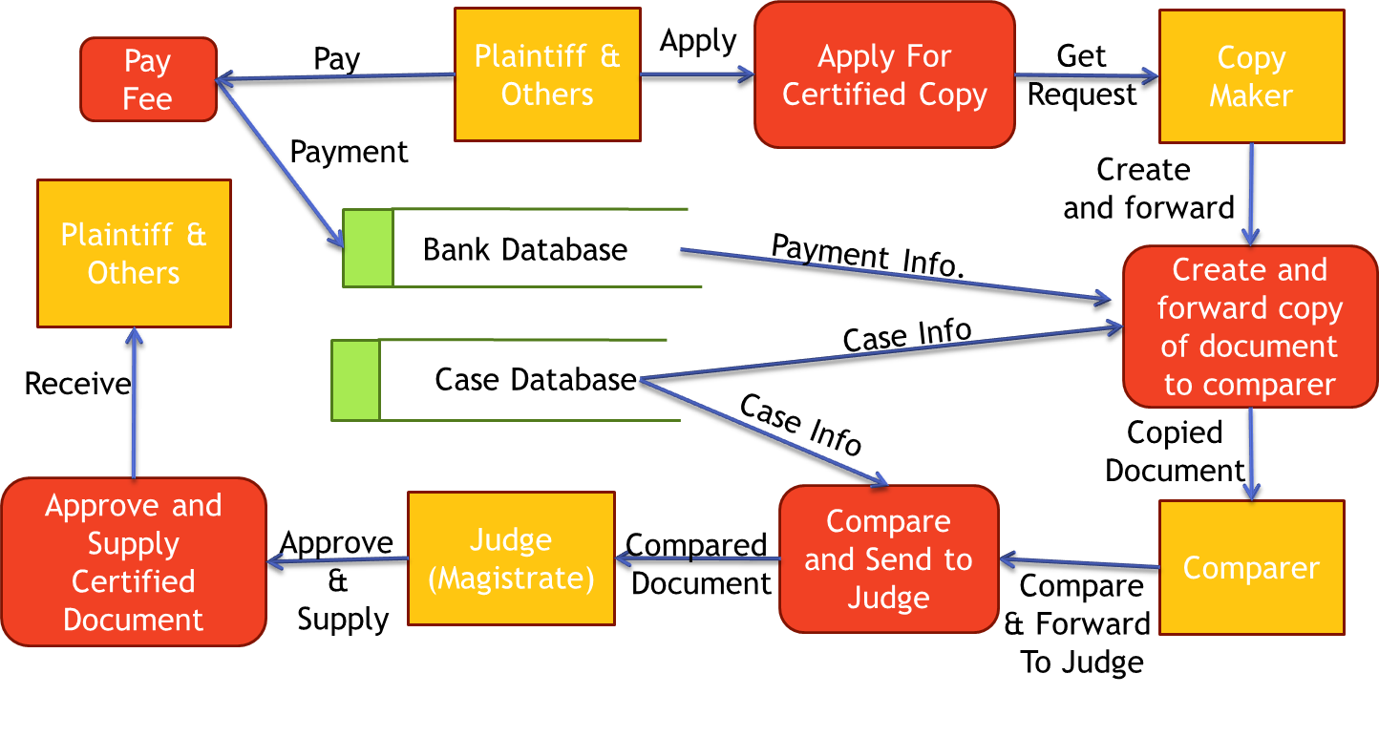**4.3.4 DFD for Document Collection Sub-system:** If a plaintiff wants to get a document he must pay the fees. This payment information will be saved in bank document and it is the responsibility of the back to convey this information to the copy makers’ office. Then the copy maker will receive the request from a plaintiff. In this step the copy maker gets information about whether a payment is done by the plaintiff. Then the comparer is sent a request to compare the copied documents. The comparers will assess the case database to compare the copied data. Comparer sends the compared and final document to the judges to approve the copy. And judge will draw an end to the flow of data in this system by approving and supplying the documents to plaintiff.

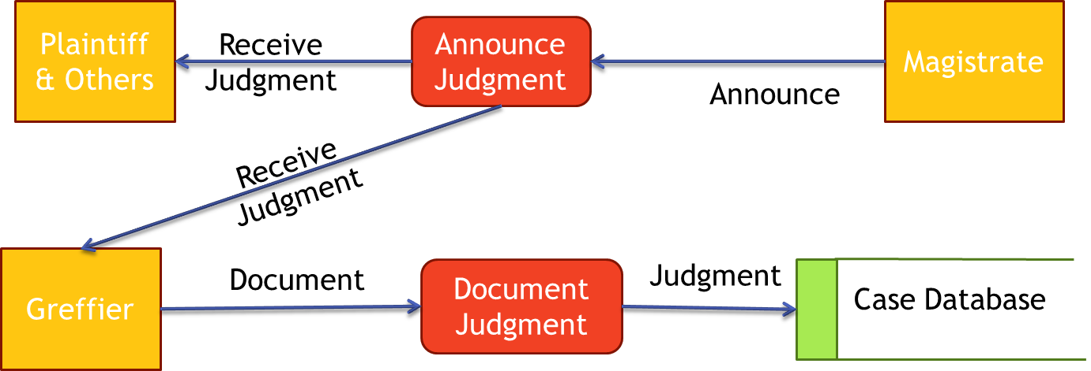**4.3.5 DFD for Trial Documentation Sub-system:** The judge will announce the judgment and the greffier will document the judgment in proper way. The only database used in this system is case database which is used to store judgment.

**4.4 System Design**

**4.4.1 Class Diagram:**

**4.4.1.1 Case Filing:**

**4.4.1.1.a File a Case Use Case:** Here is our case filing class diagram. It has four classes – CaseFileUI, Case FileController, FIRform & CasePS. CaseFileUI has select CaseType, start-Interface & insertCasedescription functions. CaseFile Controller has showFIR form, showDescription & generateFIR functions. FIRform has getFIRform function. CasePS has getChargeSheet & saveFIR functions.

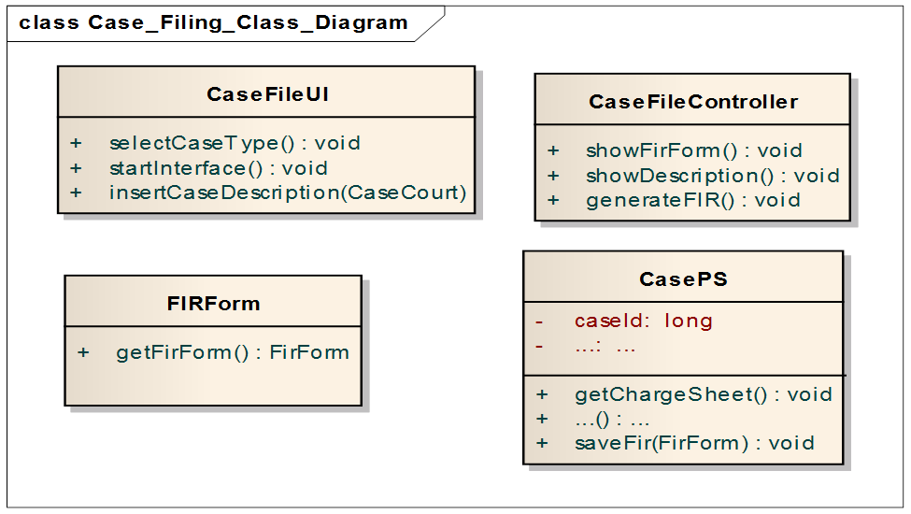

**4.4.1.1.b Forward FIR Use Case:** Here is our forwarding FIR class diagram. It has four classes – forwardFIRUI, ForwardFIRController, caseCourt & CasePS. ForwardUI has startInterface, selectCases functions. ForwardFIRController has showFIR form,showDescription & generateFIR functions. CaseCourt has getCaseID function.CasePS has getChargeSheet & saveFIR functions.

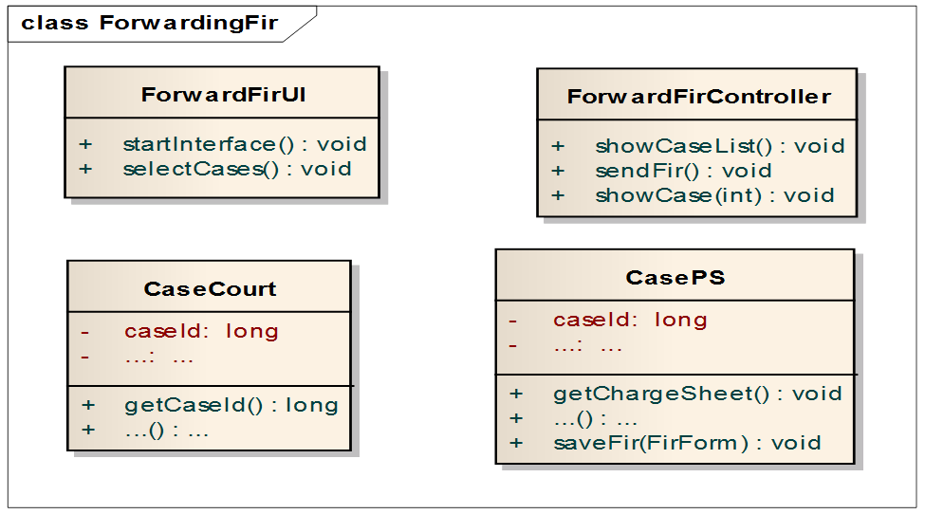

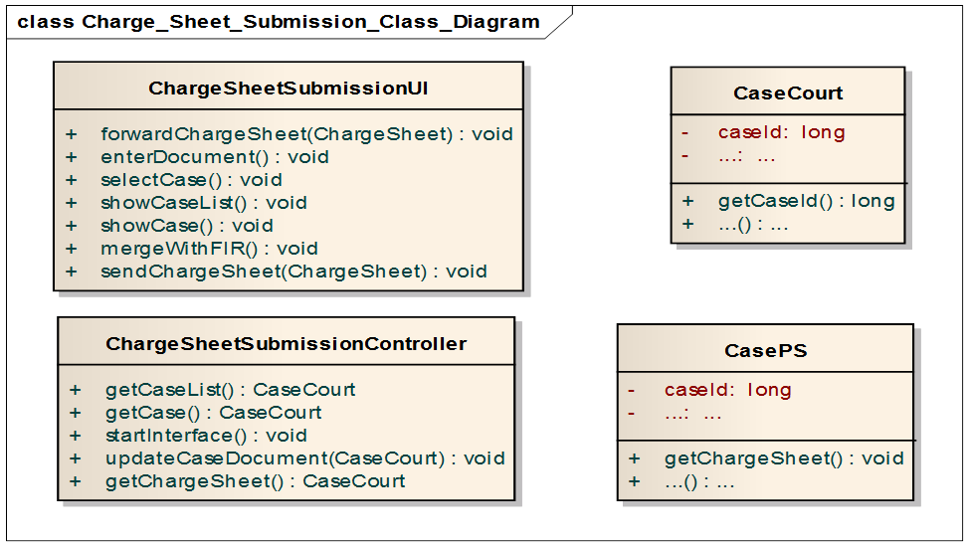**4.4.1.1.c Charge Sheet Submission Use Case:** Here is our Charge sheet submission class diagram.It has four classes – chargeSheetSubmissionUI,ChargeSheetSubmissionController,caseCourt & CasePS.ChargeSheetSubmission UI has forwardchargeSheet, enterDocument, selectCase,showCaseList, showcase, merge with FIR ,send charge sheet functions. ChargeSheetSubmission Controller has get caseList,getCase,startInterface,updateCaseDocument , get charge sheet functions.CaseCourt has getCaseID function.CasePS has getChargeSheet function.

**4.4.1.1 Cause List Generation:**

**4.4.1.2.a Received Case List Sending Use Case:** Here is our CaseListSending class diagram. It has four classes – sendReceivedcaseListUI, sendReceivedcaseListController, caseCourt & CaseCLO. SendReceivedcaseList UI has startInterface, selectCase, showCase, forwardCase functions. SendReceivedcaseListController has getNewCaseList and saveNewCaseList functions.CaseCourt has getCaseID function.CaseCLO has getID & updateList functions.

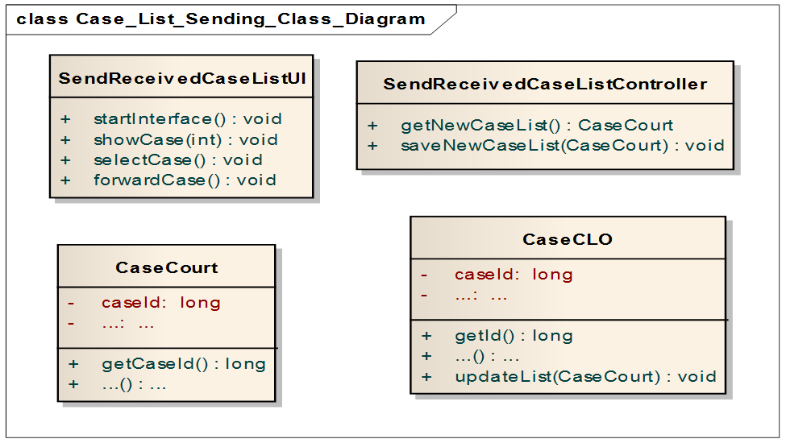

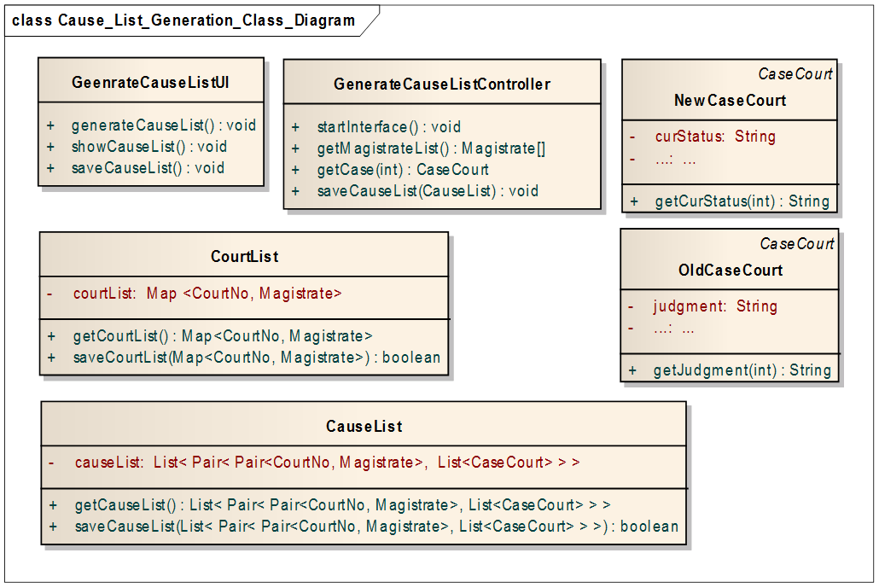**4.4.1.2.b Pair Data To Cause List Use Case:** Here is our CauseListgeneration class diagram.It has six classes – generatecauseListUI, generatecauseListController, courtList, newCaseCourt,oldCaseCourt & CauseList. GeneratecauseListUI has generateCauseList, showCause & saveCauseList functions. GeneratecauseListController has startInterface,getMagistratelist, getCase & saveCauseList functionsCourtList has getCourtList & saveCourtList functions.NewCaseCourt has getCurrentStatus function.OldCaseCourt has getJudgement function.CauseList has getCauseList & saveCauseList functions.

**4.4.1.1 Magistrate Assignment:**

**4.4.1.3.a Assign And Notify Magistrate Use Case:** Here is our Assign & notify magistrate class diagram. It has four classes – courtListGenerationUI, courtListGenerationController,Casecourt & magistrate. CourtListGenerationUI has assignMagistrate & getPreviousCourtList functions. . CourtListGeneration Controller has getMagistrateList,getPrevCourtList,saveCourtList & notify magistrate 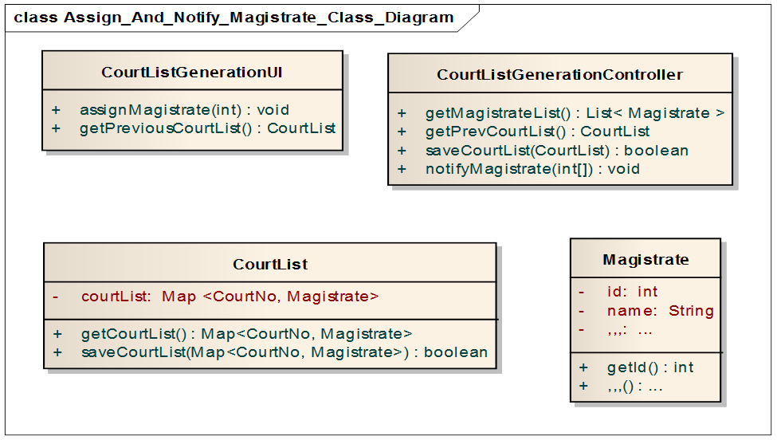functions.CourtList has getCourtList & saveCourtList functions. Magistrate has getID function.

**4.4.1.1 Document Collection:**

**4.4.1.3.a Document To Compare Use Case:** Here is our Doc Sending to the comparer class diagram. It has four classes – DocForwardingUI, DocForwardingController, docs to compare & CaseCourt. DocForwarding UI has showcase, selectCase & forwardDocs functions. DocForwardingController has startInterface, getCase, saveCase functions. DocsToComparer has getStatus & setStatus functions. CaseCourt has getCaseID function.

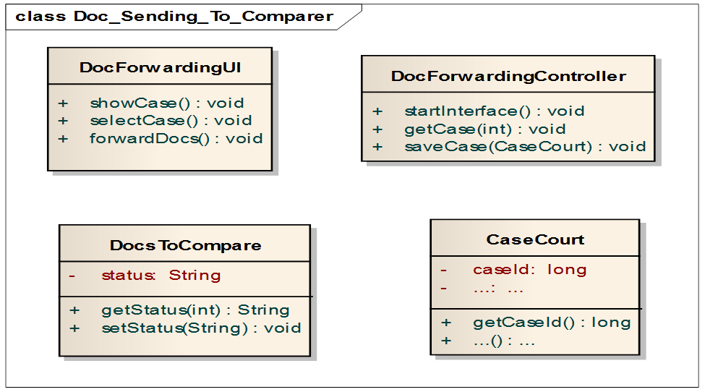

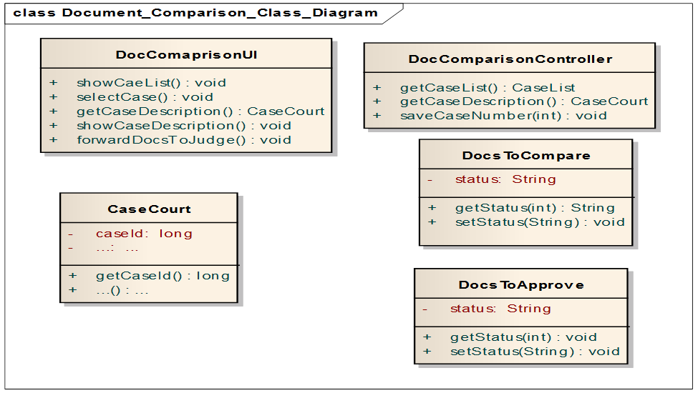**4.4.1.3.a Document Compare Use Case:** Here is our Document Comparision class diagram.It has five classes – DocComparisionUI, DocComparisionController,docs to compare, docsToApprove & Casecourt . DocComparisionUI has showCaseList, selectCase, getCaseDescription, showCasedescription & forwardDocsToJudge functions. DocComparisionController has getCaseList, getCaseDescription & saveCaseNumber functions.DocsToComparer has getStatus & setStatus functions.CaseCourt has getCaseID function.DocsToApprove has getStatus & setStatus functions.

**4.4.1.1 Trial Documentation:**

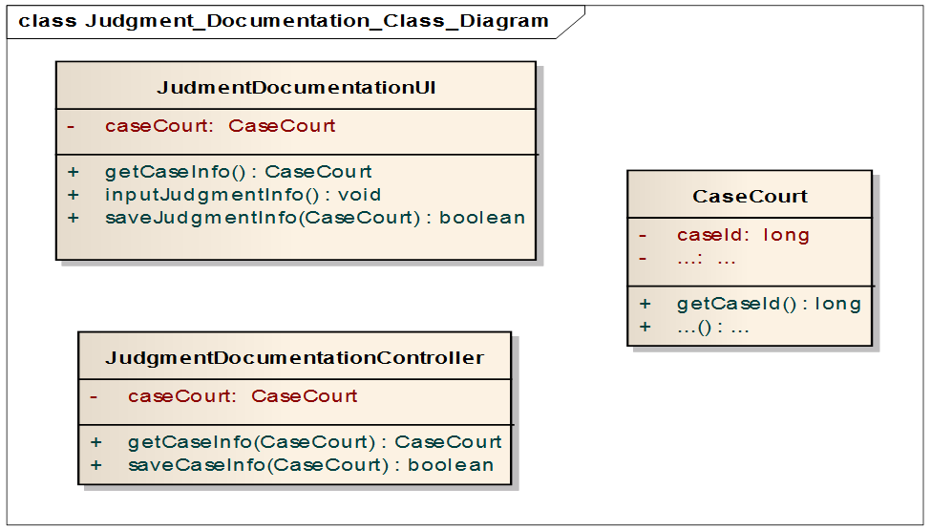 **4.4.1.3.a Judgement Documentation Use Case:** Here is our judgment Documentation class diagram. It has three classes – judgmentDocumentationUI, judgmentDocumentationController & Casecourt. Judgment DocumentationUI has getCaseInfo, inputJudgementInfo & saveJudgementInfo functions. Judgment DocumentationController has getCaseInfo & saveCaseInfo functions. CaseCourt has getCaseID function.

**4.4.2 Collaboration Diagram:**

**4.4.2.1 Case Filing:** Plaintiff, duty-officer, GRO, officer in charge are actors of this use case. Case filing, FIR generation, charge sheet submission – are the main systems here.

**4.4.2.1.a. Case Filing Use case:** First file case controller calls the get FIR form & gets the form. Then it starts the fileCase UI. The UI then shows FIR form, selects case type, inserts case description & thus generates FIR. Finally the FIR is saved in the CasePs.

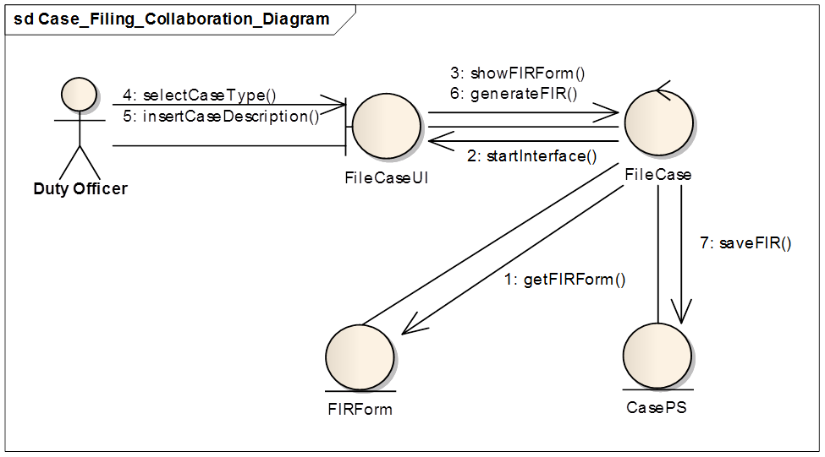

**4.4.2.1.b. FIR generation Use case:** First forward FIR controller calls getCaseList .Then it starts the forward FIR UI. The UI then shows caseList, selects & shows case, sends FIR. Finally the controller inserts new case in the case court.

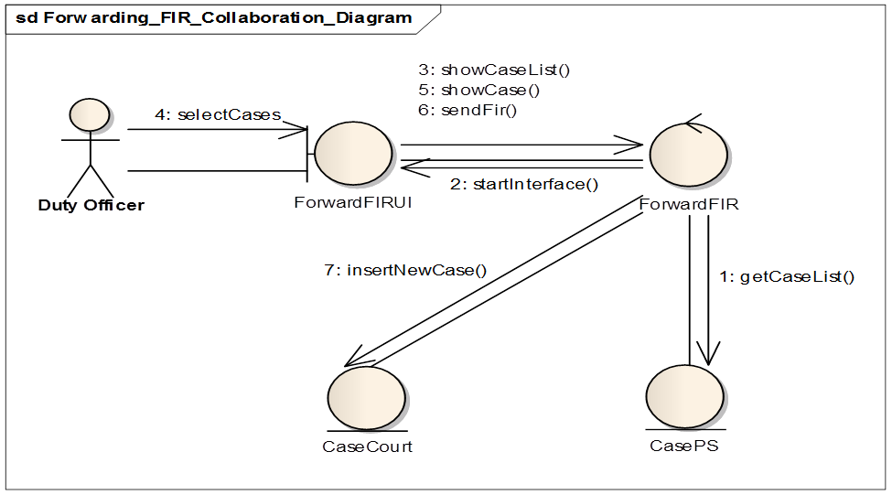

**4.2.2.1.c** **Charge Sheet Submission:** First Submit Charge Sheet controller starts the submitChargeSheet UI. The UI then shows caselist & selects cases. Next the controller gets case list from CasePS.  The UI shows cases, enters documents, merges with FIR, updates case document. The OC forwards & sends charge sheet. Case Court gets charge sheet from casePS.

**4.4.2.2 Cause List Generation Use Case:**

**4.4.2.2.a Received Case List Sending:** First sendCaseList controller gets new case from CaseCourt and starts the interface.The UI then shows,selects & forwards cases.Next the controller saves new list in CaseClo.The caseCLO ten updates the list in CaseCourt.



**4.4.2.2.b Pair Data To Cause List:** First generateCauseList controller gets cases from oldcase & newCase & gets the magistrate list from courtList. It then starts the UI.The UI then generates,shows ,approves cause list & saves it in the CauseList.



**4.4.2.3 Magistrate Assignment Use Case:**

**4.4.2.3.a Case Reception :** First the CaseReceptionUI calls getCaseList & the caseReception controller gets new caseList from caseCourt.The CMM then marks them as received.The controller marks the receptions in the caseCourt.



**4.4.2.3.b Assign And Notify Magistrate:** The CourtListGeneration controller starts the CourtListGenerationUI and gets magistrateList .The UI gets previousCourtList.Then the controller gets CourtList & the CMM assigns magistrate.The controller saves the courtList & notify the magistrate.



**4.4.2.4 Document Collection Use Case:**

**4.4.2.4.a Document To Compare:** The DocForwardController gets cases from CaseCourt & starts the interface.The DocForwardUI then shows,selects ,forwards cases & forwardDocument.The controller saves cases in the CaseToComparer.

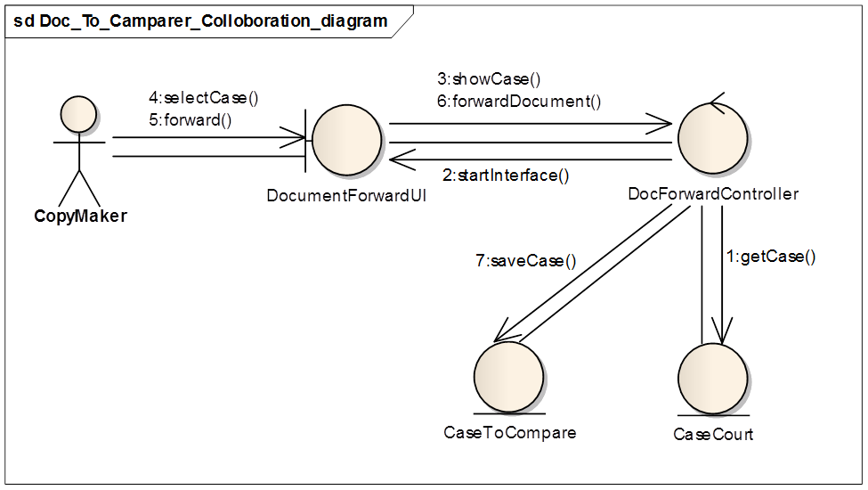

**4.4.2.4.b Document Comparison Use Case:** The DocComparisionController gets caseNumber from docToComparer. The DocComparisionUI shows CaseNumbers, gets caseDescription from CaseCourt.The UI then shows CaseDescription, forwards docs to judge.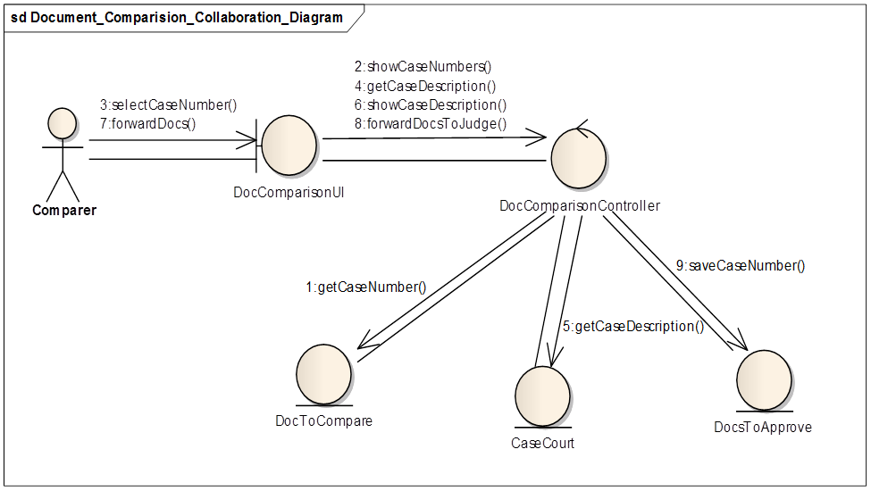

The controller saves CaseNumber in the DocsToApprove.

**4.4.2.5 Trial Documentation Use Case:**

**4.4.2.5.a Judgement Documentation:** The JudgementDocumentUI gets from the controller & gets CaseInfo. The greffier inputs judgementInfo in the UI & the controller saves judgementInfo in the CaseCourt.

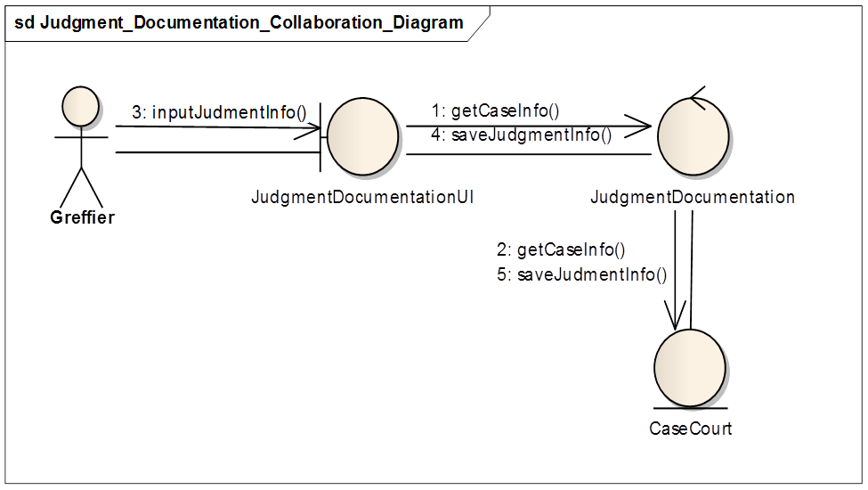

**4.5 Process Design**

**4.5.1 Sequence Diagram:** Sequence diagram shows interaction between objects arranged in a time sequence. It can be drawn at different levels of detail and to meet different purposes at several stages in the development life cycle. It is typically used for representing the detailed object interaction that occurs for one use case or for one operation.

**4.5.1.1** **Sequence Diagram: Case Filing:**

**4.5.1.1.a** **File a case Use Case:**

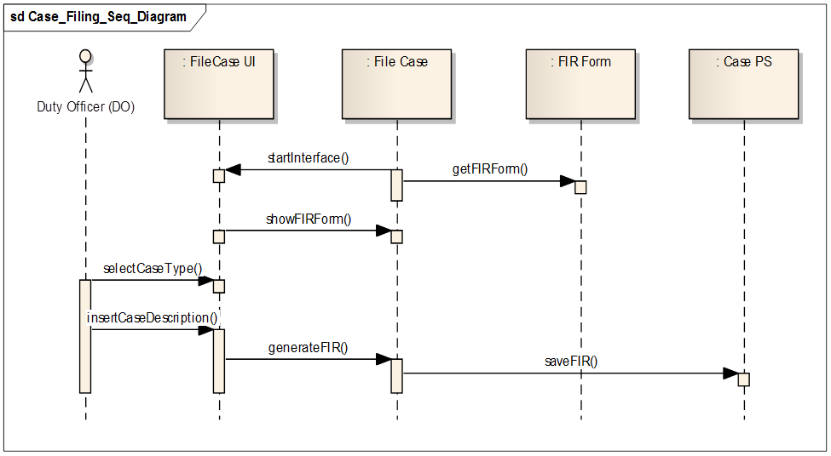

At first interface starts and then FIR form is shown in the interface. Then Duty officer enters case type and fills other necessary fields. Next FIR is generated and saved in the CasePS.

**4.5.1.1.b** **Forward FIR Use Case:**

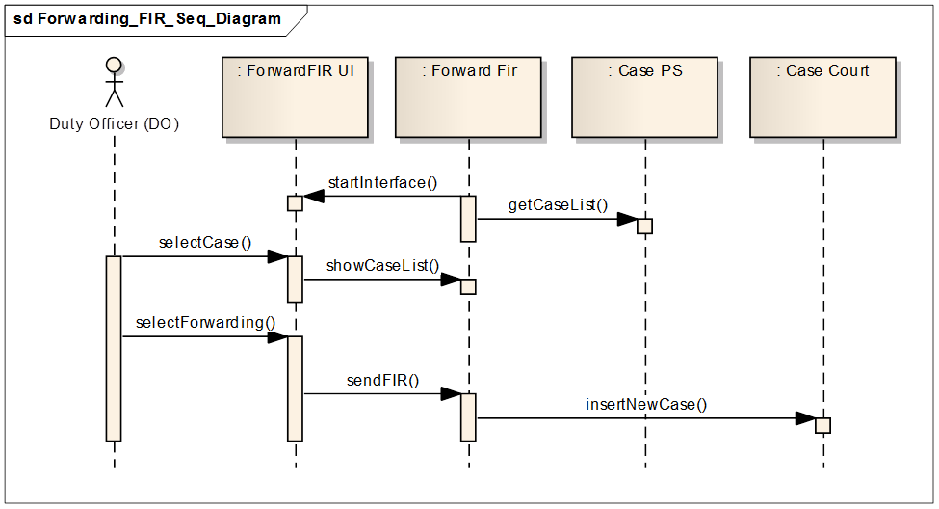

In this use case at first interface is started and a list of cases is shown in the user interface. After selecting the case, details of the case is displayed. Then, on selecting the forwarding FIR option FIR is sent to the Court.

**4.5.1.1.c** **Charge Sheet Submission Use Case:**

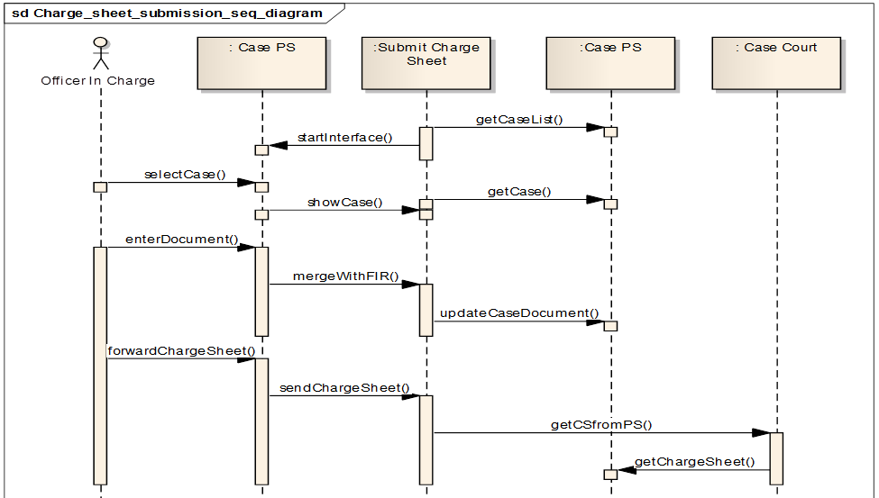

At first interface is started and case list is retrieved. Then this list is shown in the user interface. After selecting a case, case details is shown. Then charge sheet documents are added and merged with FIR and documents are updated. If some fields are not complete, it is checked again. And finally is saved and sent to the court.

**4.5.1.2** **Sequence Diagram: Cause List Generation:**

**4.5.1.2.a** **Case List Sending Use Case:**

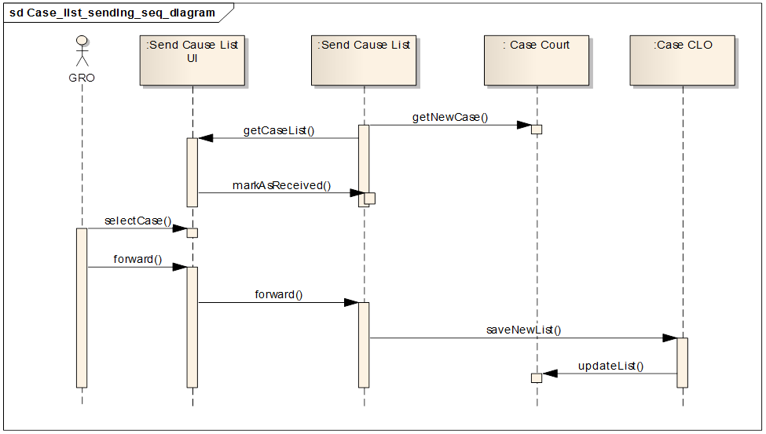

At first case list is retrieved and shown. Then these cases are mark as received. Then some cases are selected and forwarded to clerk office. The new case list saved and updated.

**4.5.1.2.b** **Pair Data to Cause List Use Case:**

At first new cases, old cases and magistrate list is retrieved. Then this info is shown in the interface. After that, combining this data a case list is created. Then this cause list is approved and saved.



**4.5.1.3** **Sequence Diagram: Magistatrate Assignment:**

**4.5.1.3.a** **Assign And Notify Masgistrate Use Case: **

At first all magistrate and court list is retrieved and shown in the user interface. Then a court is assigned a magistrate by the CMM (Chief Metropolitan Magistrate)

Then this case list saved and all the magistrates are notified by the system.

**4.5.1.4** **Sequence Diagram: Document Collection:**

**4.5.1.4.a** **Document Sending To Comparer Use Case:**



At first requested case list is retrieved and then interface is started. Then after selecting a case copied document is sent to the comparer for next step of the process.

**4.5.1.4.b** **Document Comparing Use Case:**

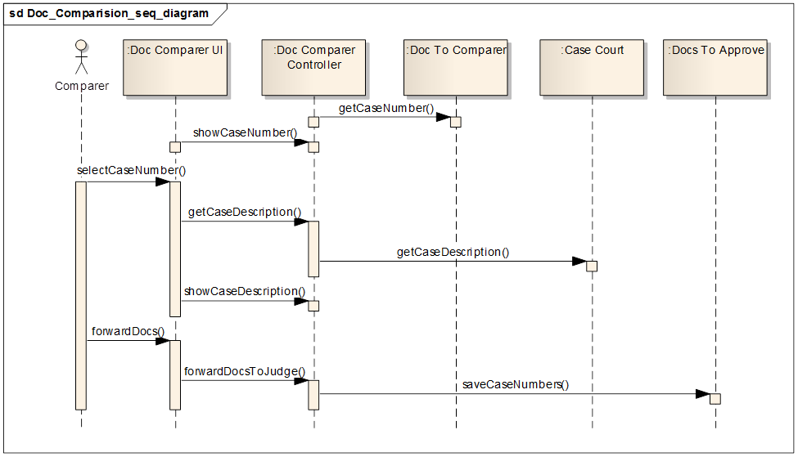

At first requested document number is retrieved. Then after selecting case number, case description is retrieved and then documents are checked with original document. If everything is Ok then documents are sent to judge for next step of the process and database is updated with necessary information.

**4.5.1.5** **Sequence Diagram: Trial Documentation:**

**4.5.1.5.a** **Judgement Documentation Use Case:**

At first case data is retrieved by case number. Then documents are inserted and saved. If judge gives his approval documents are finally published.



**4.5.2 State Chart Diagram:** A state diagram is used to define a behavior of a system. A state is a condition during the life of an object or an interaction during which it satisfies some condition, performs some action or waits for some event.

**4.5.2.1 State Chart Diagram: Case PS:**

Case PS is initiated when an FIR form is shown in the interface. Then it goes to the updated state when data is inserted and other checks are being made. When it is saved in the archive it goes to the completed state.

**4.5.2.2 State Chart Diagram: FIR form :**



A FIR is initiated when an FIR form is shown in the interface. Then it goes to the ready state when data is inserted and other checks are being made. When it is saved in the archive and sent to the court it goes to the completed sate.

**4.5.2.3 State Chart Diagram: Case PS:**

Case PS entity class starts when getcase() function is called. When description is shown and checked for necessary fields it is in the being checked state. After forwarding it goes into the Forwarded and final state.



**4.5.2.4 State Chart Diagram: Case Court :**

Case court goes into the active state when insertnewcase() function is called and when case is saved it goes into the finished and final state.

**4.5.2.5 State Chart Diagram: Cause List :**



A cause is initialized by generateCauseList() function is called. When magistrate list and case list is assigned to it, it goes to populated state. When is saved and notification to magistrate is done, it goes to the complete state.

**4.5.2.6 State Chart Diagram: Court List :**

Court List is initialized when magistrate list is retrieved. Then is goes to shuffled and then to updated state when magistrate list is merged with the list of courts. Then it is saved and it goes to the completed state.



**4.5.2.7 State Chart Diagram: Magistrate :**



At first it is in the ready state when magistrate list is retrieved. Then magistrate is assigned and it goes to the processing state. Next it goes to the finished state.

**4.5.3 Activity Diagram:** Activity diagram is graphical representation of workflows of stepwise activities and actions with support for choice, iteration and concurrency.

**4.5.3.5** **Activity Diagram: Case Filling:**

**4.5.3.1.a Activity Diagram: Case Filing:**

Use case starts when duty officer open a FIR form. Then he fills up the form. Then he checks the FIR form. If it’s ok , then he saves it and if there is a issue to be checked he updates that and after updating it is saved.



**4.5.3.1.b Activity Diagram: Forwarding FIR:**

At first officer in charge selects form case list. Then details of the case are shown. Then OC inserts necessary documents. If everything is all right it is saved and sent to the court. Otherwise FIR is checked for the errors again.



**4.5.3.1.c Activity Diagram: Charge Sheet Submission:**

Charge sheet submission is started with getting case list. Then it list is shown. After selecting a case details is shown and documents are uploaded. Then these documents are merged with the FIR. After

Proper checking the charge sheet is sent to the court.



**4.5.3.5** **Activity Diagram: Cause List Generation:**

**4.5.3.2.a Activity Diagram: Case List Sending :**

At first case list is retrieved. Then appropriate cases are selected and approved. Then they are forwarded the clerk office.

**4.5.3.2.b Activity Diagram: Pair Data to Cause List:**

At first case list is retrieved. Then Case type is checked. If case type is old then status is updated. Then new case and old case are merged together to generate the cause list. Then case list is saved and notification is sent to the concern magistrates.



**4.5.3.5** **Activity Diagram: Magistatrate Assignment:**

**4.5.3.3.a Activity Diagram: Assign And Notify Magistrate:**

At first the list of magistrate is retrieved. Then they are assigned a court. If anybody is unavailable, a check is made for them. Then the list is saved.



**4.5.3.5** **Activity Diagram: Document Collection:**

**4.5.3.4.a Activity Diagram: Document Sending To Comparer:**

At first requested case list is shown. Then a case is selected and a copy is made. Then it is sent to the comparer for further processing



**4.5.3.4.b Activity Diagram: Document Comparison:**

Comparer first checks the document number. Then he takes the original document and compares them with the

Supplied document. If everything is Ok document is supplied otherwise it is sent back to the comparer.



**4.5.3.5** **Activity Diagram: Trial Documentation:**

**4.5.3.5.a Activity Diagram: Judgement Documentation:**

At first case is selected form the case list. Then judgment info is inserted to the document. Next, document info is saved. If it is approved by the judge then is finally published for public.



**Chapter 5**

**Database Design**

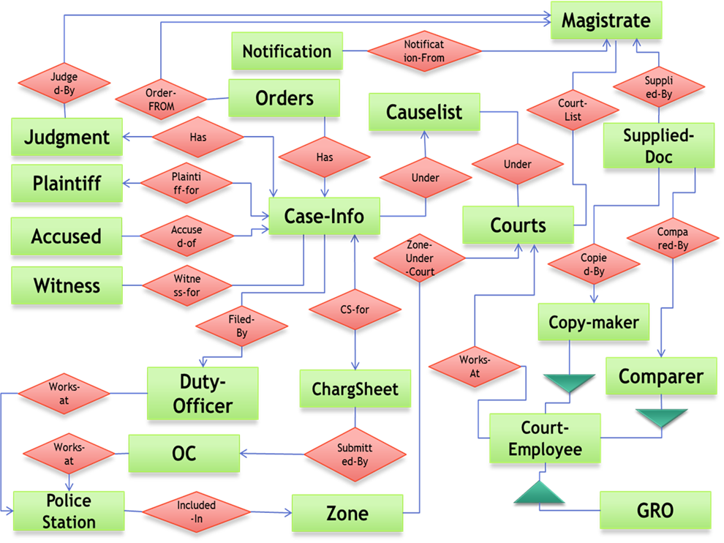**5.1 Introduction:**

Entity relation diagram is an important part for planning the database design for a system. In this diagram the shown entities are those for which we need a relation in our database. For each relationship another relation must be kept in the database. In this chapter we are going to show the Entity Relationship Diagram of our Project. Some triggers and procedures have been added in the ERD that was presented earlier. Deletion of case information have been avoided in our design. Instead of deleting entries we have preferred maintaining states.

**5.2 Overview of the Design Process:**

In our ERD we tried to keep consistency between Collaboration diagram and ER diagram. In our collaboration diagram there where several entity class and for each of those class we have designed an entity in our database. We have tried to reduce the amount of memory wastage. Managing states have been a big issue in our database.

**5.3 ERD & Its Brief Description:**

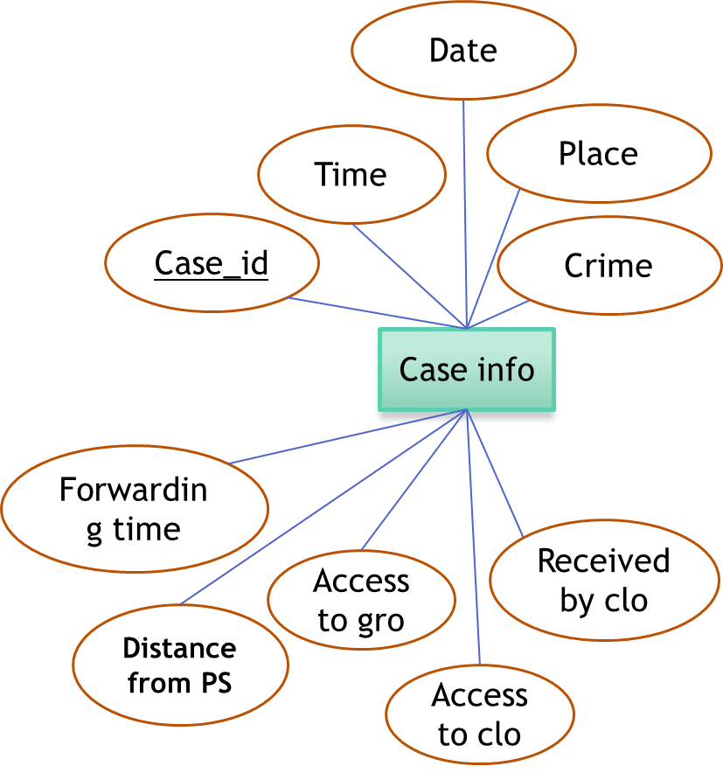 **5.3.1 The ERD at A Glance:** In our system’s ERD there are 20 entities. Here is the ERD of our Information system. The entities are case-info, Duty officer, Officer In Charge, police station, zone, Court Employees, Magistrate, Court, Cause List, Orders, Notification , Judgment, Plaintiff, Accused, Witness. There are relations between entities and there are many to one, many to many and one to one relations between them.

**5.3.2 Anatomizing the ERD:** In this section we will be describing the erd part by part. First of all the case info entity is for saving the case information and to maintain state information about a case. This entity is the most important entity of our database. The attributes of this entity is case_id, time, date, place, crime, received by CLO, access to CLO, access to GRO, distance from police station, forwarding time .

The second entity is plaintiff entity. Its attributes are plaintiff_id, name, gender, father’s name, mother’s name, phone no., house no., road no., address and district.

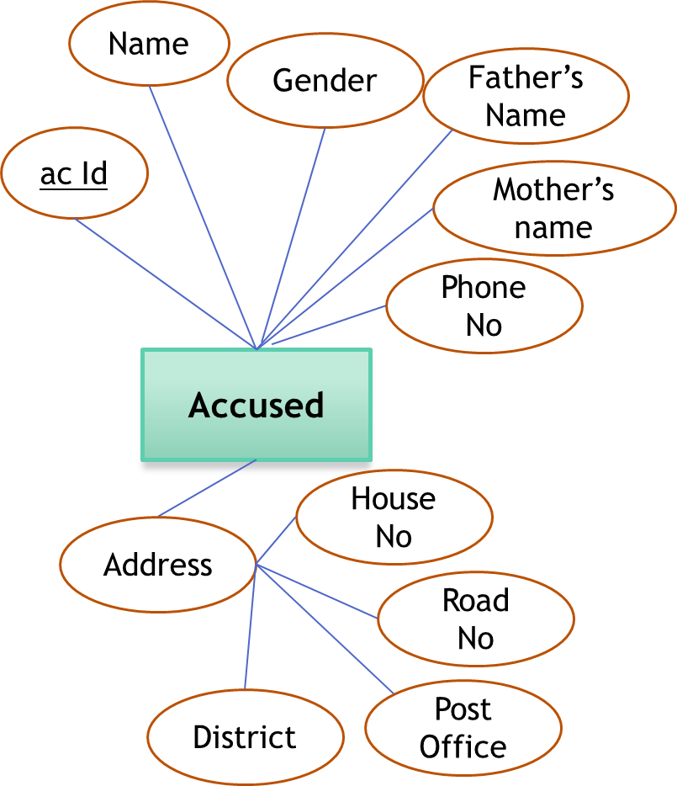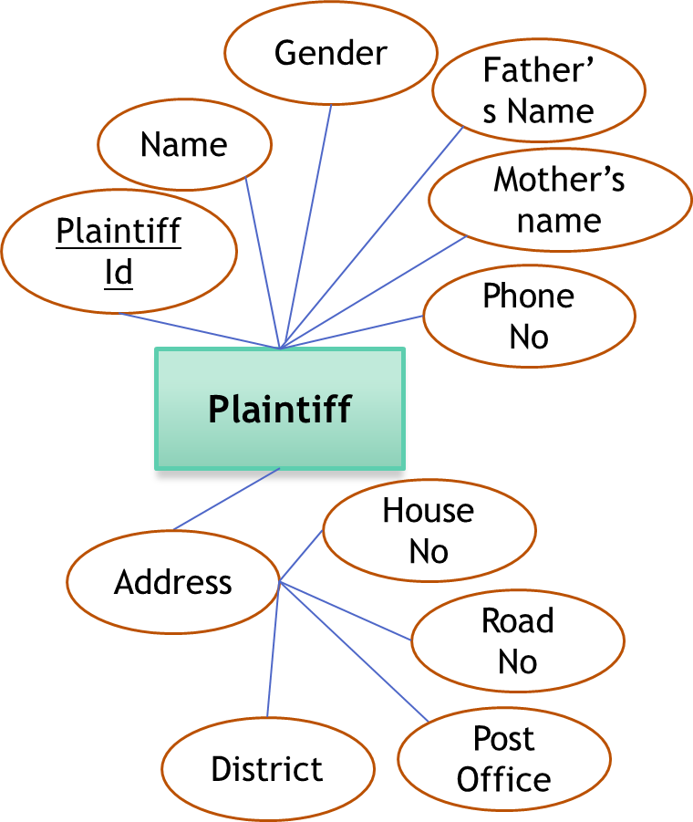The accused entity has the same attributes as the plaintiff entity. The next entity is witness entity having the same set of attributes as that of the plaintiff entity. The duty officer entity has the following attributes.

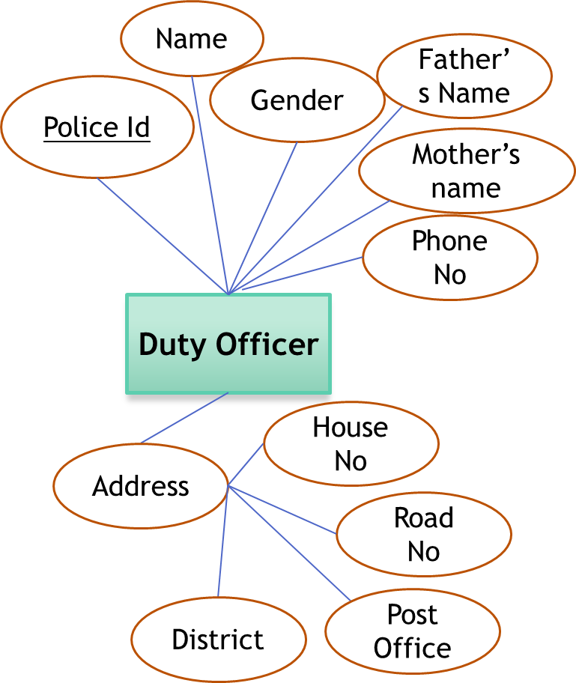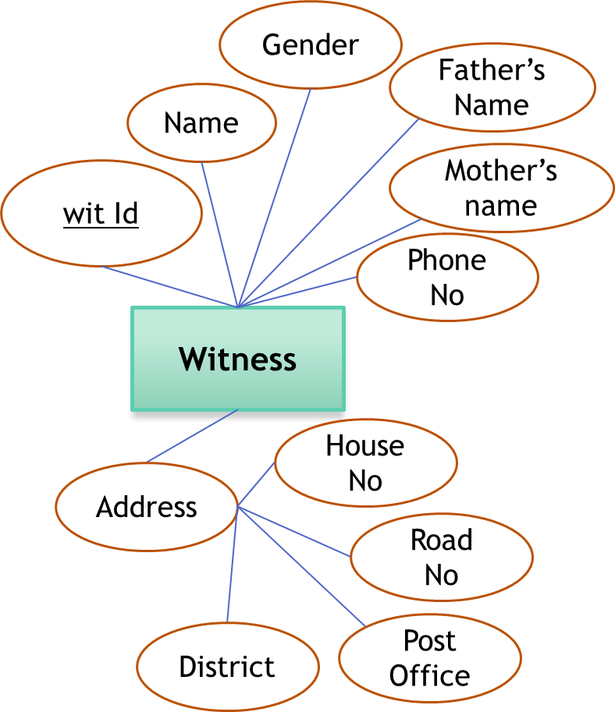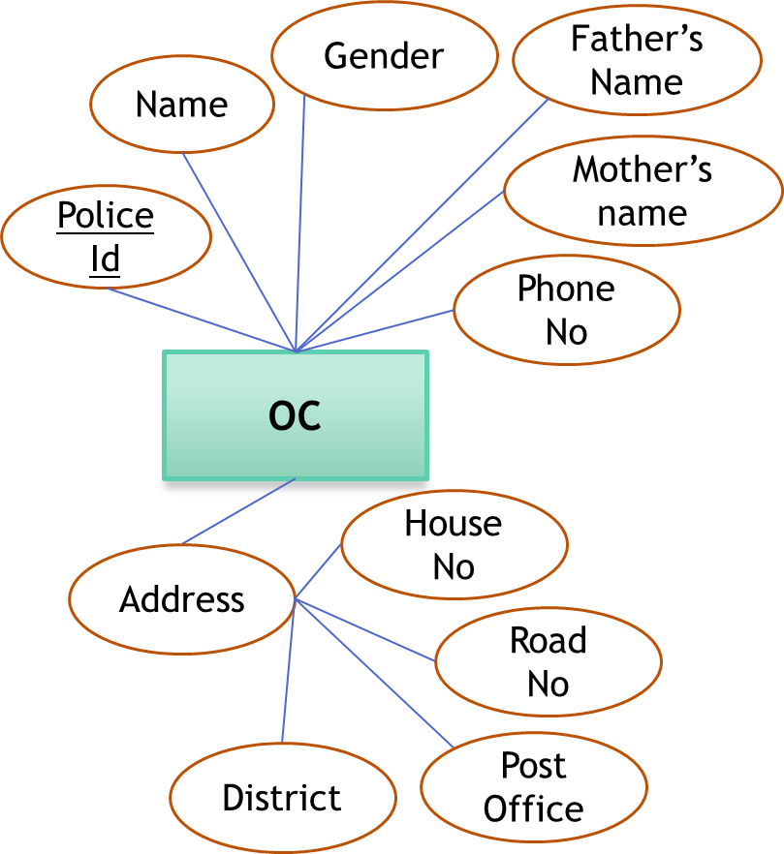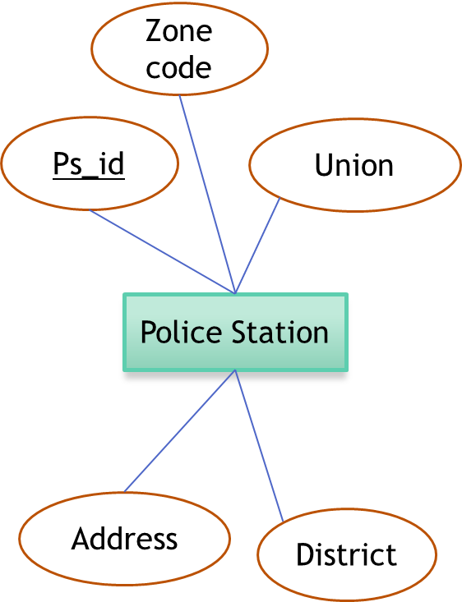The oc entity has the same attributes as the duty officer entity. The attributes of police statin entity are ps_id, zone code, union, district, address. For the zone entity there are 2 attributes. They are zone_id and name of the zone. In the order entity we have planned to keep order_id, body, date, status as its attributes.

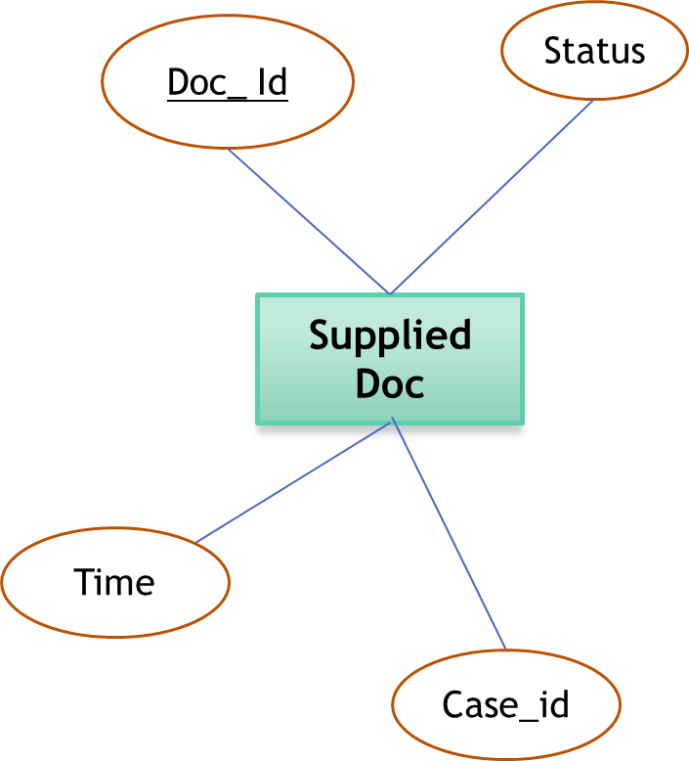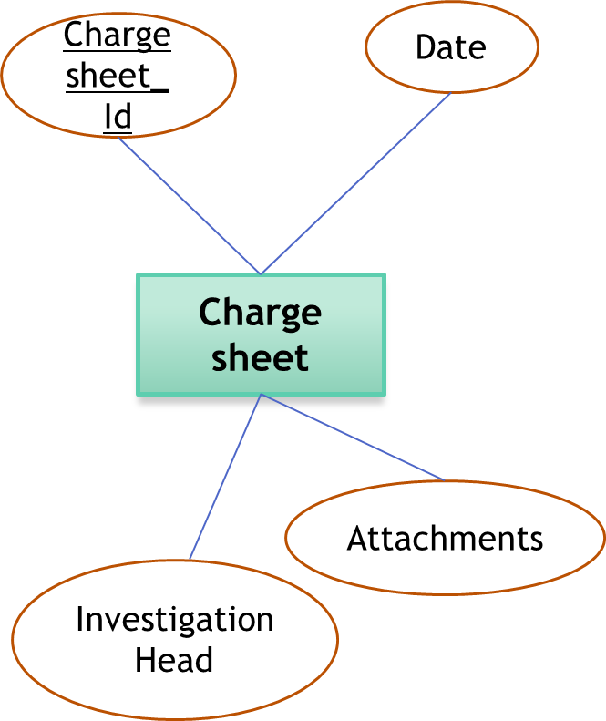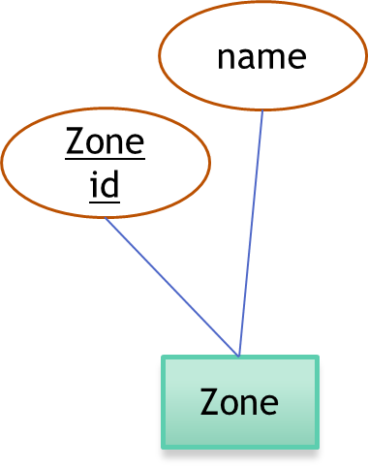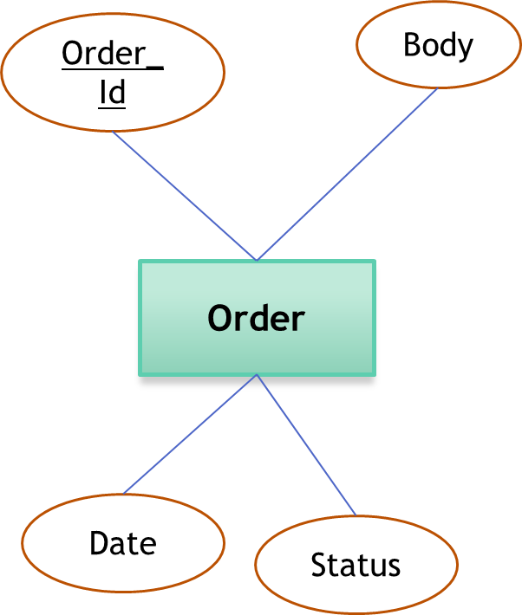The judgement entity has 3 attributes judgment_id, body, date. The magistrate entity has magistrate_id, name, gender, father’s name, mother’s name, phone no., address, road no., post office, district etc as its attribute.The attributes of the chargesheet entity are chargesheet_id, date, attachments, investigation head. The attributes of supplied doc entity are doc_id, status, time, and case_id.

Now we will be describing the realtions between entities. The first one is the relation between case- info and plaintiff. Each case has atmost one plaintiff and one plaintiff can be a plaintiff of only one case so there is a one to one relation between them.

The next relation is the one between accused and case-info. One case can have several accused one accused. So there is many to one relation between them.

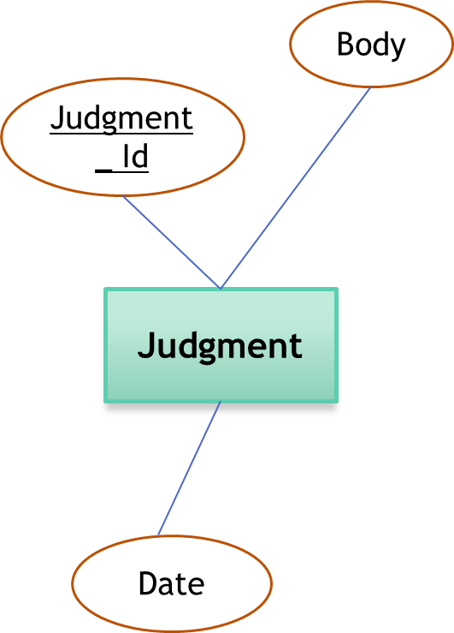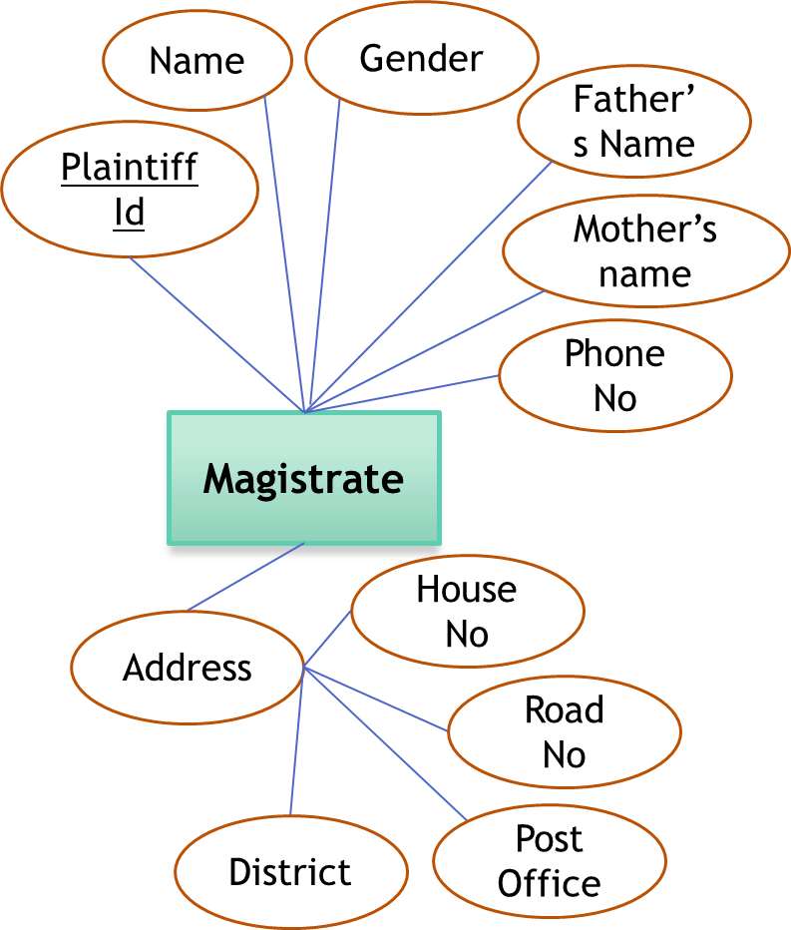

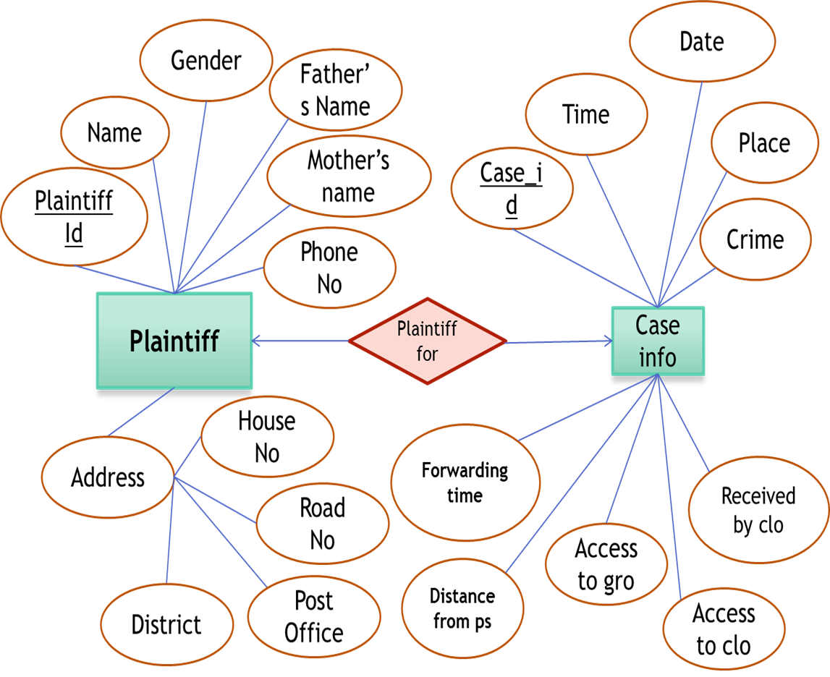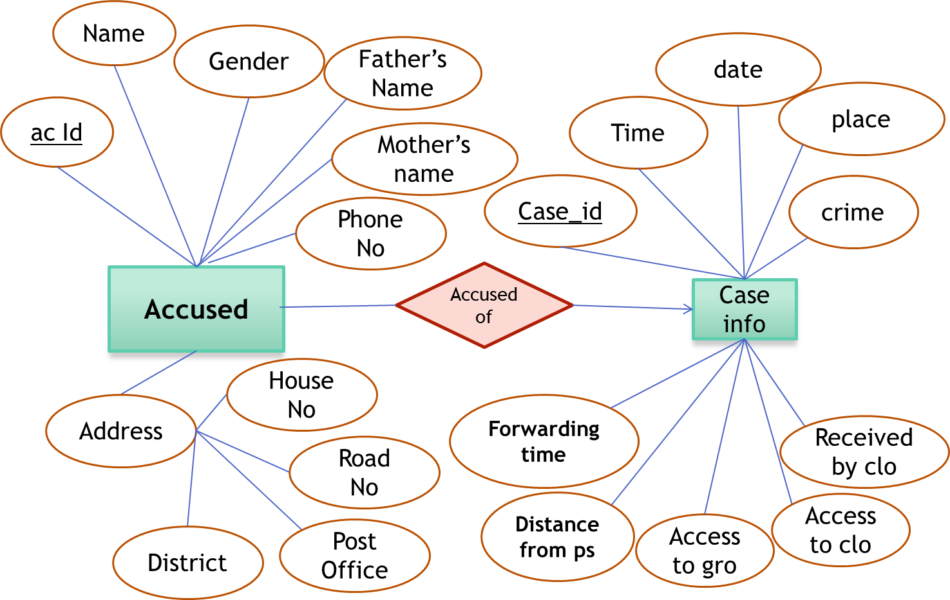The next relation is the one between witness and caseinfo. One case can have many witnesses so there is a many to one relation there.

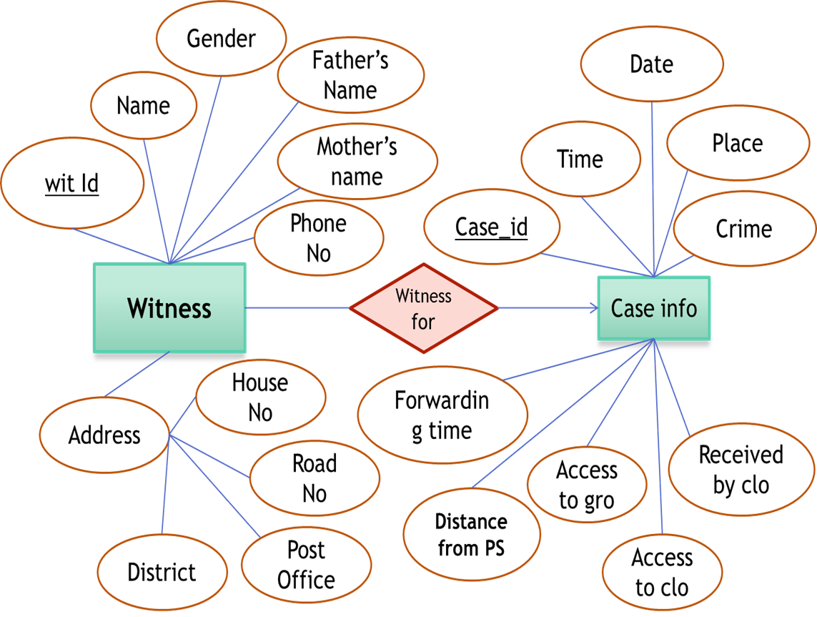

Both the duty officer and the oc has a relation with the police station. One police station can have several officer in charge and several duty officers.

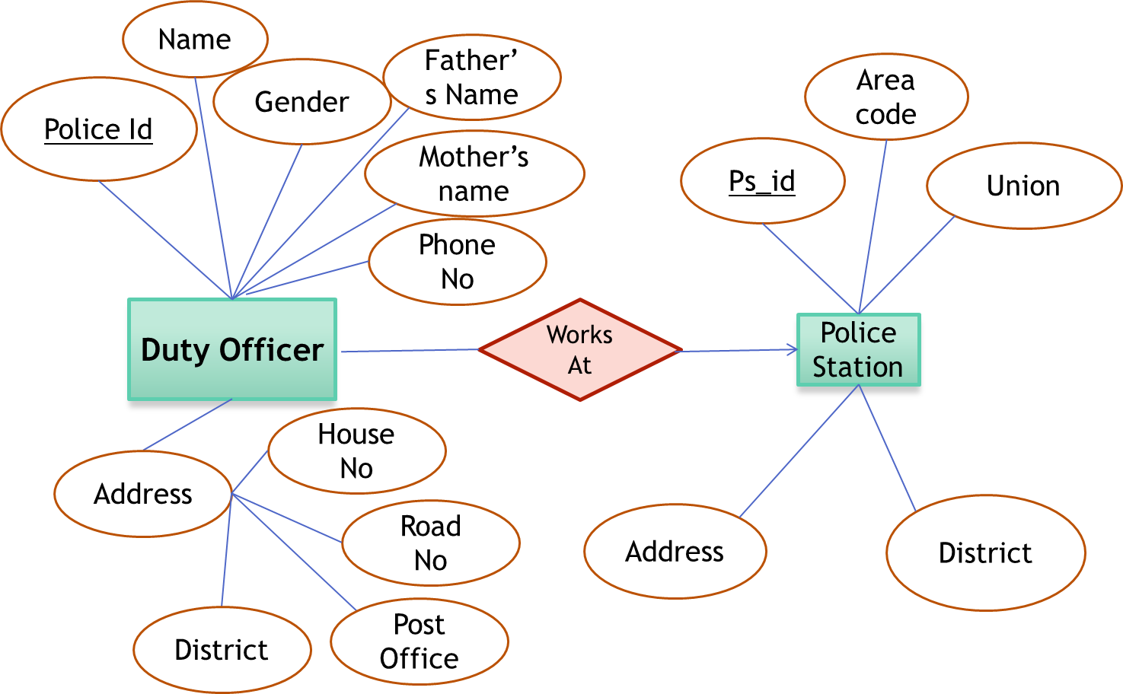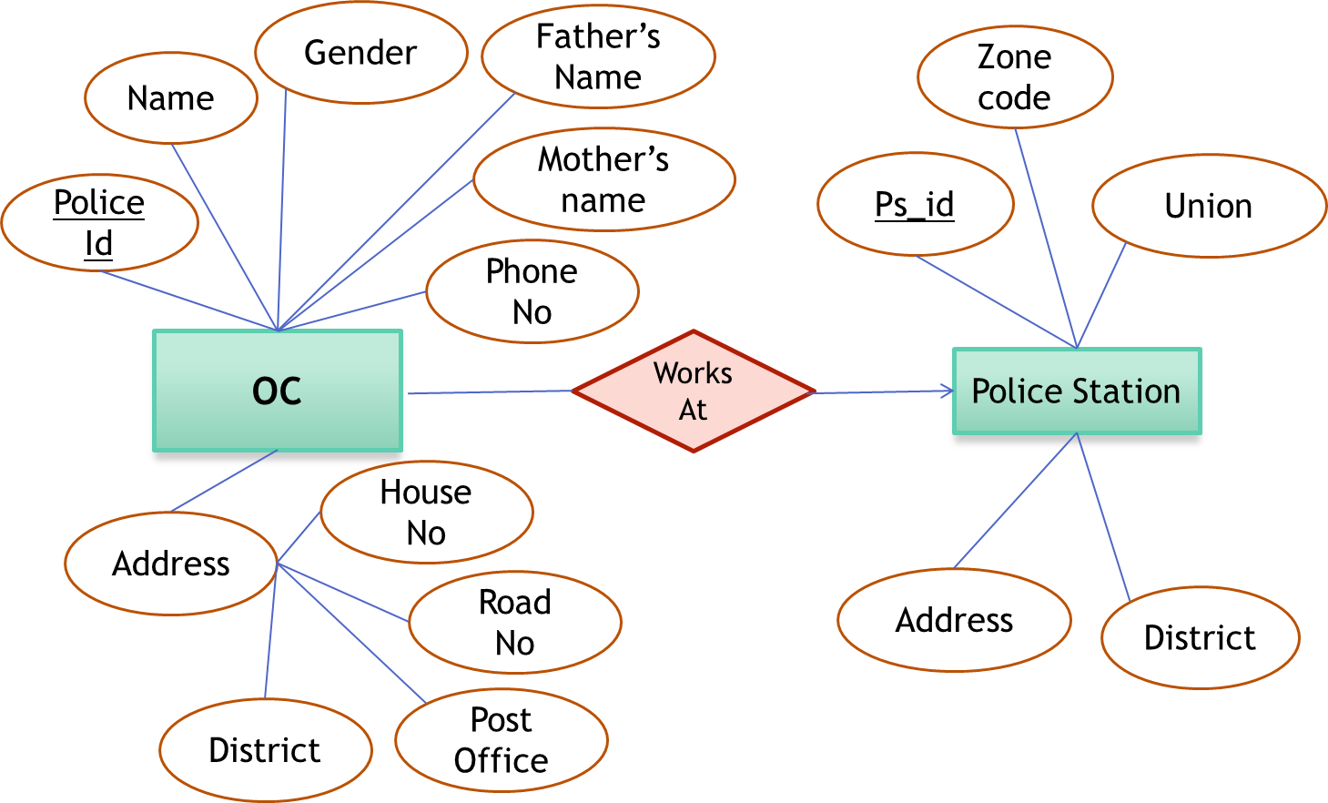

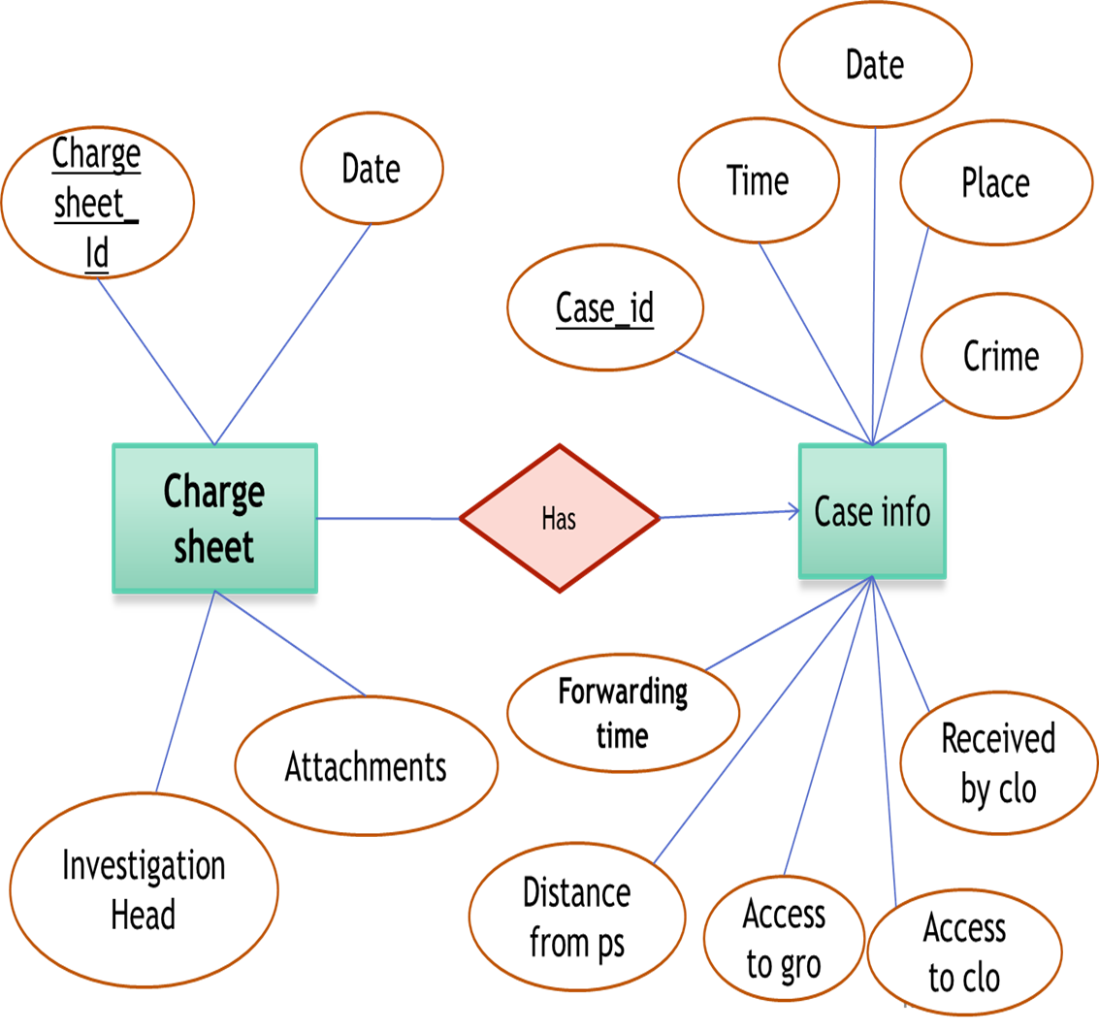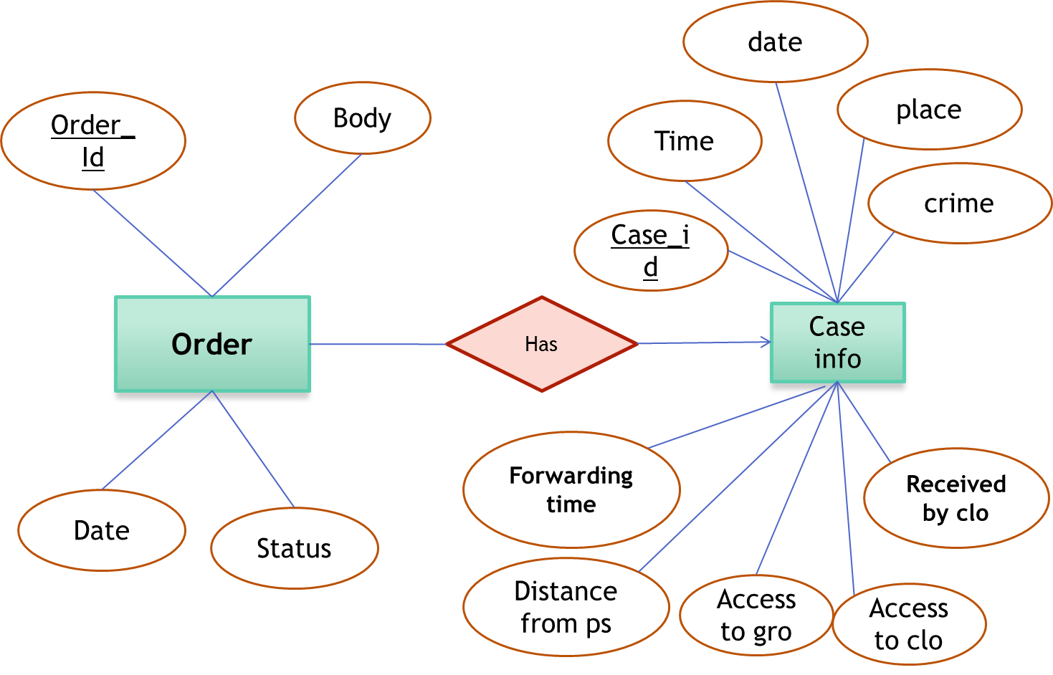Every case information has a charge-sheet. So there will be a relation between charge sheet and case-info table.

Each case info has a corresponding order so there will be a one to many relationship between them. The judgment entity has a relation with the case-info because every case has a judgment.

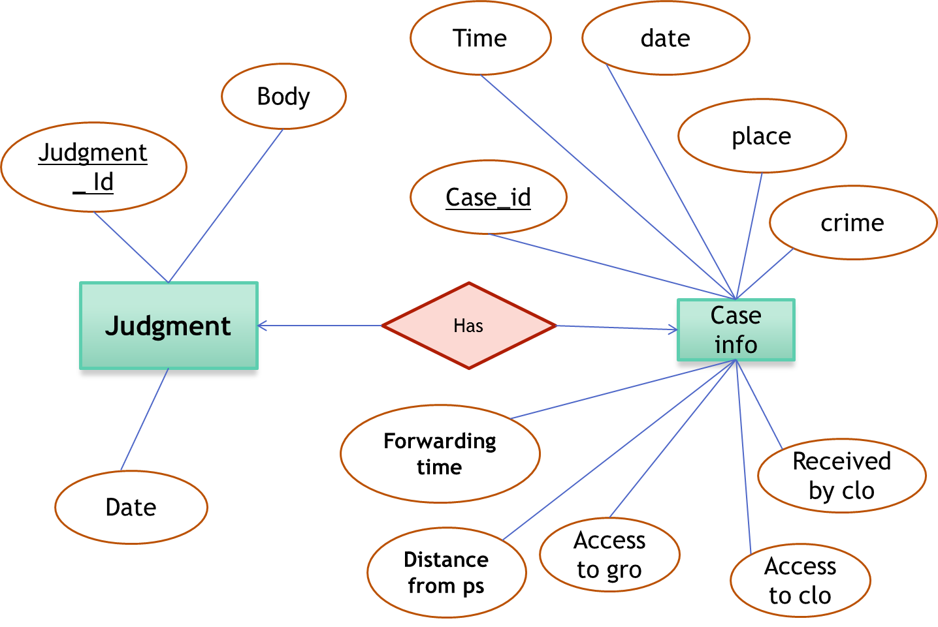Each magistrate are responsible to give orders for the cases under them. The information, which magistrate gave the order, should be stored in database. So there is a relation between the magistrate entity and its order entity.

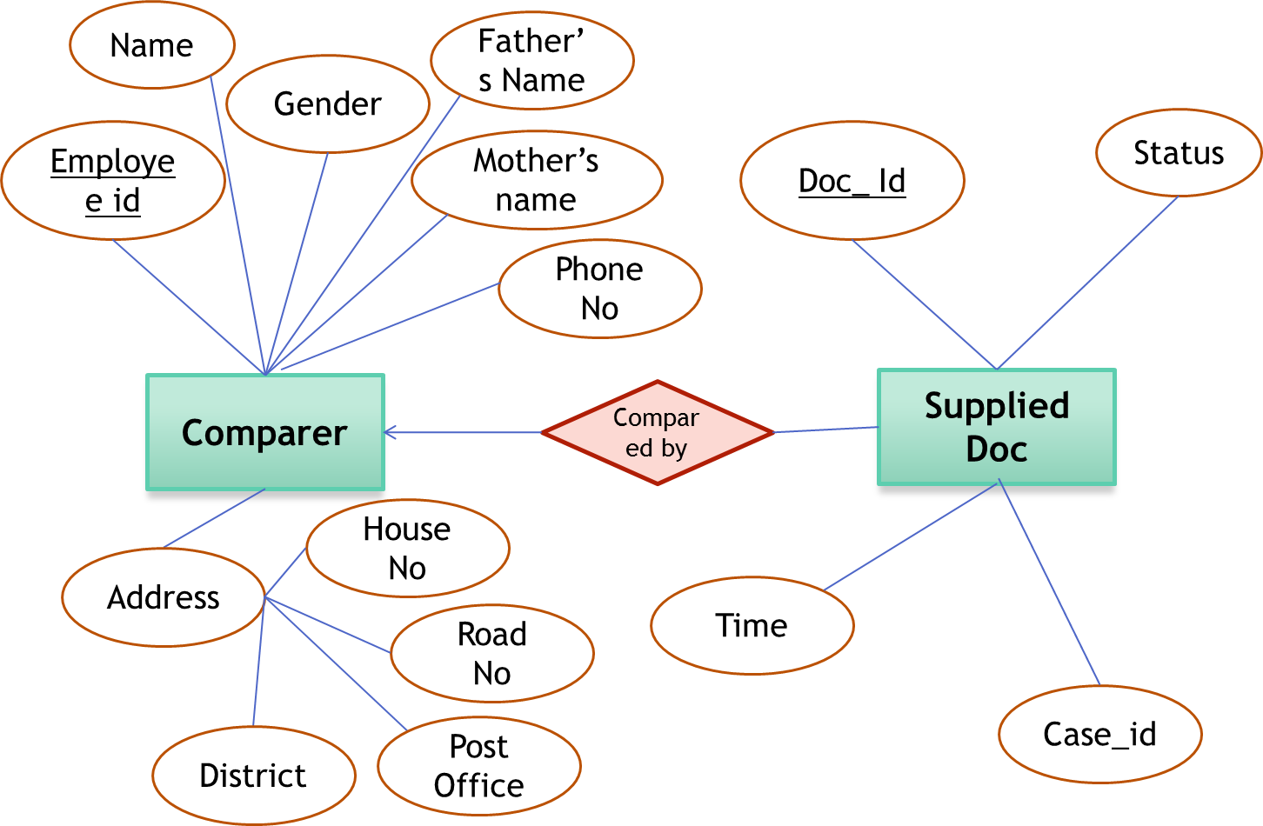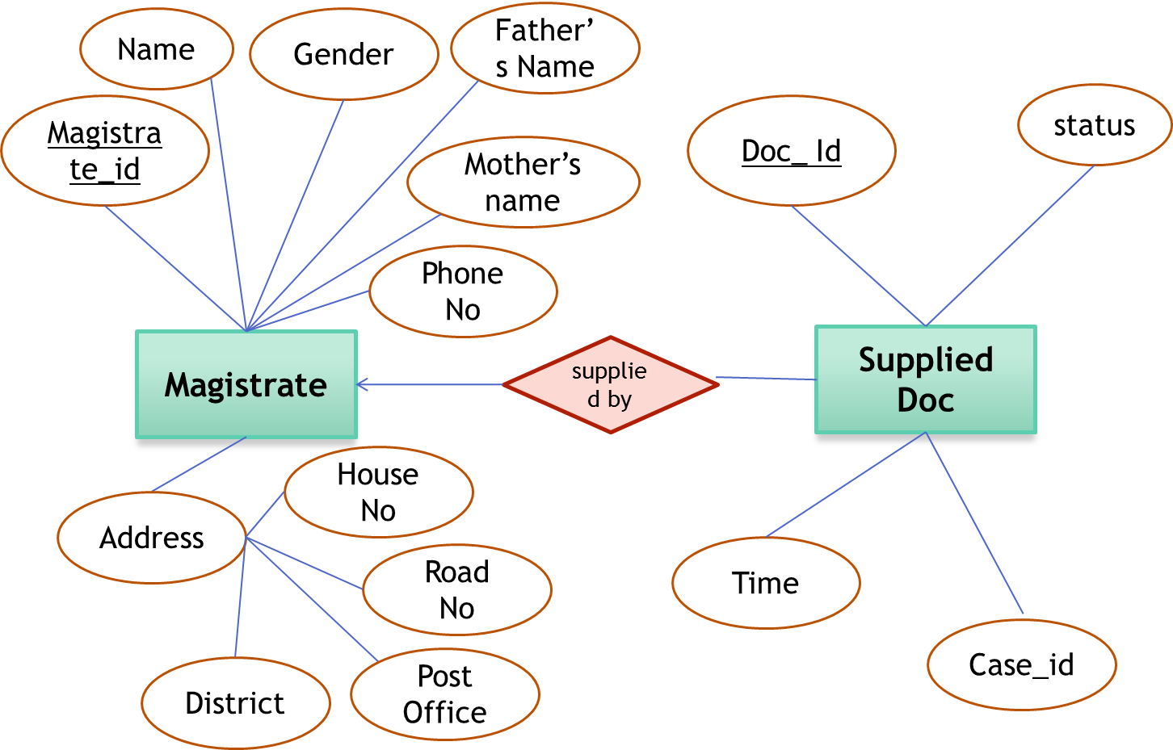Each supplied doc is approved by a magistrate. All the supplied doc has a corresponding magistrate who has approved the doc.

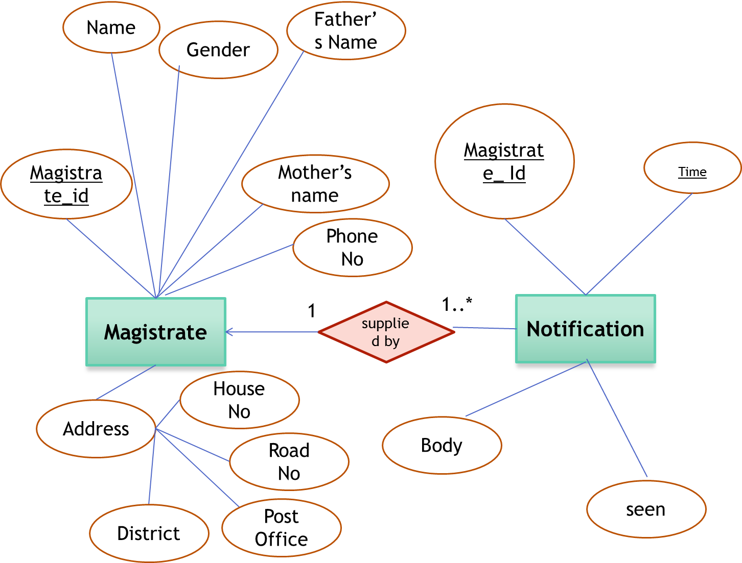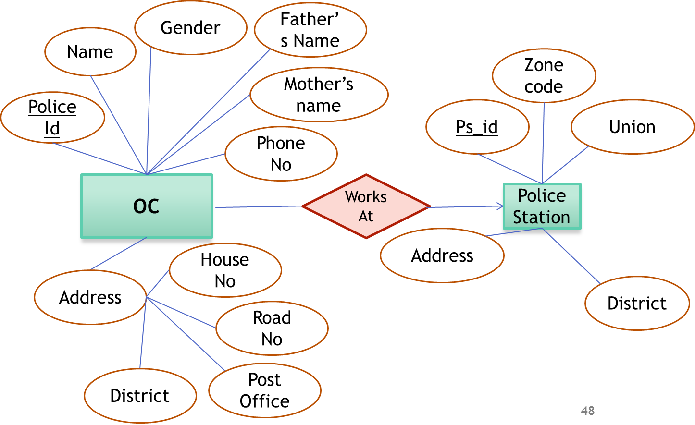For these information there is a relationship between magistrate and supplied docs. The supplied doc also has information about which comparer has compared the document with the original copy. To store this information we need to have a relationship between comparer and supplied doc.

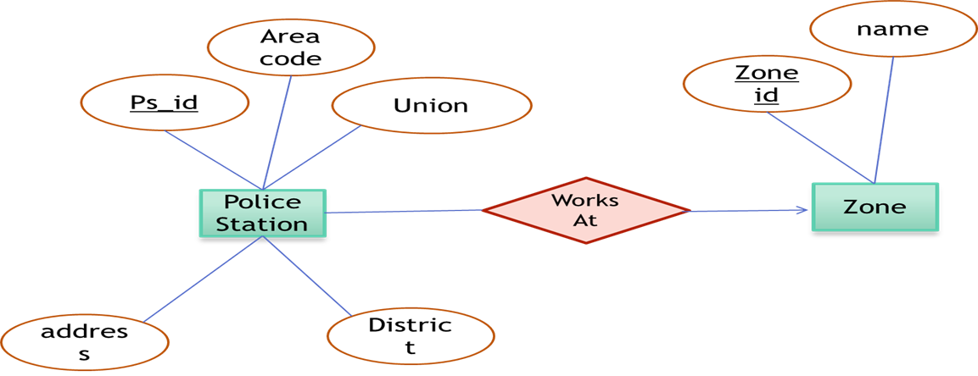Each magistrate will be send some notifications about there assignment to a court or about their cause List. This notifications should be saved in database. To represent this relation we have used a relationship between magistrate and notification. This relation is a one to many realtion. Lastly every police station must be under some zone . To store these information a relation between police station and zone must be maintained.

**5.4 Database Schema:** Database schema is a formal definition of tables which shows table name and name of the attributes of the table. The schemas for the database designed for this **system are given below.**

Table : Database schema for Case Info

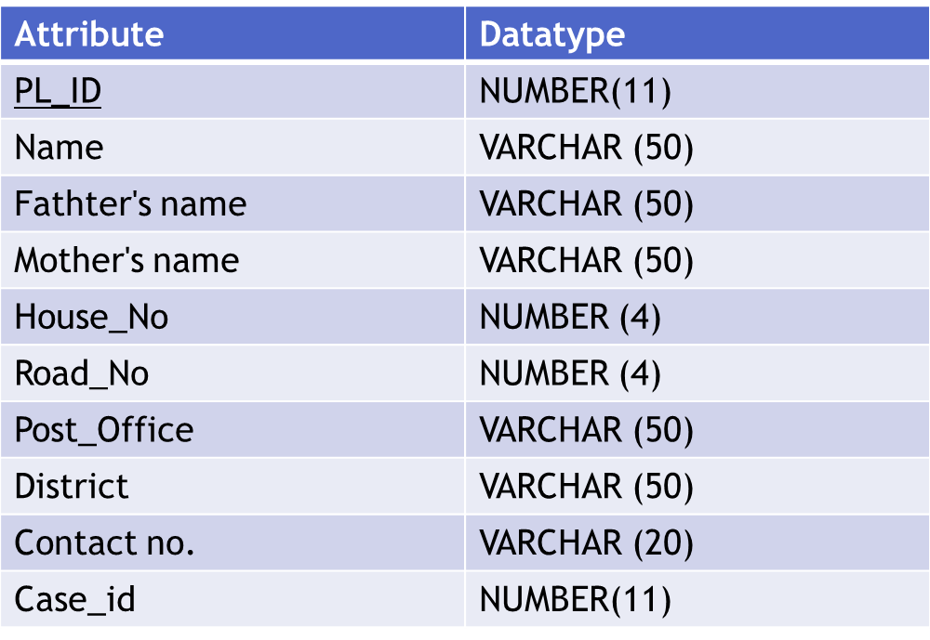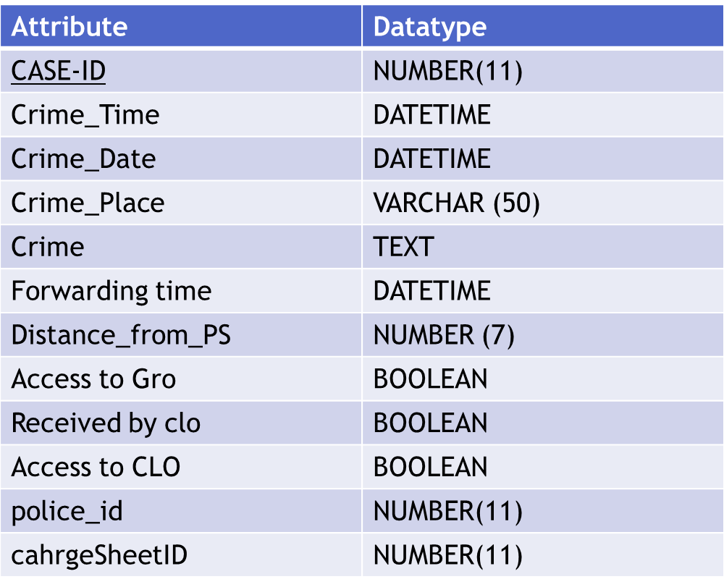

Table 2:Database Schema for table Plaintiff

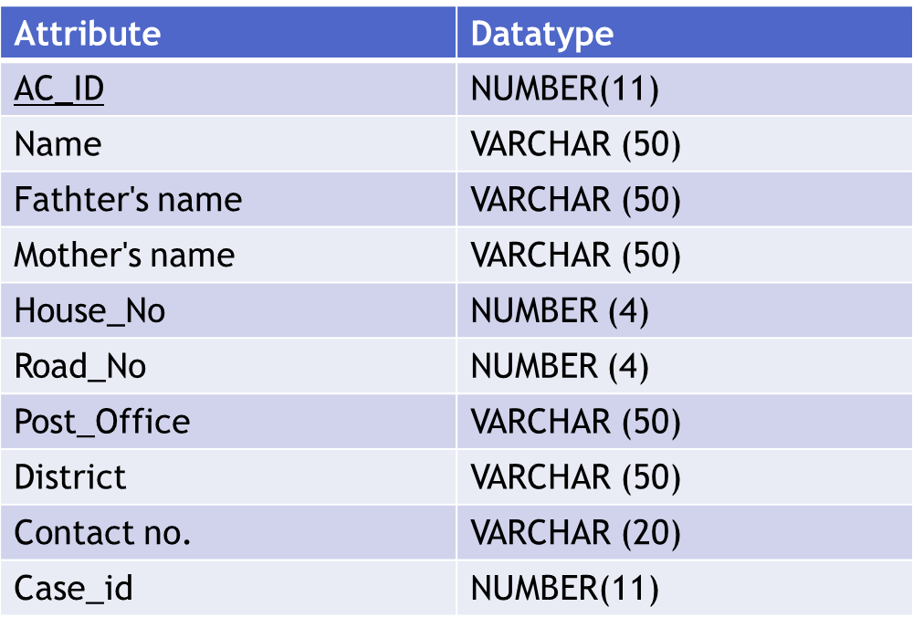

Table 2:Database Schema for Accused

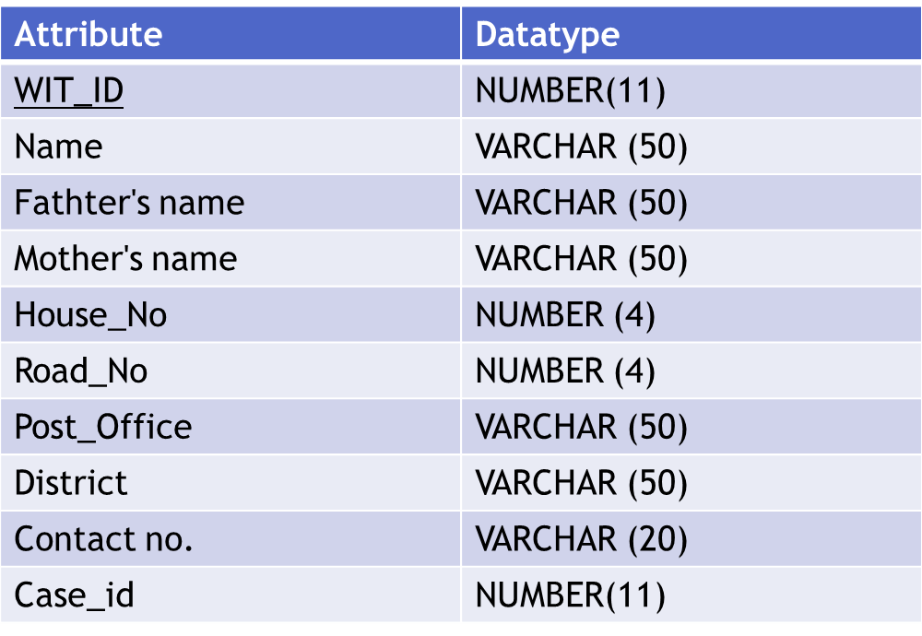

Table 3:Database Schema for table Witness

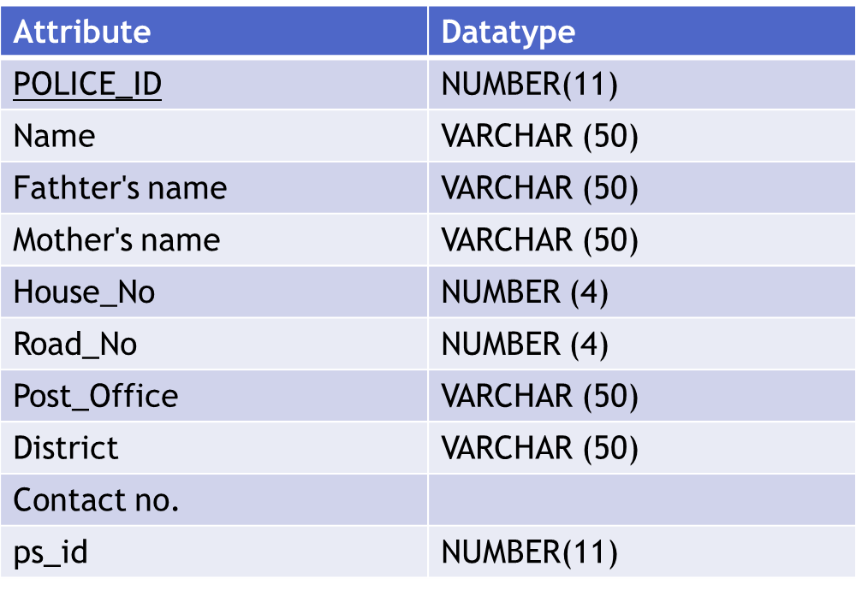

Table 4Database Schema for table Duty Officer

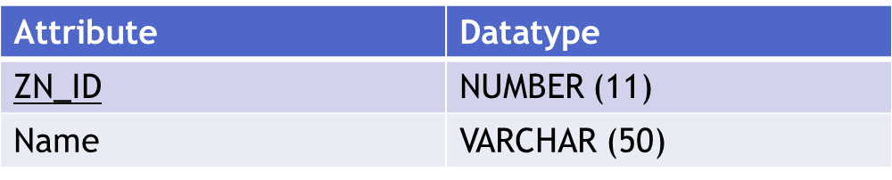

Table 5Database Schema for table Zone

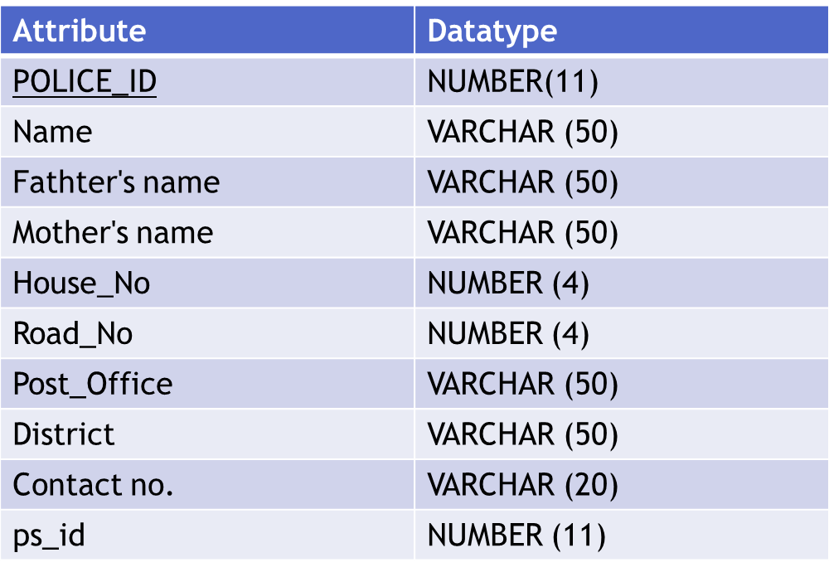

Table 6:Database Schema for table Officer In Charge

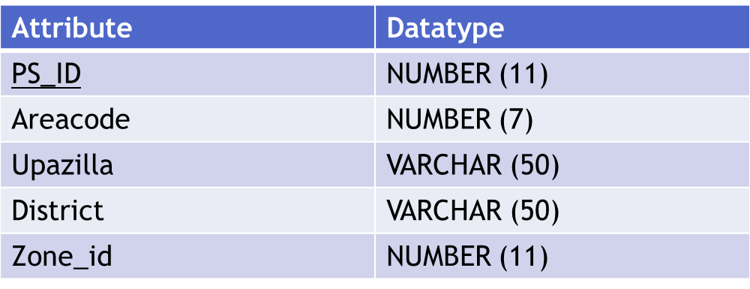

Table 7:Database Schema for table Police Station

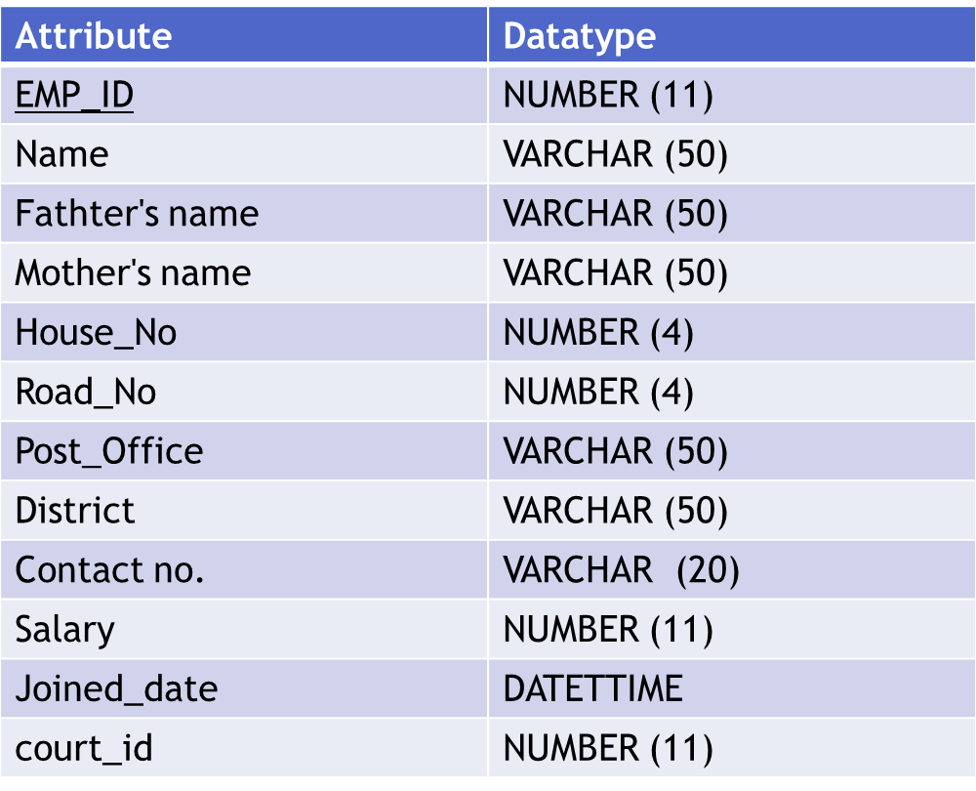

Table 8:Database Schema for table Emplyees

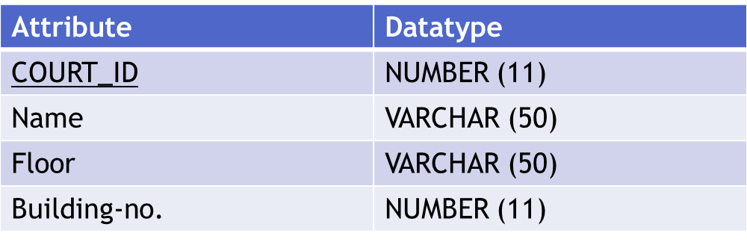

Table 9:Database Schema for table Courts

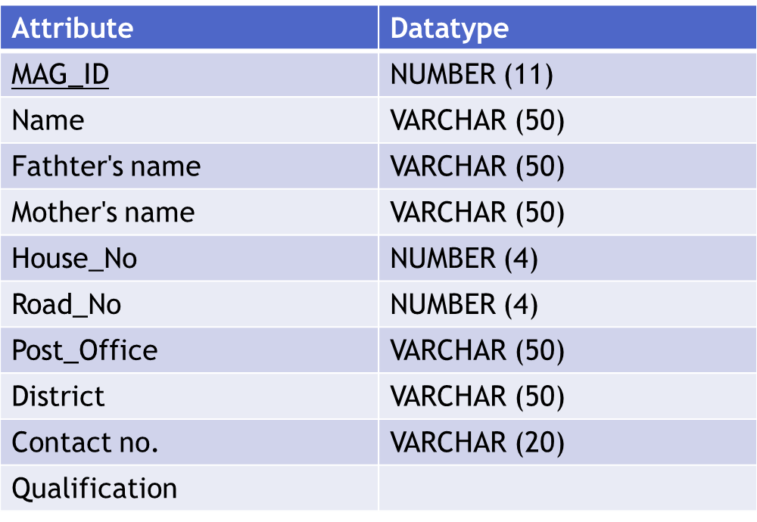

Table 10:Database Schema for table Magistrate

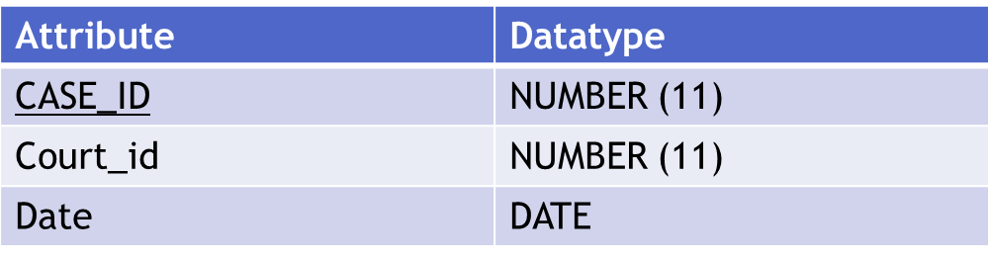

Table 11:Database Schema for table Cause List

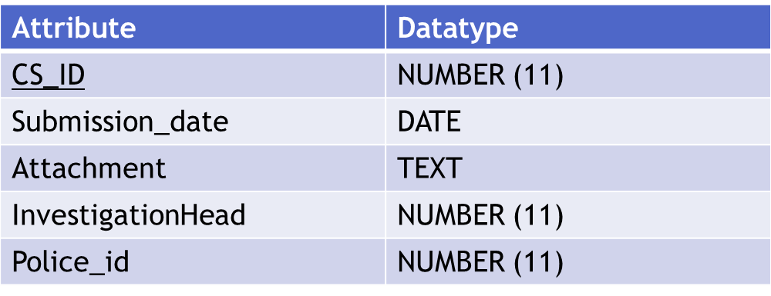

Table 12:Database Schema for table Charge Sheet

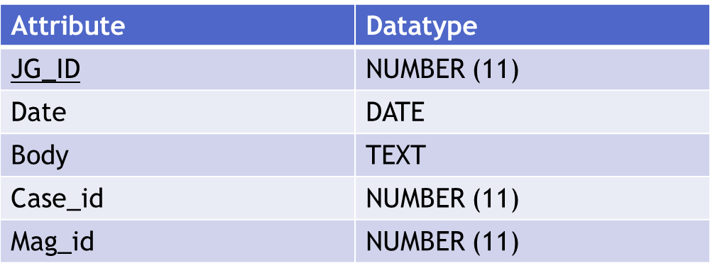

Table 13: Database Schema for table Judgement

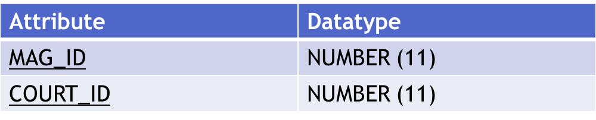

Table 14Database Schema for table Court List

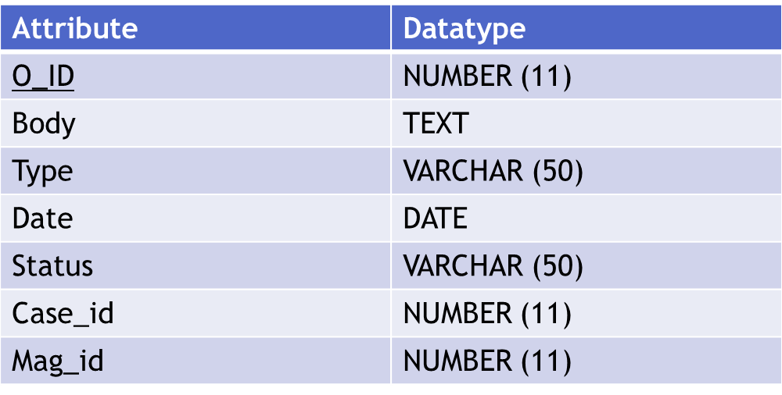

Table 15:Database Schema for table Order

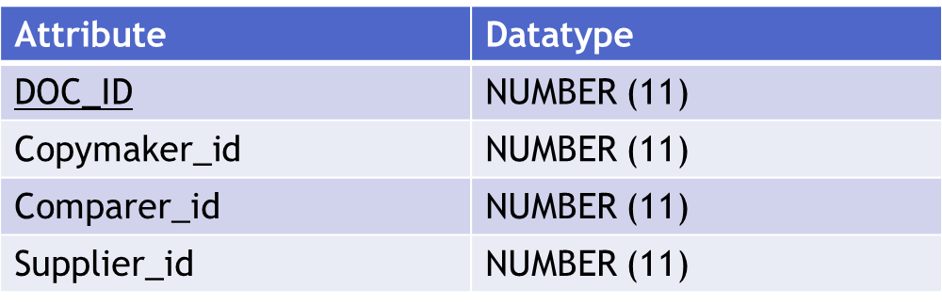

Table 16:Database Schema for table Supplied Document

**5.5 Triggers:**

Triggers are those events that are automatically initiated if some insert, update or delete is done in the database. Triggers can be used to handle insertion deletion that should be done when another query run. Below the trigger than have been designed for a system.

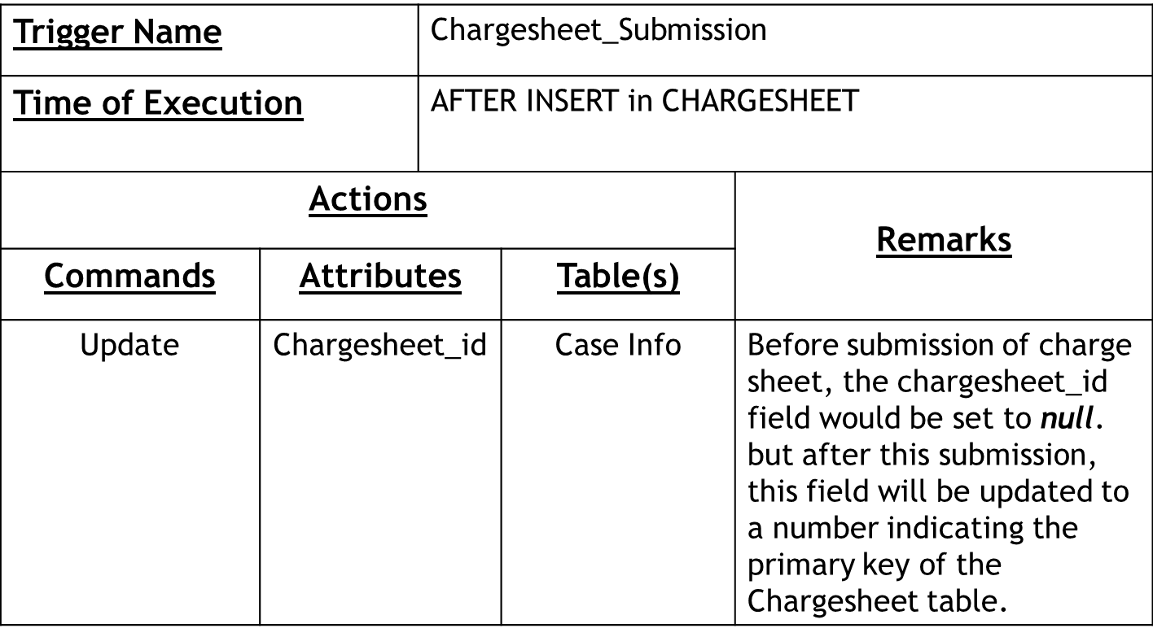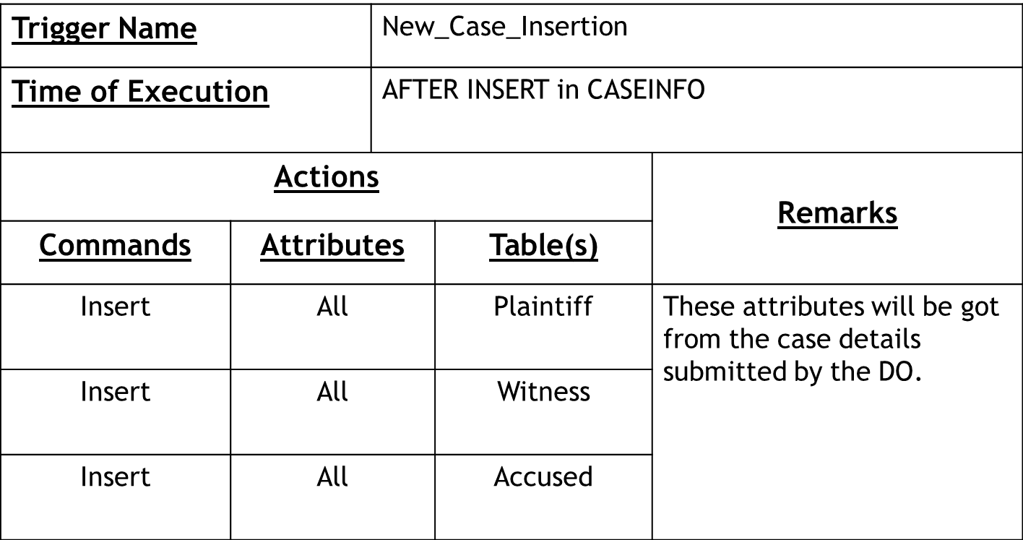

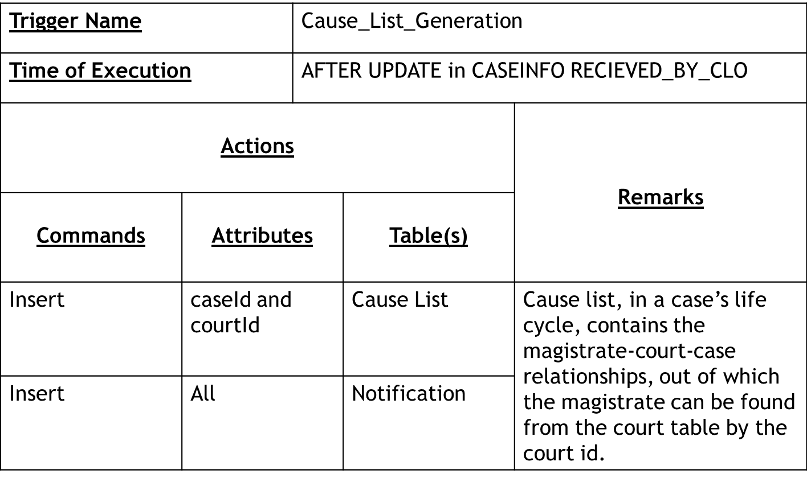

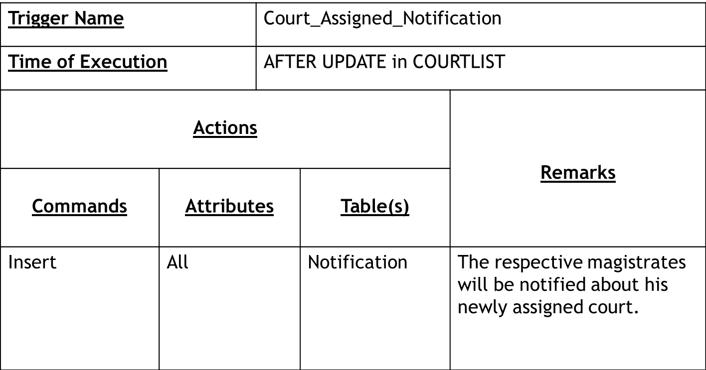

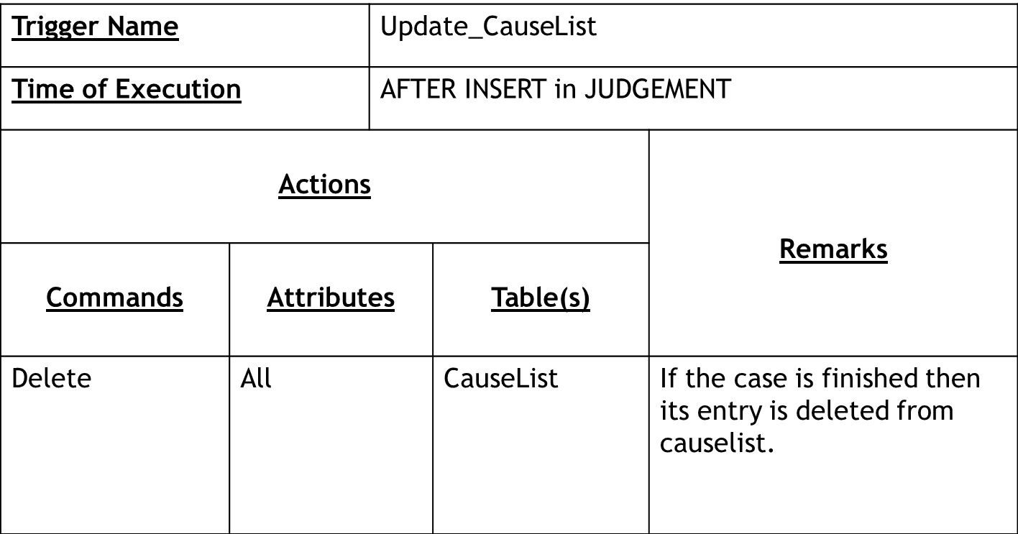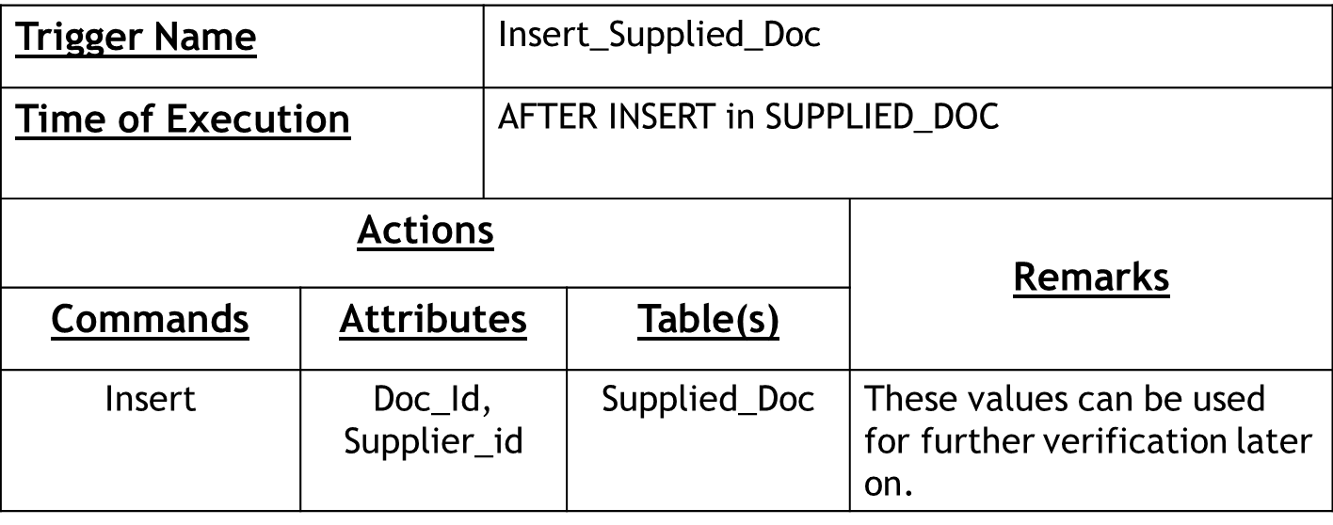

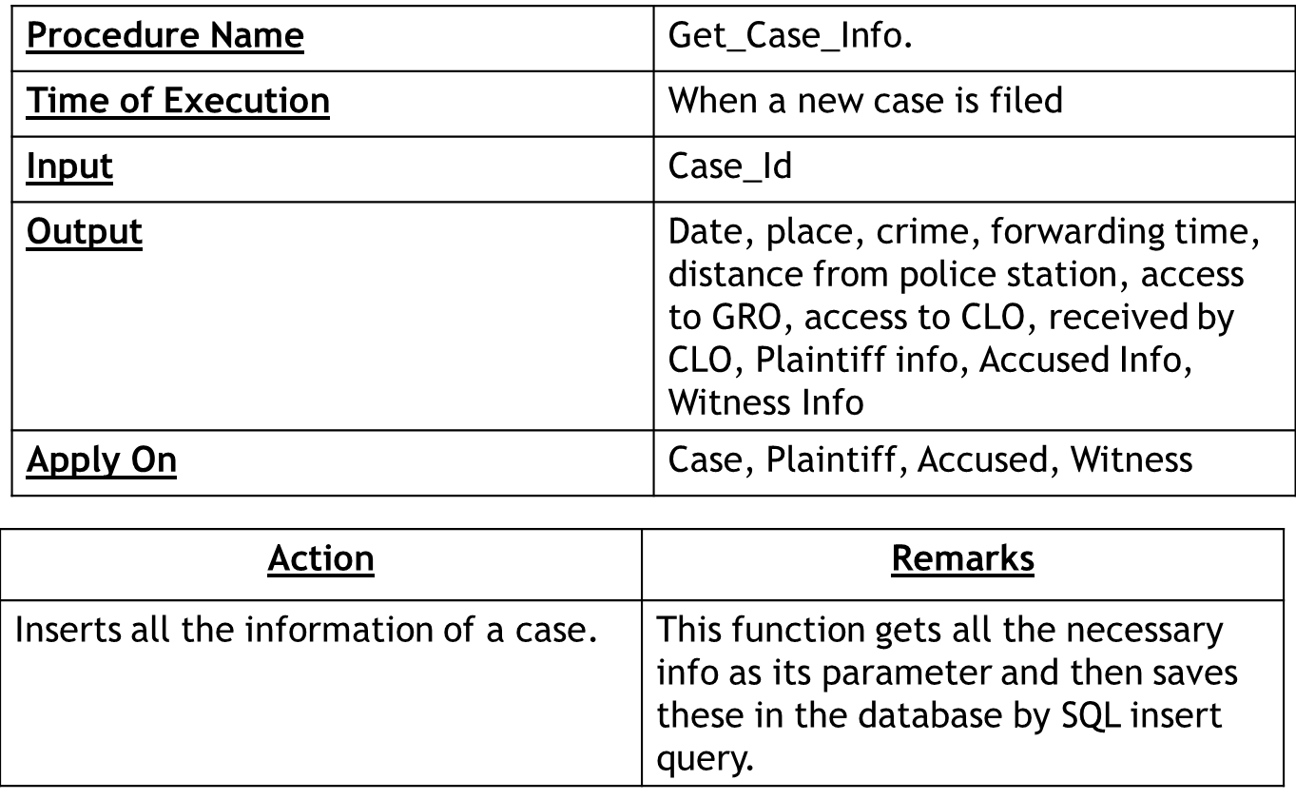**5.6 Procedures:**

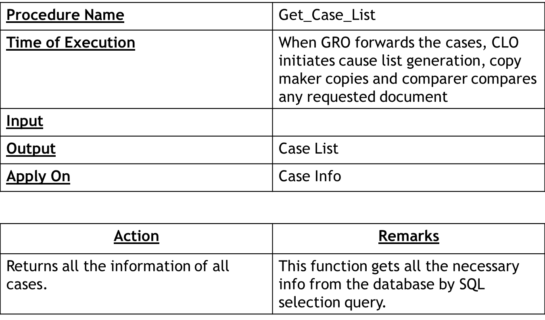Procedures are those functions that are stored in a database to compute various calculations on data. The procedures designed for our system are given below.

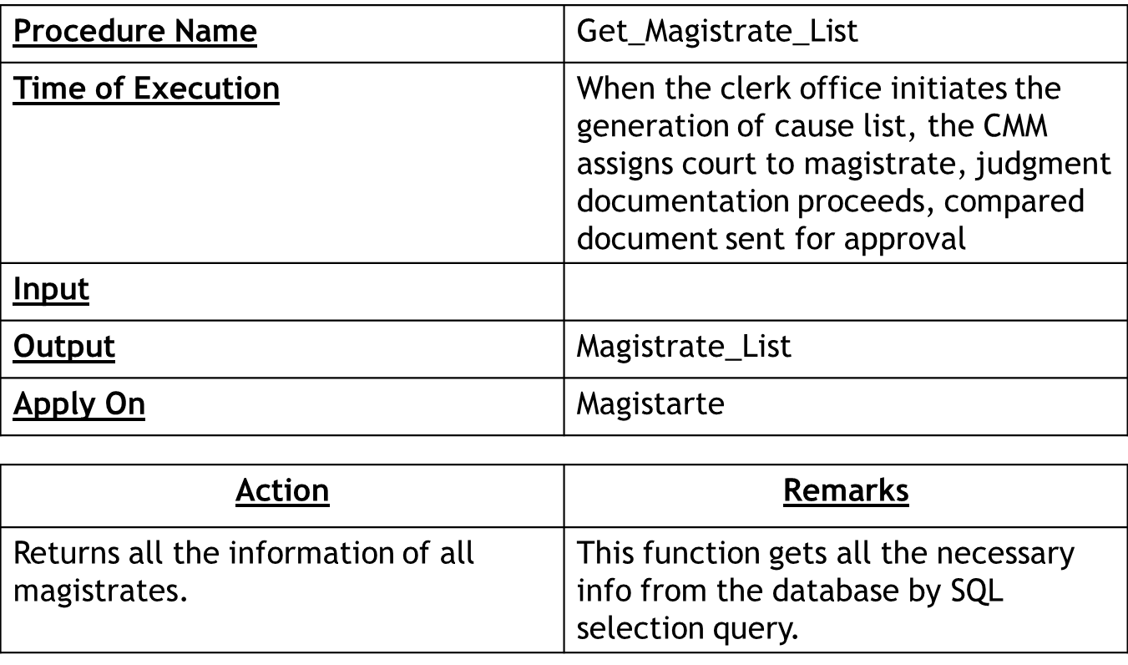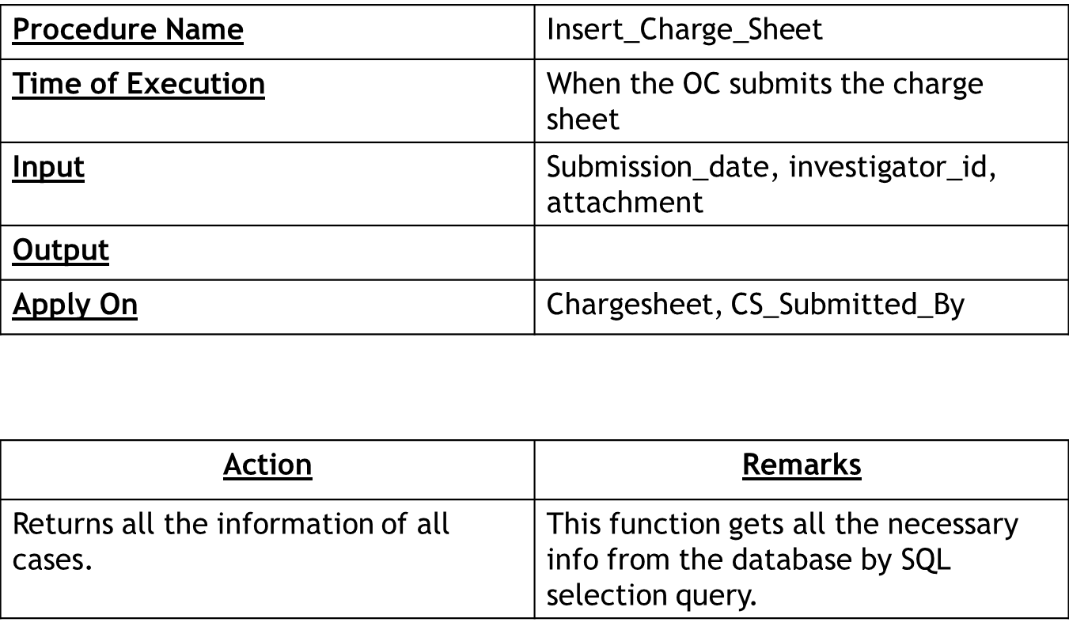

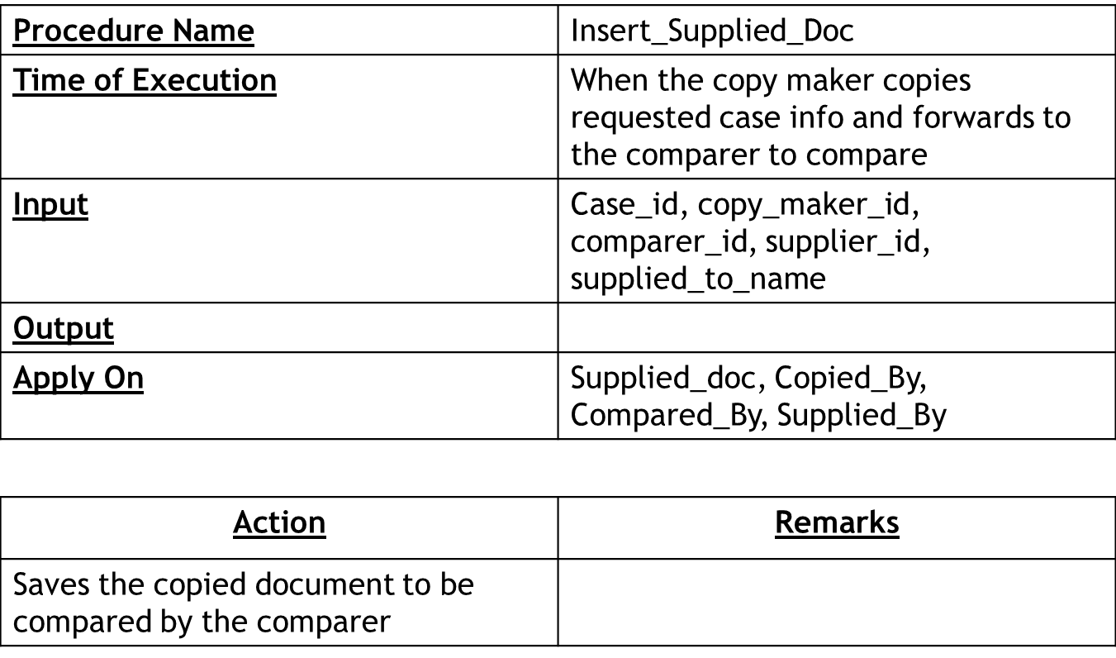

**Chapter 6**

**Input & Output Design**

**6.1 Introduction:**

The UI of the project will be given as for a desktop application. The presented UI for the presentation had some scroll pages, which were marked as inappropriate in terms of SOLID principle. The corrected UIs are now categorized in six categories as:

1. Common UIs
2. UI for case filing sub-system
3. UI for Cause List Generation sub-system
4. UI for Magistrate Assignment sub-system
5. UI for Document Collection sub-system
6. UI for Judgment Documentation sub-system

**6.2 Common UIs:**

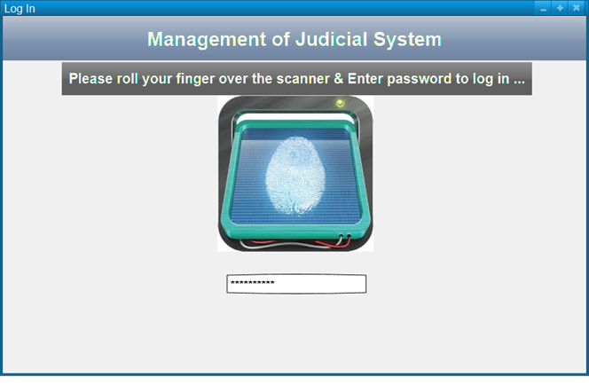**6.2.1: Log In UI:**

The log in will be done using the fingerprint scan of any user of the system. The system will be able to identify the finger print of any user distinctly and for extra security measures, a password will also be prompted out from the user.

**6.2.2 Case Details Show:**

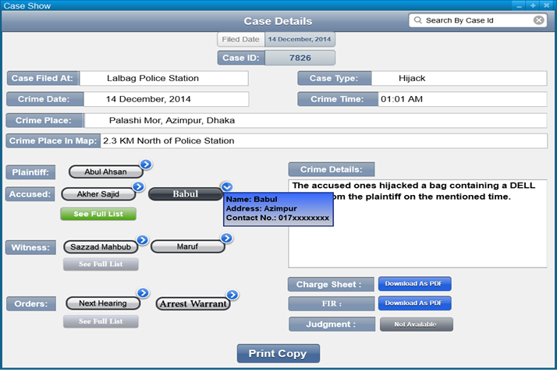This UI will be shown to OC, GRO, CLO, copy maker, comparer, Magistrate and CMM when they prompt to see any case. Here, the necessary fields are shown with self-explanatory labels, while the plaintiff, accused persons, witnesses and orders are shown by name buttons with a side arrow, which will show a dialog with the entered details of the person or order on click. There will be download buttons for downloading the FIR, charge sheet and other judgment documents when available. These downloads will give PDF of the document those can be of hundreds of pages. The print button at the bottom of the UI will print out the case with well formatted details.

**6.3 UIs for Case Filing Sub-system:**

**6.3.1 Case Filing:**

The DO of the police station will use this UI to input the case details as described the plaintiff. The case type will be selected from a drop down and the crime date and time will be selected through pickers. Crime place will take a manual input, while the crime place in map will provide a map to identify the specific location of the crime place with respect to the police station. The plaintiff details are must, so the fields are shown explicitly. But the accused and witness list will be populated through an addition dialog. At last there will be a text input field for the crime details. When the form is completely filled up, a copy can be printed out as well as the case filing process will be succeeded by clicking on file case prompt button.

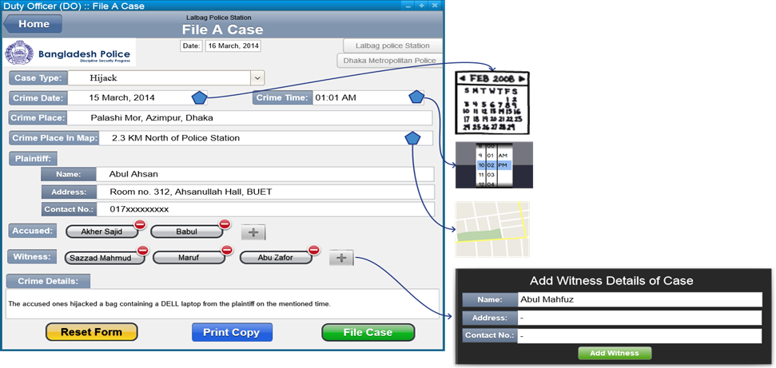

**6.3.2 Charge Sheet Submission:**

The officer in charge (OC) will use this UI to see the cases filed at that police station. An upload charge sheet button will be available at the charge sheet column of the case list if this is yet to be submitted. On clicking this button, the OC can upload the scanned PDF or the typed document of the charge sheet. If the case has the charge sheet already uploaded, then the shown charge sheet id will download the PDF when clicked on. Moreover, clicking on the case row, the OC can see the details of the case.

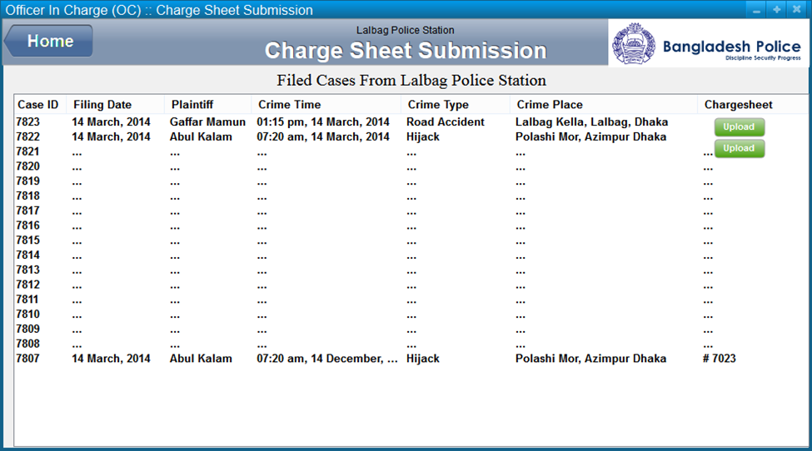

**6.4 UI for Cause List Generation Sub-system:**

**6.4.1 Case List Sending UI:**

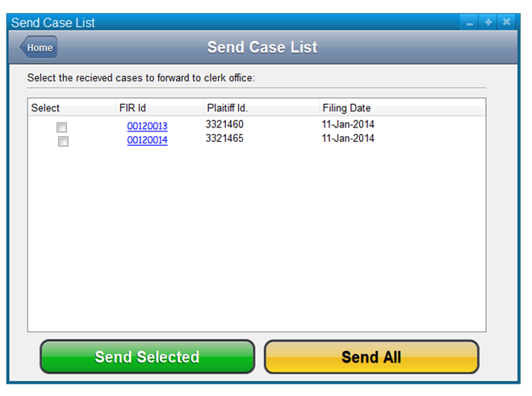The General Record Officer (GRO) of the local magistrate office will use this UI to see the filed cases at the police stations of that locality. The list rows, when clicked on, will show the GRO the case details. There will be a check button, which the GRO can check if the details are ok and then he can forward the cases to the clerk office of the magistrate office.

**6.4.2 Cause List Show UI:**

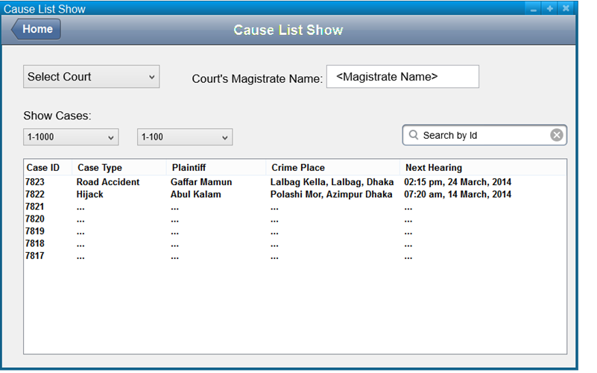The clerk office will use this UI to see the cases under the Magistrate and the respective order notice will also be shown as a column in the list. As there may thousands of cases, there are two dropdowns to select the thousand and hundred volumes of the cases. Any case can also be searched out from the list by the id.

**6.4.3 Magistrate Home UI:**

A magistrate can log in to the system and see this UI to navigate to his case list and notification list from this UI.

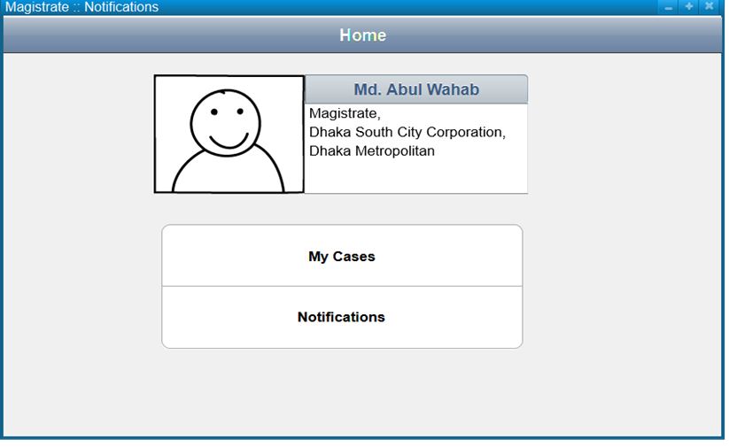

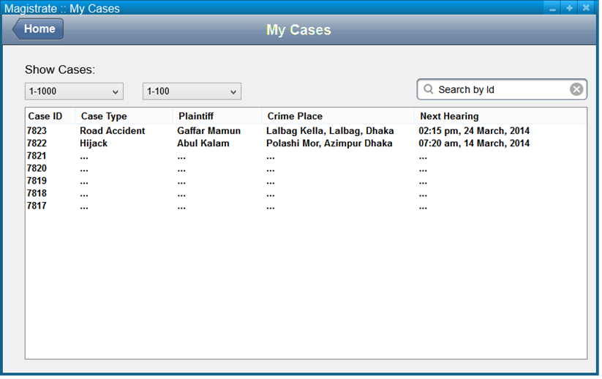**6.4.4 Magistrate Case List Show:**

The magistrate can see the cases under his judgment in this UI. ONclicking any row, he will be able to see the details of the case. He can also search out any case by the id from this UI.

**6.4.5 Magistrate Notification UI:**

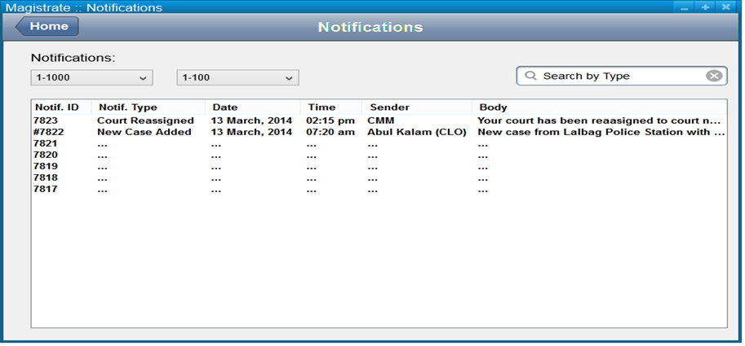A magistrate can receive notifications from the CMM about the new court assignment after a new court list generation. He may also get notification after recepetion of a new case under his judgment. He can see the details of the case by clicking on the row from the list.

**6.5 UI for Magistrate Assignment Sub-system:**

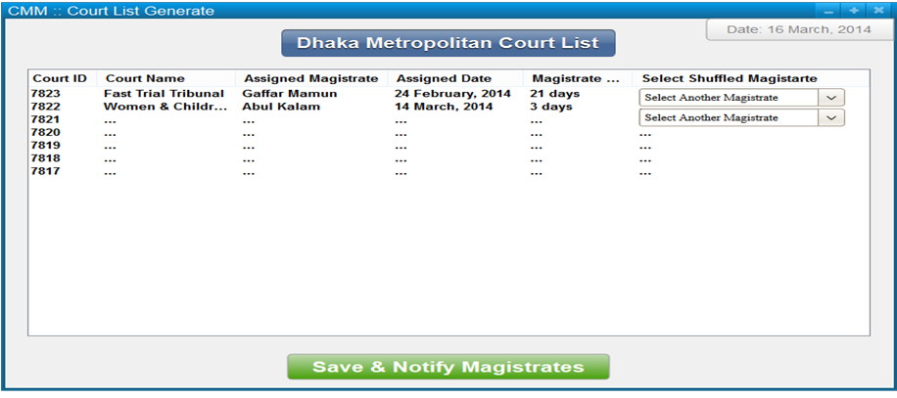**6.5.1 Court List Generation UI**:

The Chief Metropolitan Magistrate (CMM) can use this UI to shuffle the magistrates among the courts which will generate a new court list. The CMM will see all courts listed with the assigned magistrate details. There will be a drop down list to select another magistrate for the respective court. When another magistrate is selected, the previous magistrate will be swapped with the new magistrate between the two courts. After swapping magistrates, the CMM can save the new court list which will also notify the respective magistrates about the new court list.

**6.6 UI for Document Collection:**

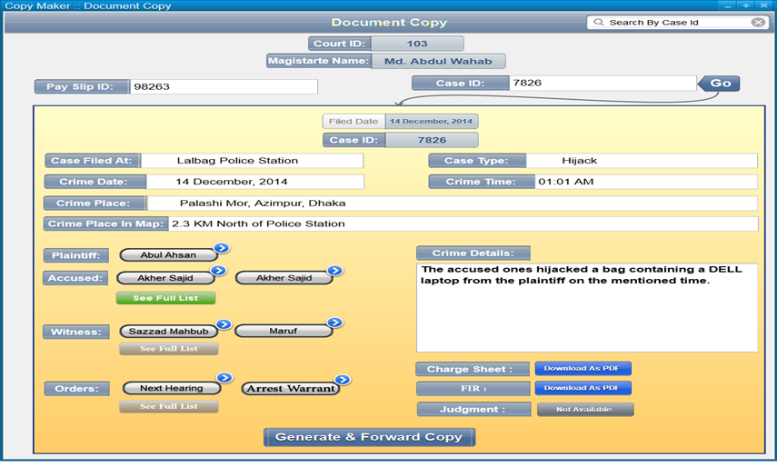**6.6.1 Document Copying UI:**

After checking the provided payment slip, copy maker will search out the requested case details which will set an exact case show UI described above. Then he will prompt to generate and forward the reuqested copy to the compare for further comparison.

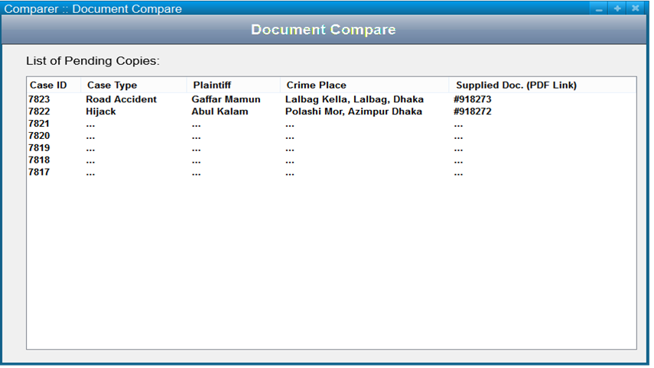**6.6.2 Document Comaprison UI:**

Comparer will see the pending cases to be compared in this UI, where he may download the supplied copy and then click on the row to see the main details of the case.

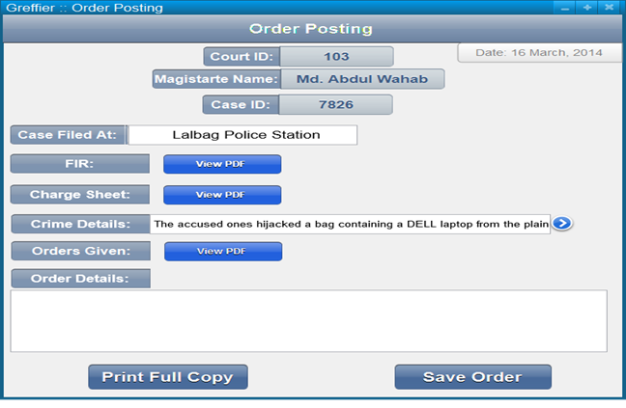**6.7 UI for Trial Documentation:**

**6.7.1 Order Posting UI:**

When a case receives any order as arrest warrant, witness presence, next hearing date and so on, then the greffier will use this UI to document that. The FIR, charge sheet and previous orders of the case can also be seen from this UI as downloaded PDF format. After completion of the order input, the copy can be printed out for any other uses readily.

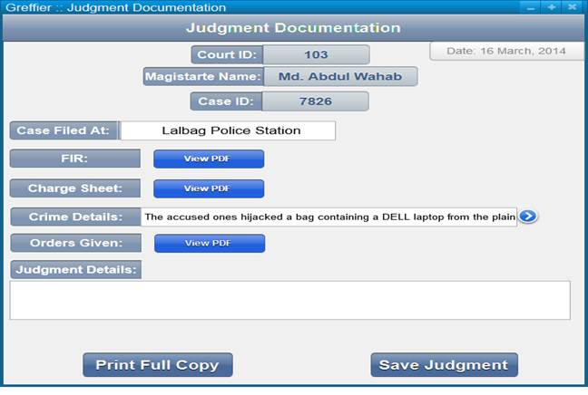**6.7.2 Judgment Documentation UI:**

This UI will be invoked when the final judgment needs to be documented. The greffier will use this UI as the previous order posting UI.

**6.8 Conclusion:** These are the basic UIs of the system. TheseUIs include the total active users of the system as the duty officer, OC, GRO, clerks, magistrates, CMM and greffiers of the courts.

**Chapter 7**

**Project Timeline & Activity**

**7.1 Introduction:**

Time division is important for project management and development due to limited number of resources and fixed number of developers. It is kept in mind that distribution should be done in such a way that highest work is done witihin minimal possible time. Also during a project life time, disastrous events may occur such as project disapproval. Before starting development, we should sketch up a better escape plans from this type of events.

**7.2 Work Schedule & Project Time Analysis:**

**7.2.1 Activity Network:**

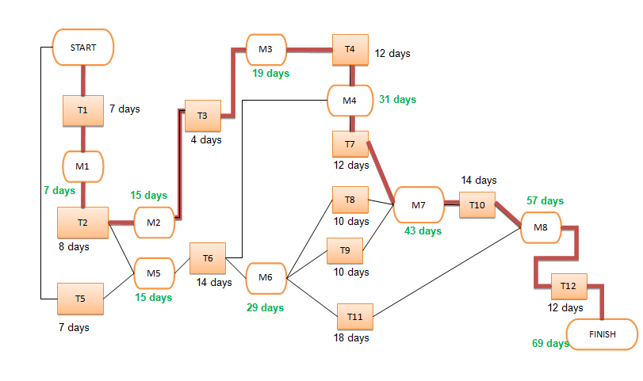

**7.2.2 Activity Timeline:**

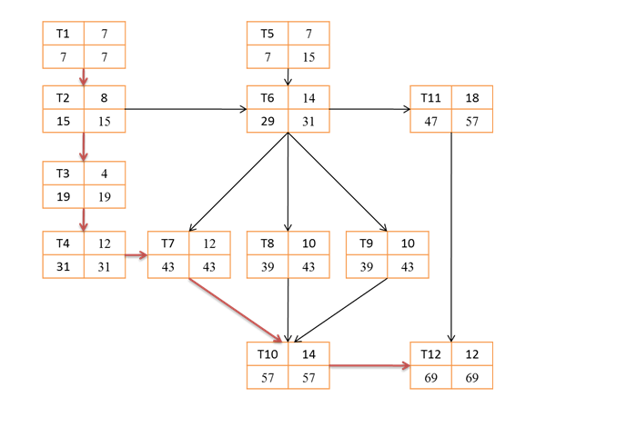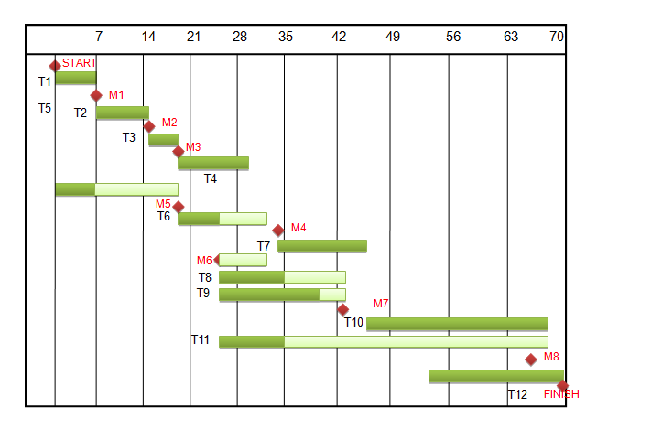

**7.2.3 Pert Chart:**

**7.3 Cost Benefit Analysis**

**7.3.1 Development Costs:** 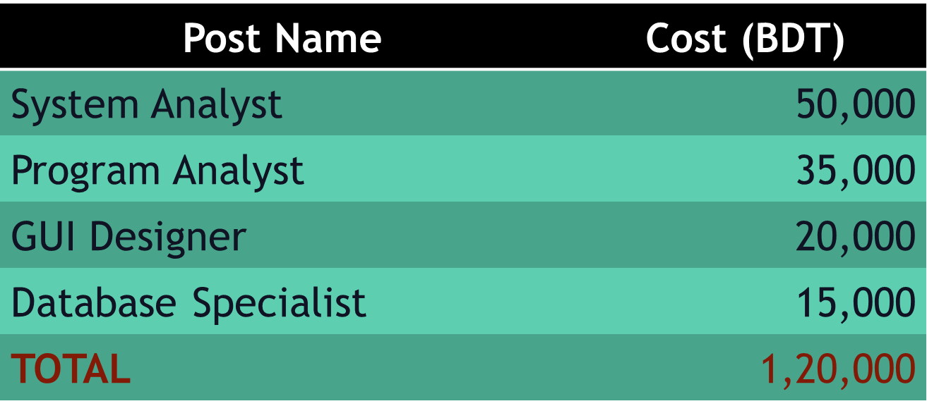 The first of the fixed costs are development cost. System analyst, program analyst, GUI designer, and database specialist are to paid to develop the system. The total estimated cost for development is 1, 20, 000 BDT.

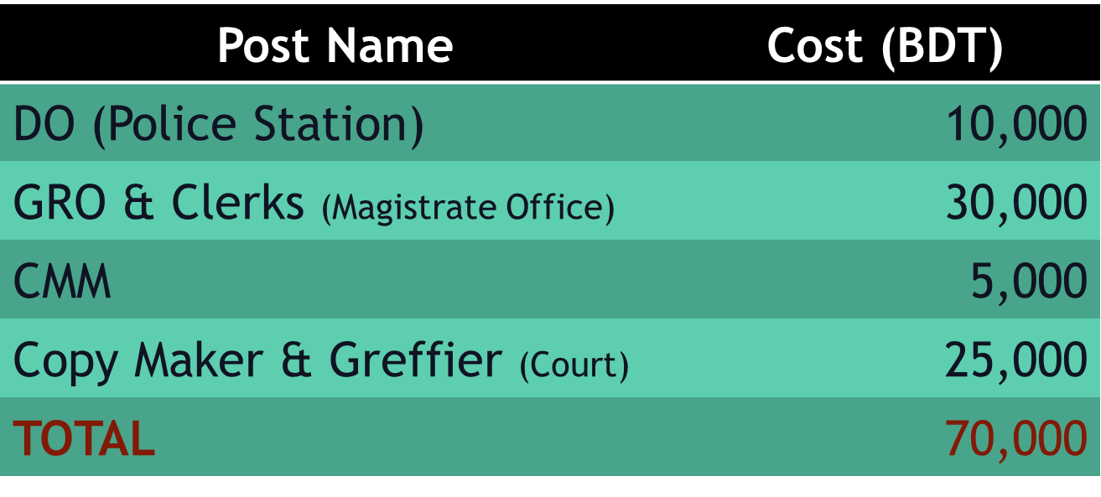**7.3.2 Operational Costs:**

**7.3.2.1 Training Cost:** People of our country are not much skilled in using computer and so are the people working in the courts. To ensure that our designed system will be working properly we need to provide proper training to every employee. The training procedure will include duty officer, GRO, clerks, greffier and even magistrate. This process has an estimated cost of 70000 BDT. But this is a cost the government will have to bear only once.

**7.3.2.2 Hardware & Software Implementation Cost:** 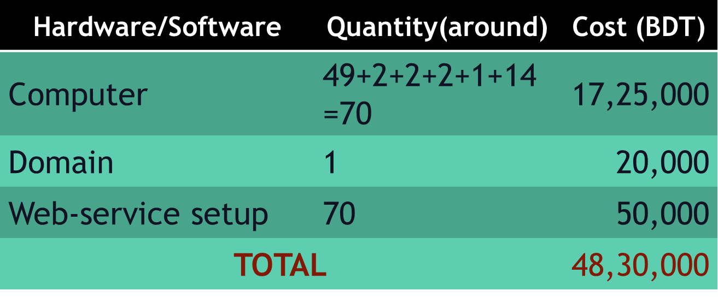As we are implementing the software for this system a computer is needed for every police station, every clerk office in court and finally every CMM office. There are nearly 49 police stations in the Dhaka metropolitan. So each Police station needs a computer. Then 2 computers for the GRO, 2 for clerk office and 2 are needed for greffiers. Then 1 computer is needed in the CMM court and 14 computers are allocated for the copy makers and comparers. The total amount needed for computer setup is 17,25,000 BDT. Also to keep the databases a domain should be bought which might cost 20,000BDT. The number of police station and courts in Dhaka metropolitan are taken from the official websites. And the cost of computers is estimated with the help of Ryans computers official website. The links are given below.

Sources: <http://www.dmp.gov.bd>, <http://mopa.gov.bd/pmis/Forums/dslist.php>, <http://www.ryanscomputers.com>

**7.3.2.3 Variable Costs**: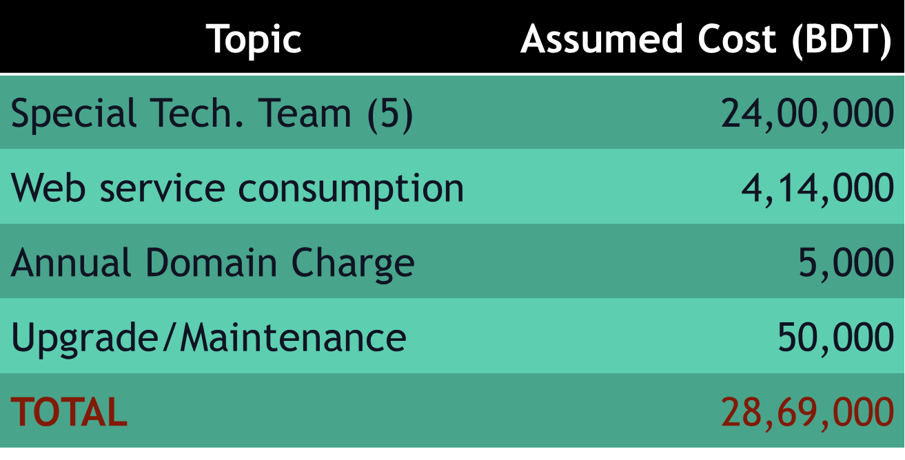 Variable costs are those which are dependent on usage of the system. These are usually annual costs to maintain the system. The main cost for maintaining the system will be from hiring technology specialist team. Web service consumption is also a notable aspect of variable cost. The overall variable cost is calculated to be 28, 69,000 BDT per year.

**7.3.1 Tangible Benefits:**

Tangible benefits are those which has an easily quantifiable value. Some of them are given below.

* No Paper Document cost
* Reduction of book-cost for the lawyers

**7.3.2 Intangible Benefit of the System:** The benefits those don’t have a quantifiable value are counted as intangible benefits. Benefits like saving of something, time, resulting in a better working environment are included in tangible benefits. Some of the intangible benefits derived from our system are listed below.

* **Time Saving:** 
  + - Saving of time of both the employees and the users. The employees get a fast and easily manageable system. Also the user will not have to rush to the courts and wait every now and then.
  + **Saving Money :** 
    - In the whole process of case proceedings a plaintiff and his lawyers need to collect same document again and again by paying fees for those document. This is in no way a desired process. But in our system as all the data are documented in the database access for people to public data can be provided to them without any cost.
  + **Reducing of manual labor:**
    - In the current process every document is written by hand and manually managed. The system under consideration will reduce manual labor.
  + **Reducing crowd:**
    - As our system can provide faster service to the users there will less crowd in the courts and will result in a better working environment.
  + **Automation, Easy management, Efficient searching**
    - An automated system is always easy and efficient to use. It will ensure zero data loss and anyone can easily search for documents and get better results.

**7.4 Risk Analysis:**

**7.4.1 Long Term Risk Analysis & Management:**

**7.4.1.1 Risk Identification:**

|  |  |  |  |
| --- | --- | --- | --- |
| **Risk** | **Type** | **Affects** | **Description** |
| Stuff turnover | People | Project | Skilled and key stuffs may leave the project before finish. |
| Authoritative disapproval | Organization | Project and product | The government may not agree to integrate the system with the existing system. |
| Requirement change | Requirements | Project and product | Some added functions as online case filing, online trial process, active interaction of lawyers in the system may be required later. |
| Size underestimate | Estimation | Project and product | The project estimations are done only for Dhaka CMM court. The implement may be extended for the whole country. |
| Management change | Organizational | Project | Change in the government with different motivation may cancel the project. |
| Product competition | Product | Business | Other alternative system may emerge to replace our system. |

After analyzing it is observed that above mentioned risks are of different probability and effect which is as follows:

|  |  |  |
| --- | --- | --- |
| **Risk** | **Probability** | **Effect** |
| Stuff turnover | Medium | tolerable |
| Authoritative disapproval | Medium | serious |
| Requirement change | High | serious |
| Size underestimate | Medium | Serious |
| Management change | Low | Catastrophic |
| Product competition | Low | Catastrophic |

**7.4.1.2 Risk planning:** Based on the risk analysis some minimization, avoidance and contingency strategy is made to deal with these risks.

|  |  |  |
| --- | --- | --- |
| **Risk** | **Strategy type** | **Strategy** |
| Stuff turnover | Minimization | Reorganize team so that there is more overlap of work and people therefore understand each other’s jobs |
| Authoritative disapproval | Avoidance | Prepare a briefing document for the government authority showing how the system is making a very important contribution to the goals. |
| Requirement change | Avoidance | Alert the authority, employees and magistrates about particular difficulties and potential delays involved with requirement change. Also try to persuade them current requirement is good enough to operate nicely. |
| Minimization | Increase collaboration with the users and authority to identify their entire requirement also try to predict future requirement change and start taking preparation for that. |
| Size underestimation | Minimization | Investigate tool’s capability, code efficiency. Also try to find out critical implementation points and also try to recruit experienced and highly skilled developers. |
| Management change | Avoidance | Same as ‘authoritative disapproval’ |
| Product competition | Contingency | Try to figure out which possible existing system may override our proposed system. Also try find out the features and points where all other systems must lack because of inherent reasons. Reinforce efforts to compete with other systems continually until we establish ourselves in a secured level. |

**7.4.1.3 Risk Monitoring:** Risks identified have to be monitored in a regular manner. Every twice week we need to re assess the probability and monitor the functionality of the proposed strategy. In case where probability of a risk rising we need to take necessary back-up plans. Some key indicator of risks is:

1) Poor morale and poor relationship among team members may trigger staff turnover.

2) Plaintiff, CLO, GRO, greffiers and magistrates disinterest may result in requirements change.

3) Failure to persuade authority about amount of work need to be done to develop this system may trigger them to reduce project budget.  
In any case when an indicator of a risk shows up necessary strategy needs to be taken into account throughout the project timeline.

Chapter 8

Conclusion

In the existing management system of the judicial system in Bangladesh is not automatized. Use of this traditional system creates public harassment. Also the people who work in this system also have to struggle to cope up with the system and repeating the same monotonous and laborious process again and again. The goal of our project is to build a better and faster management system for our country with the existing technology. That’s why first requirement analysis is done to find out the problems to solve and features that we can implement in our system. Then feasibility analysis is done to find out whether the system we are planning will be beneficial. While planning the system we have used several diagrams. Some of them are use case diagram, sequence diagram, collaboration diagram etc. In the later phase database design and UI design is done to get a better overview of the system. This is the report about our findings and the system we are that we are planning to develop in the future.